EYFS | 30-50 months:  - Uses various construction materials.  - Realises tools can be used for a purpose.  40-60 months:  - Understands that different media can be combined to create new effects.  - Constructs with a purpose in mind, using a variety of resources.  - Selects appropriate resources and adapts work where necessary.  - Selects tools and techniques needed to shape, assemble and join materials they are using.
 | Autumn | Spring | Summer
Nursery | Helping Hands  (Fire  Firefighters, police, ambulance)  Self portraits  Photograph and draw staff and visitors to Nursery  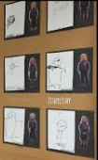 | Into the Wild  (Animals with a pattern)  Pattern making with a range of materials e.g. art materials, natural materials.  Look carefully at illustrations in stories e.g. Eric Carle  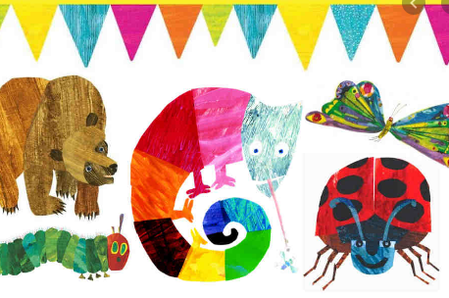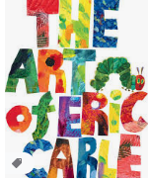 | Making a splash  (Sea, river, under the sea)  Explore different textures in paint. Add sand, sawdust, glitter, soap and shaving foam.  Blow bubbles in soapy paint. Take prints from the bubbles. 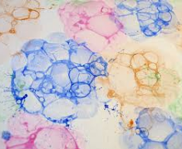
Ongoing | Exploration of a range of materials inside and outside.  Work at different scales; individually and in groups; transient and more permanent models and images.  Talk about their own creations and those made by others including artists and crafts people.

EYFS | 40-60 months:  - Understands that different media can be combined to create new effects.  - Constructs with a purpose in mind, using a variety of resources.  - Selects appropriate resources and adapts work where necessary.  - Selects tools and techniques needed to shape, assemble and join materials they are using.  ELG:  - They safely use and explore a variety of materials, tools and techniques, experimenting with colour, design, texture, form and function.
 | Autumn | Spring | Summer
Reception | Helping Hands | Into the wild | Making a splash
 | Portraits of people who help us in the community e.g. PCSO, Firefighter.  Self portraits  Hands – observe closely  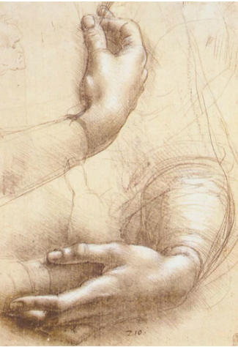Leonardo da Vinci  Study of hands  Use charcoal and work large scale, pencil for smaller scale work.  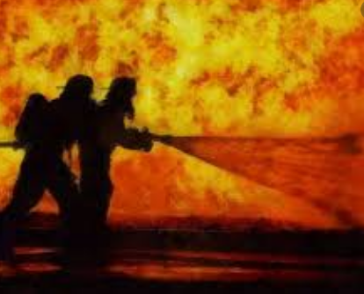  paint/pastel on black paper | Animal puppets  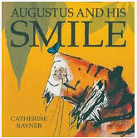Katherine Rayner  Backgrounds based on illustrations.  Tiger or other animal to walk through scene.  Record using Shadowpuppet on iPad.  Artist: Henri Rousseau  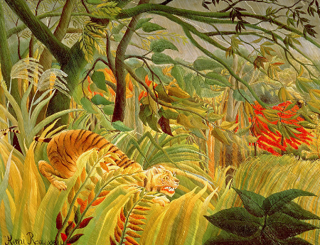  Tiger in a tropical storm | sea creatures  Observe, photograph and draw fish at aquarium. Observe fish from the fish counter up close.  Fish – wax drawings/oil pastel with water colour wash. Wax resist.  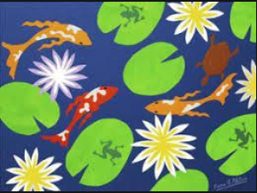  Artist:  Henri Matisse  Printing, collage, painting.
Ongoing | By the end of Reception  Generating ideas:  1. Work purposefully responding to colours, shapes, materials etc.  2. create simple representations of people and other things  Making:  3. Work spontaneously and enjoy the act of making/creating  4. Sustain concentration and control when experimenting with tools and materials  Evaluating:  5. recognise and describe key features of their own and others’ work  Knowledge and Understanding:  6. That art, (design and craft) is made by artists exhibiting care and skill and is valued for its qualities.  7. how to explain what they are doing  (NSEAD)

KS1 | Use drawing, painting and sculpture to develop and share their ideas, experiences and imagination, using a range of materials creatively to design and make products. Develop a wide range of art and design techniques in using colour, pattern, texture, line, shape, form and space. Learn about the work of a range of artists, craft makers and designers, describing the differences and similarities between different practices and disciplines, and making links to their own work.
 | Autumn  The Great Food Journey | Spring  Great Leaders | Summer  Just the tickert
Year 1 & 2 | Collage  - Make pictures from found materials e.g. fruit, vegetables and photograph them.  - Cut and tear coloured paper and painted paper and arrange the pieces and glue down to form a picture e.g. to resemble cut sections of fruit and vegetables  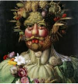  Artist: Giuseppe Archimboldo | Painting  - Paint a background using watery paint and once dry paint a foreground with thicker paint.  - Mix purple, orange, green, brown using powder/ready mix paint  - Use a thicker brush for large areas and a thin brush to paint details.  - Pull a paint brush rather than push it when painting.  Artist:  Portraits of the Queen  Chris Levine Holographic photograph  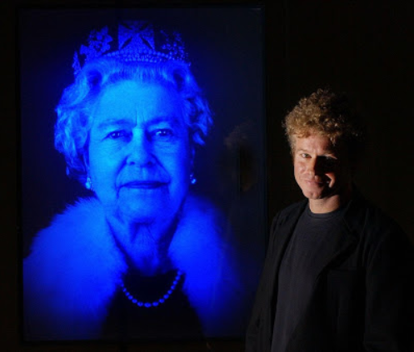  Andy Warhol Chinwe Chukwuogo-Roy  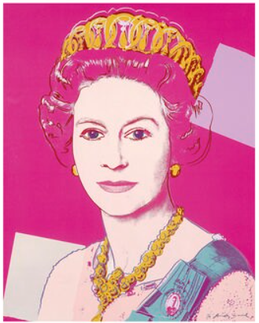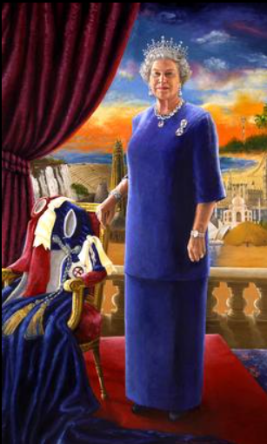 | Sculpture  - Roll a ball of clay and pinch it to create a thumb pot. Smooth the outside using fingers.  - Create texture by pushing objects into the clay to create texture and pattern.  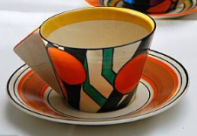  Artist/Designer:  Clarice Cliff ?  Printing  - wheels, cogs, tyre tread from toy cars to print with  - rubbings from tyre tread patterns and print from rolling full size wheels into printing ink  - create repeated patterns, overlap, print in 2 colours  - draw design into polystyrene tile and print with  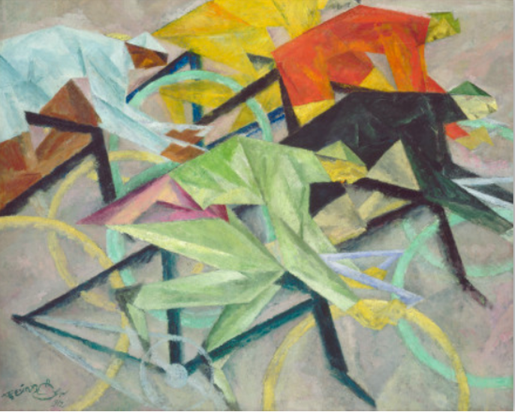 Lionel Feininger
Ongoing | Planning, developing and reviewing.  - Ask and answer questions about your starting points  - Try things out and change your mind  Say what you are pleased with in your work and what you would change another time.  Drawing  - Draw using pencils, crayons, chalks, felt tips.  - Experiment with colouring over areas to make darker.  - Show pattern and texture using lines, dots and make rubbings using pencil and wax crayon.  - In observational drawings make careful choices about size and colour.

KS2 | Create sketch books to record their observations and use them to review and revisit ideas. Improve their mastery of art and design techniques, including drawing, painting and sculpture with a range of materials. Find out about great artists, architects and designers in history.
 | Autumn  Stone Age | Spring  Romans | Summer  Ancient Egypt
Year 3 & 4 | Painting  - Use a range of brushes sizes purposefully  - Use black to create tones and white to create tints with control  - Produce textures using brush techniques  - Use colour to create mood.  - Use thinner and thicker paint for effect  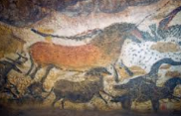  Artist: cave painting at Lascaux | Collage  - Prepare materials for collage by painting washes over newsprint, collecting magazines, cardboard and paper packaging and by collecting rubbings of textures. Collect fabric (e.g. old clothes)  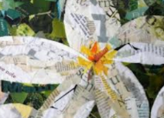  - Cut and tear papers and fabric and arrange before gluing down.  Artist: Eileen Downes | Sculpture  - Create a coil pot and smooth the outside. Make side of even thickness.  - Finish the pot carefully with intricate pattern and/or texture  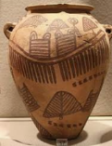  - Or paint a base coat and add intricate painted decoration  Artist: Ancient Egyptian pots  Ancient Egyptian frieze patterns  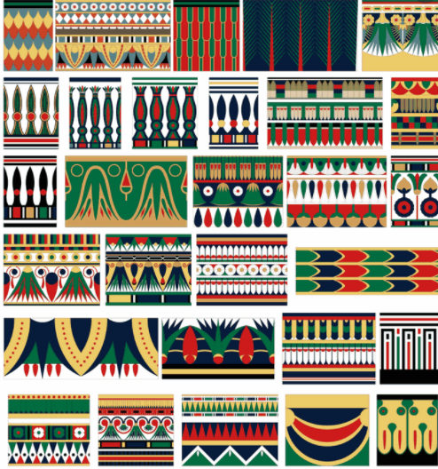  Egyptian carpet border  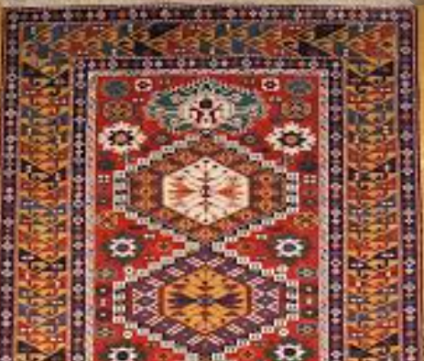
Ongoing | Planning, developing and reviewing.  - Use sketch books to explore the work of artists and crafts people and to practise and refine techniques  - Plan work, review work and make changes as you work.  - Use artistic language: portrait, still life, seascape, landscape, city scape, abstract  - Ask and answer questions about your starting points  - Try things out and change your mind  - Say what you are pleased with in your work and what you would change another time.  Drawing  - Use light lines for initial sketch so lines do not need to be rubbed out in order to make changes.  - Use a range of pencil grades to create line, tone and texture.  - Use tone to show light and shadow  - Show accuracy in size and proportion in observational drawings.

KS2 | Create sketch books to record their observations and use them to review and revisit ideas. Improve their mastery of art and design techniques, including drawing, painting and sculpture with a range of materials. Find out about great artists, architects and designers in history.
 | Autumn  Space | Spring  After the heartbreak  Refugees | Summer  Magic, monsters and mayhem  Vikings and Anglo Saxons
Year 5 | Collage  - Prepare materials for collage including researching and photocopying/printing papers, painting washes over newsprint, collecting magazines, cardboard and paper packaging and by collecting rubbings of textures. Collect fabric (e.g. old clothes)  - Use collage as part of multimedia work.  - Use drawing software to create shapes that can be copied, rotated and moved to create artwork.  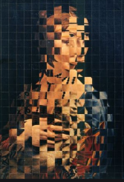  Artist: Robert Rauschenberg  Jiri Kolar  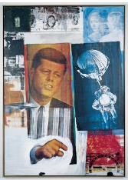  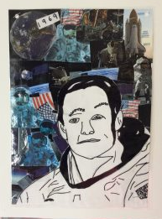 | Painting  - Continue using the 2 pot method of watercolour  - Experiment with watercolour, exploring intensity of colour to develop shades.  - Know how to show reflections.  - Choosing the appropriate brush or tool for the task.  - Using the appropriate colours to reflect the mood/purpose of the painting.  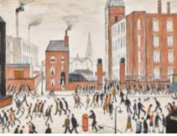  Artist: L. S. Lowry  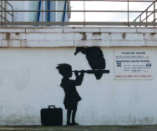  Banksy  Cityscapes – local architecture | Clay  - Roll clay using pieces of wood to ensure even thickness.  - Make a tile and add decorative pieces joining by scoring and water.  - Make and use slip to join smaller, delicate pieces.  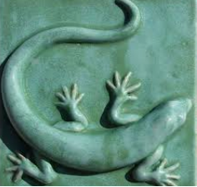
Ongoing | Planning, developing and reviewing.  - Develop and imaginatively extend ideas, collecting ideas, sketches and resources and present imaginatively in a sketch book.  - Comment on artworks using visual language.  - Begin to use terms for art movements.  Drawing  · Use tone to show light falling in different directions.  · Show perspective in objects in the foreground and background.  · Using line, tone, shape and colour to represent figures and forms in movement.

KS2 | Create sketch books to record their observations and use them to review and revisit ideas. Improve their mastery of art and design techniques, including drawing, painting and sculpture with a range of materials. Find out about great artists, architects and designers in history.
 | Autumn | Spring | Summer
 | Only the Brave  Olympic Challenge | Rivers and coasts  Dracula  Whitby | Mission impossible  (2nd World War)
Year 6 | Greek masks  Clay  Greek masks  • Roll clay using pieces of wood to ensure even thickness.  Lay over bowl etc to form shape  • Join pieces using scratch and slip technique  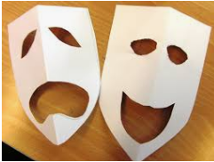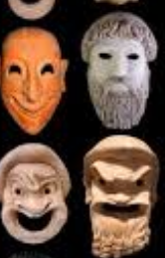 | Printing  • Make a potato relief printing block and over print with different colours starting from lightest colour, cutting parts of block away to print each colour.  • Make relief printing block from foam board, push into the board to change the print and over print in another colour.  Textiles  Simple weaving technique  Landscape weaving  Artist:  Artist: Sue Spooner  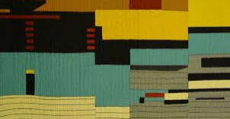  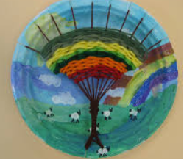 paper plate  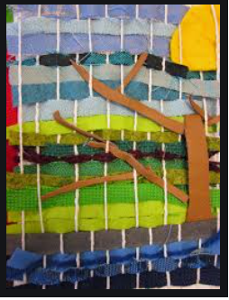 card weaving | Painting  • Use brush techniques and the qualities of paint to create texture.  • Develop a personal style of painting, drawing upon ideas from other artists.  • Make choices about paint and tools and explain their own choices using terms such as tone, tint, shade, mood.  • Explore and use a digital painting app.  Artist:  Digital painting – David Hockney  Brush Reddux for iPad  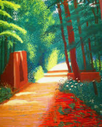  See exhibition at Salts Mill
Ongoing | Planning, developing, reviewing.  • Develop and imaginatively extend ideas, collecting ideas, sketches and resources and present imaginatively in a sketch book.  • Explain how own work has been influenced by the work of a famous artist.  Drawing  • Able to use perspective in their work including vanishing points. Roads and walls.  • Use a variety of techniques to add interesting effects e.g. reflections, shadows, direction of sunlight and to depict movement and perspective  • Choose a style of drawing suitable for the work (e.g. realistic or impressionistic).  • Use rubbers to draw into work and highlight areas.

