Monday 1st March 2021

Last week, we planned the ending for what thought would happen next in Tootega and Derek’s lives. You also planned the camera shots for the scenes you would have.
1 minute – write down all the camera shot types!

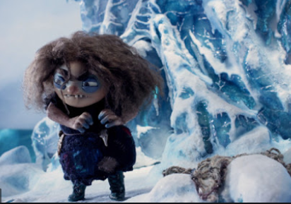
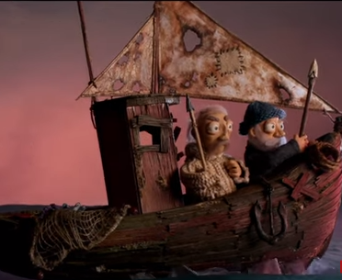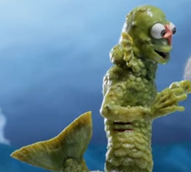
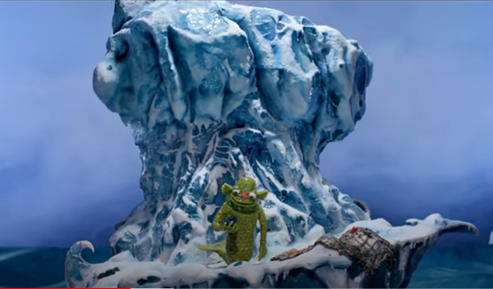

Get filming!
Use your camera shot plans to help you film the next scenes. You can use the pictures provided, draw your own, use Lego or model characters out of play dough- it’s entirely down to you!
Remember to keep your camera’s still, concentrate on your camera shots and think about whether your still images tell the story you want them to.

Remember to share your films with us – we will be handing our prizes!

