Friday 5th March 2021
Use the features to write lines of poetry about Dracula!
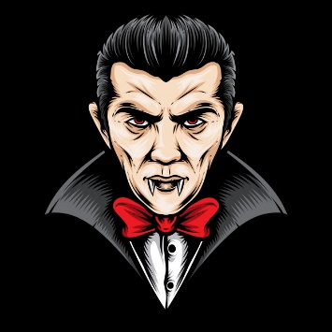
How many points can you earn?

rhyme (2pts) | simile (3pts) | personification (4pts)
expanded noun phrases (2pts) | repetition (3pts) | alliteration (4pts)

Today, we are going to create blackout poetry, using the text from Dracula.

We can try to create the poetic features from the words available, but that might not always be possible.

Blackout poetry is when a page of text is completely blacked
out (coloured over with permanent marker so that it is no
longer visible) except for a select few words.

When only these words are visible, a summary of what is
written or a brand new story is created from the existing text.

