LI: To find coordinates of positive in the First Quadrant
I will be successful if…
I know that 2 points make a coordinate.
I know you go along the corridor (1st coordinate) and then up the stairs (2nd coordinate).
I can explain why a question is wrong
You do…

Challenge…
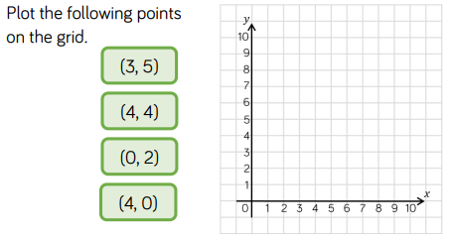

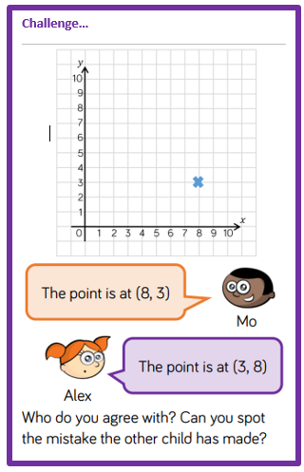
Challenge…
