02.03.2020
LI: To add two digit numbers.
I can partition numbers into tens and ones
I can model numbers using tens and ones
I can add 2 digit number by combining 2 sets and counting in tens and ones.

Cut out the tens and ones. Use them to model the numbers in the problem. Count all the tens and ones to find how many altogether.
How many animals altogether?
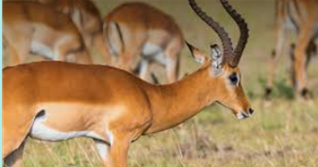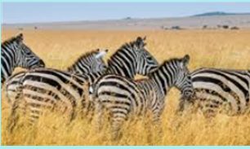
13 11

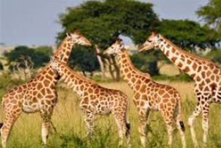
11 15

15 13

