

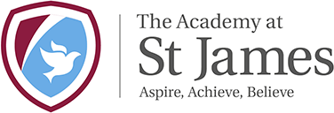

**R.E. Vision**

By the end of their time at St James our children will:

* Discuss and compare the similarities and differences between all religion and atheist.
* Ask and answer challenging religious questions that make links between cultures, faiths and religious texts.
* Use religious terms accurately in their effective communication of ideas and judgements
* Enjoy learning, regard religion as fun and want more challenges and success
* Feel prepared for the next stage of their religious education and part of their adult life
* Feel proud of their beliefs, identity and their community.
* Developing the whole school understanding of the children’s spirituality and the development of the curriculum.
* Allow for quiet reflective time and spaces.
* Have memories for life from visitors, visits and rich experiences.
* Investigating the beliefs and practices of other world religions.
* Understand how religion is relevant to a modern society.
* Develop a high-quality sequential religious education programme which is suitable for each year group.
* Select and apply their knowledge and skills from other subjects to draw conclusions and communicate their findings
* Develop the ability to critically reflect on, evaluate and apply their learning to their own understanding of religion, themselves and the world.