Monday 1st March 2021
Content Domain:1b identify / explain key aspects of fiction and non-fiction texts, such as characters, events, titles and information
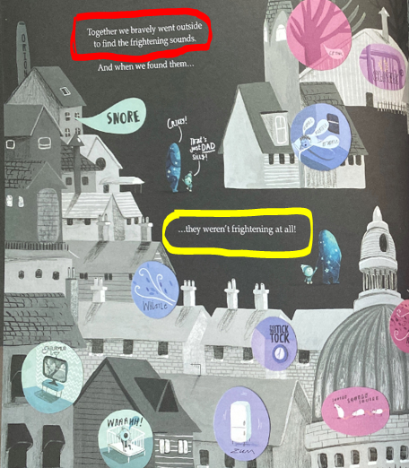

- How do you think Orion would walk if he went outside bravely?

You could make a short video clip to show how walking bravely would look.

- Why weren’t the outside sounds very scary in the end?
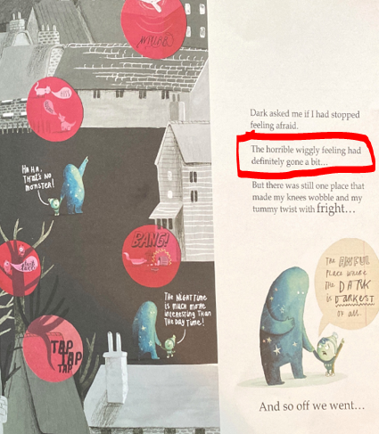
- Why did Orion have a horrible wiggly feeling?

- Where would he feel this in his body?

- Have you ever had a horrible wiggly feeling and why?

