Tuesday 2nd March 2021
Content Domain: 1c identify and explain the sequence of events in texts.
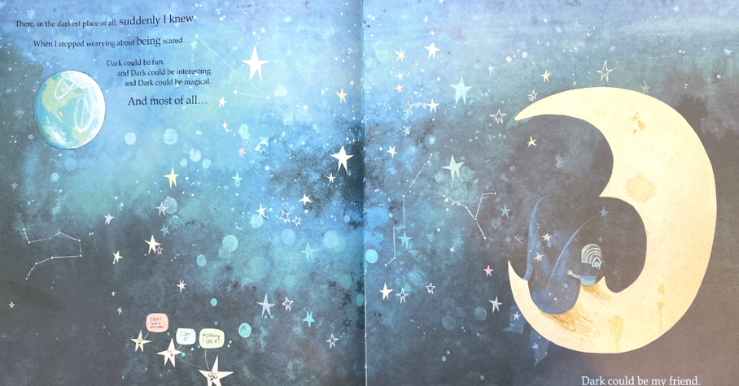

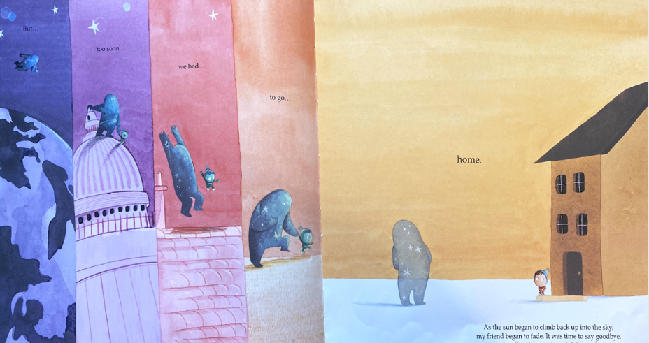
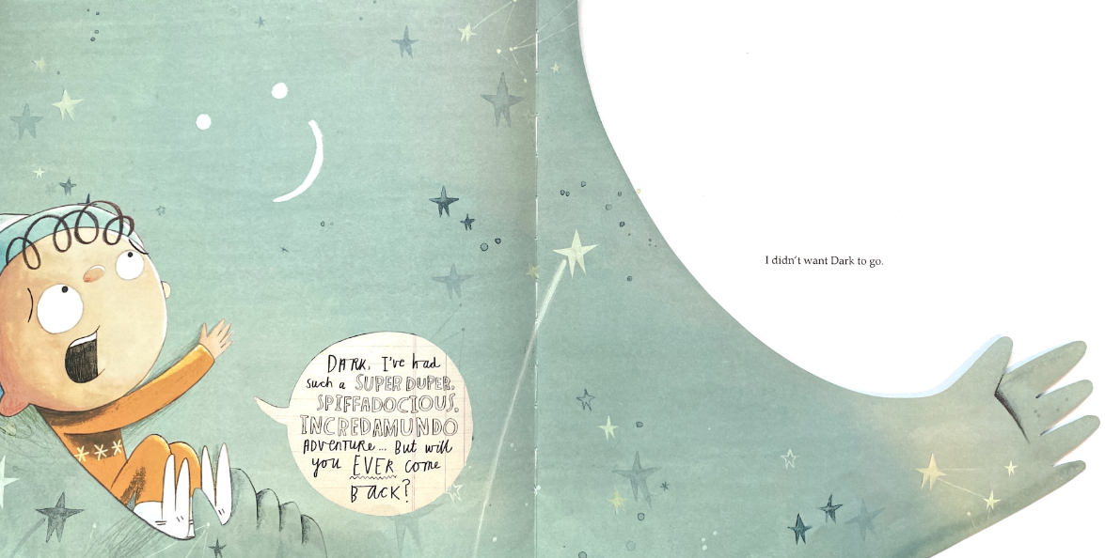
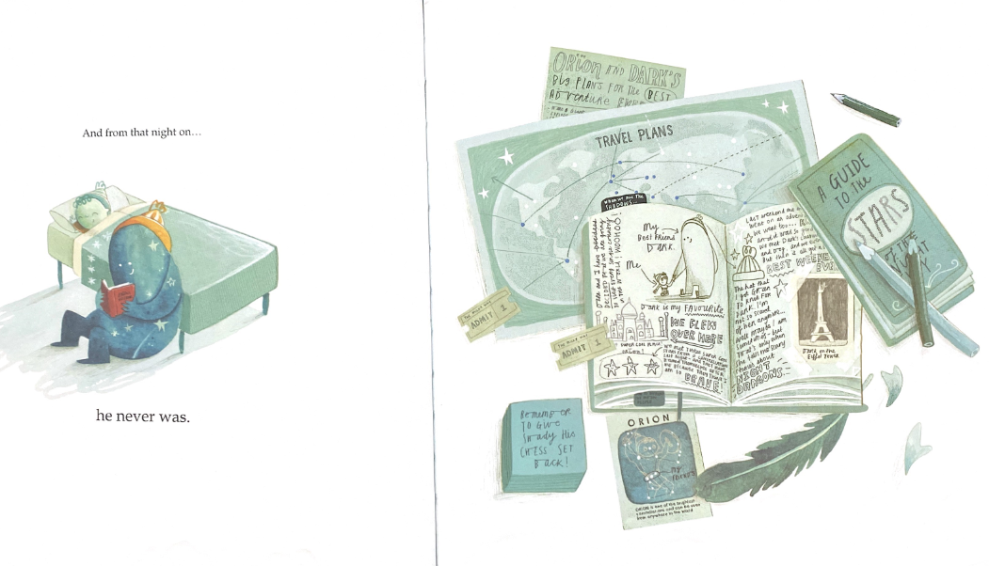

Write the three most important fact from the story.
What was important for us to know at the start?
Who came to help him get over his fear?
What happens at the end?
Try to write all these facts as a summary using no more than 20 words. You can write one word in each box to make sure you don’t write more than 20 words.

