Tuesday 2nd March 2021
Write a paragraph about the image of using the following features.
How many points can you earn?
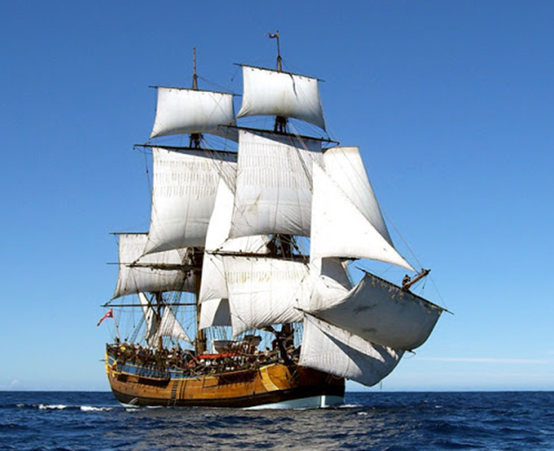
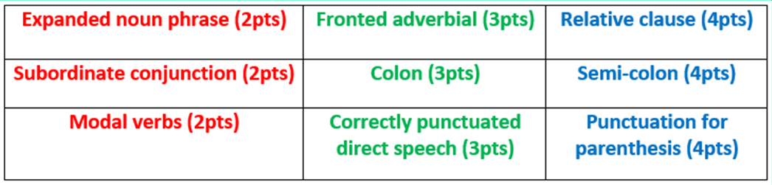

L.I. To make predictions based on details provided. (2e)
I can use the images and words to make predictions.
I can clearly explain my predictions, using conjunctions (because, so).
I can develop my oracy by using correct spoken language.

The title of our new text is:
Music of the Dead

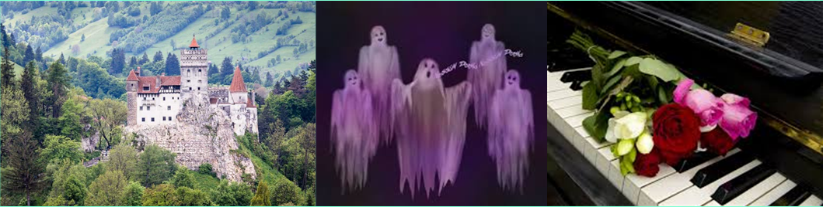
Based on the new evidence…

Use the context of the lines of poetry they are using and/or a dictionary to match the vocabulary to the definitions.
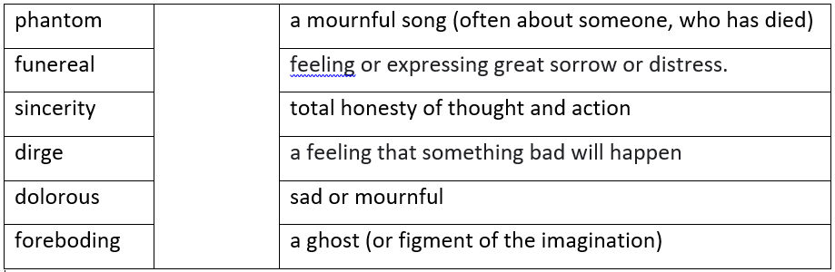

Draw the scene described in the poem, labelling your image with key phrase.
- I can recall key events
- I can understand key vocabulary
- I can represent a poem’s words in pictorial form.

LI: to be able to answer a range of questions on the text.
I will be successful if:
- I can retrieve information
- I can infer meaning
- I can use PEE technique
- I can explain authorial intent

Find and copy a phrase which tells the reader that the spirits’ dreams come true in Transylvania.
___________________________________________________________________________

Name three musical terms in the poem:
- _____________________________________
- _____________________________________
- _____________________________________

‘Choruses from resurrected spectral choirs’ –
What does this line tell us about who is creating the music? Explain your answer.
___________________________________________________________________________

___________________________________________________________________________

‘Music of the Dead is designed to scare the reader’
Do you agree with this statement? Justify your answer with evidence from the text.

___________________________________________________________________________
___________________________________________________________________________
___________________________________________________________________________
___________________________________________________________________________
___________________________________________________________________________

