Wednesday 3rd March 2021
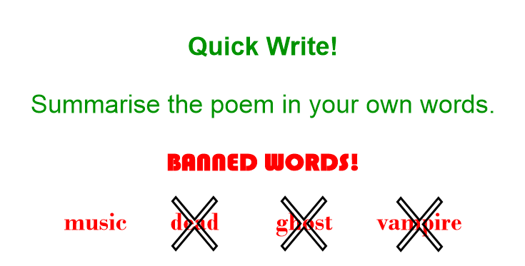

Let's re-read the poem.
Which features do you notice in the poem?
Are there similes / metaphors / rhyme / repetition?

To write our own poems, it would be useful to understand the structure of the poem.

For example, do the lines start with nouns, adjectives or verbs? Is there a pattern?

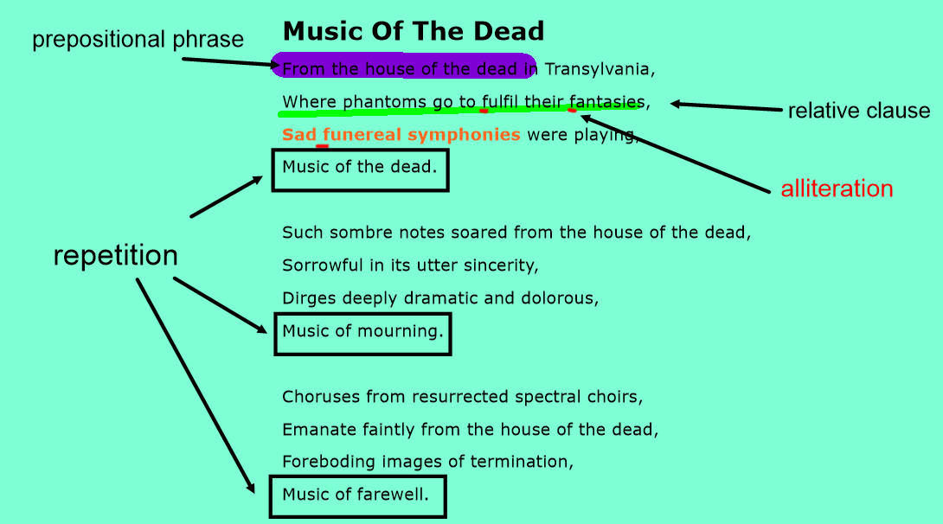

Let's use the structure that we have dissected from Music of the Dead to write our own poem.

What could our (near-)repeat phrase be?

- laughter
- sneering
- biting

LI: to be able to write and perform a poem, using an existing structure.
I will be successful:
- I can identify the features and word choices of the original poem.
- I can use the existing to write my own poem.
- I can make sure my poem uses a range of poetic features (alliteration, repetition etc.)
I can use tone of voice, pitch and pace for effect when performing.

How would you perform your poem?
What tone of voice would be appropriate?
What pace would you read it at?

