World Book Day

- Watch the book trailer
https://www.youtube.com/watch?v=nvkSk2T69Ms&feature=youtu.be

- Listen to the story
https://www.youtube.com/watch?v=ScscZlCQXnU
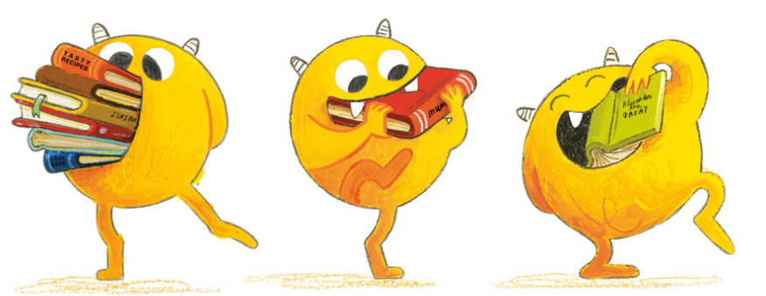
- Fill in the grid to help you formulate a plan for your WANTED poster

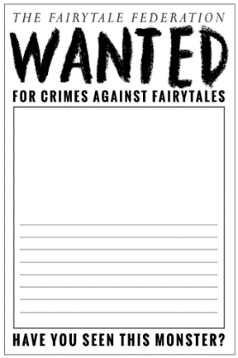
- Write your text to describe Nibbles onto your poster template – don’t draw your picture yet…

- Join the live lesson or follow the instructions below to draw your picture of Nibbles onto your poster.
First lightly draw a circle Then, lightly draw on some long triangles…
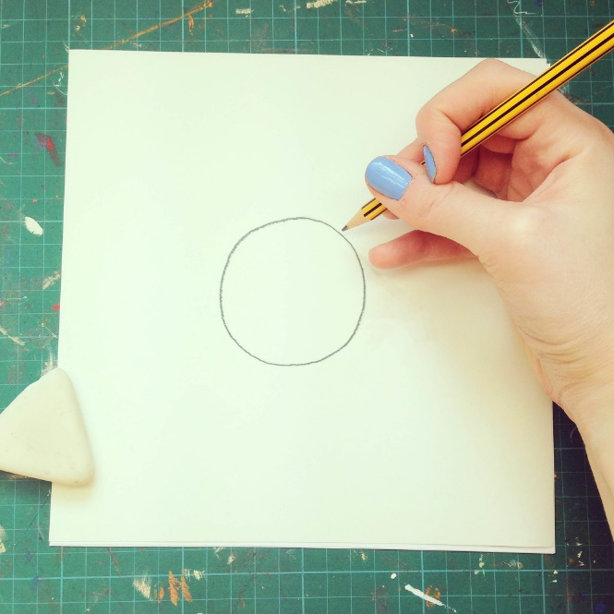
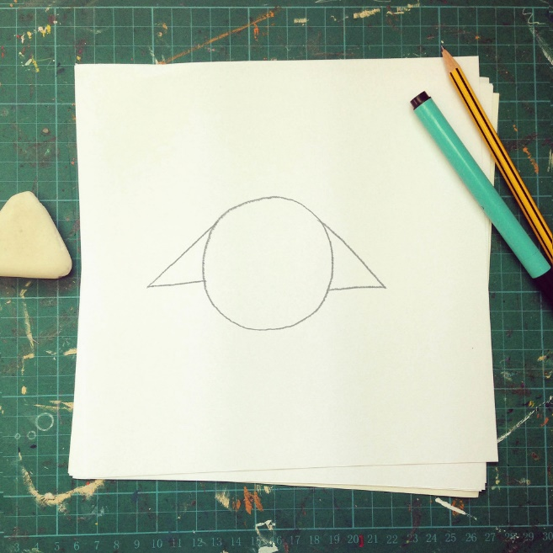

Now this monster needs legs and feet. This monster loves to go places fast. Draw two bendy upside down straws… And then outline..
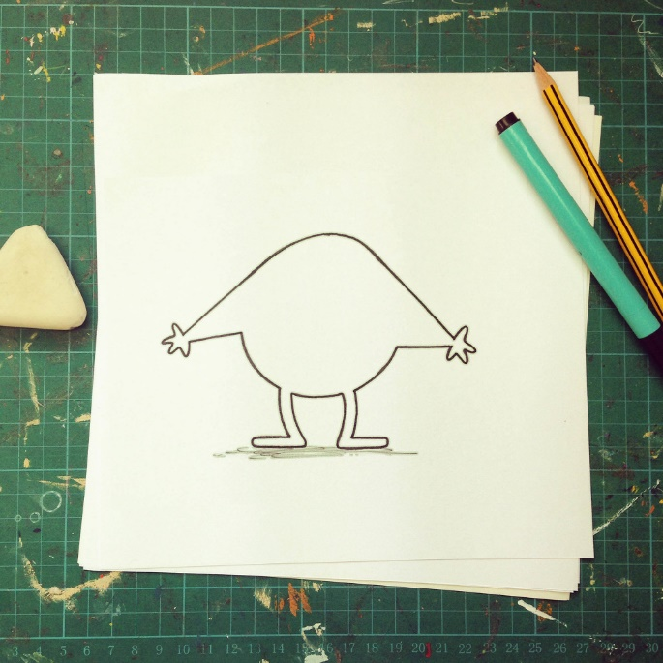
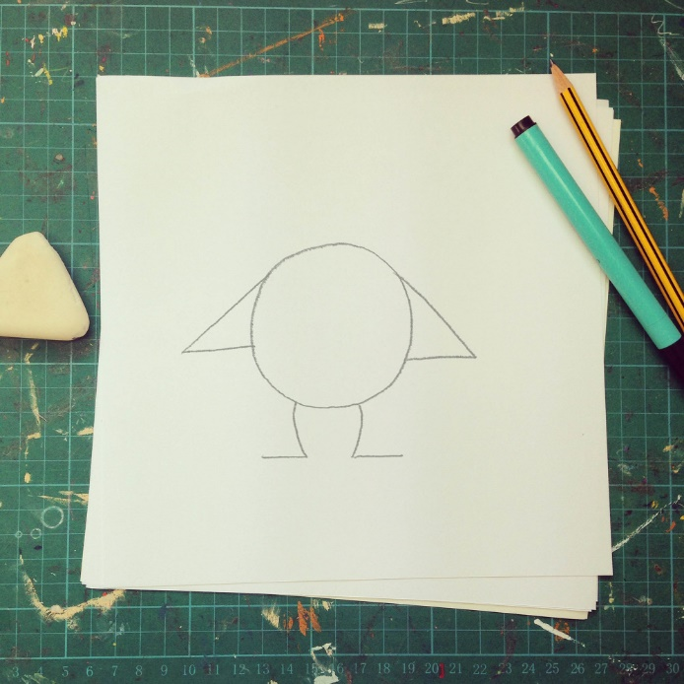

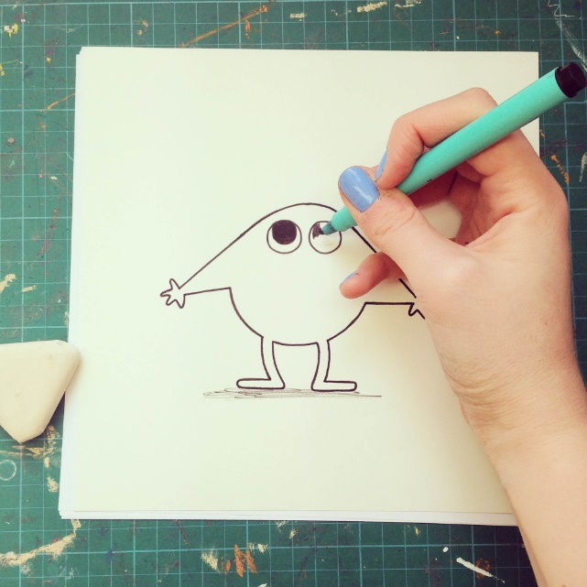
Let’s give him some eyes before he hurts himself. Two beady big eyes And two triangular naughty little stripy horns.
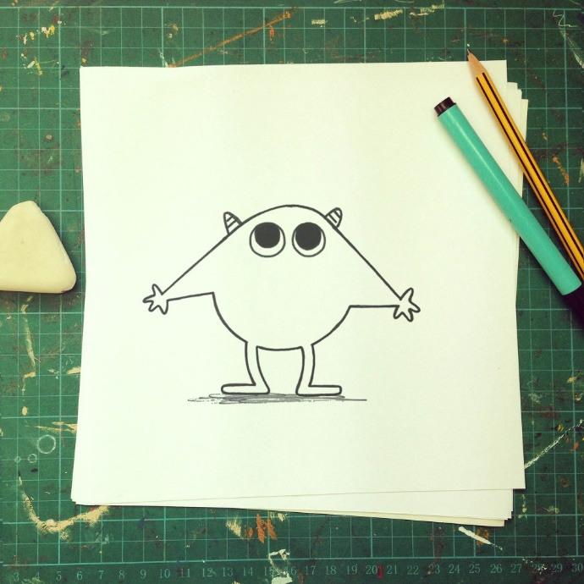
Ah yes! How can a Book Monster nibble without his nibbley mouth? Draw a big banana in the middle of his face.
Add some triangle teeth and colour in the banana - but NOT the teeth!
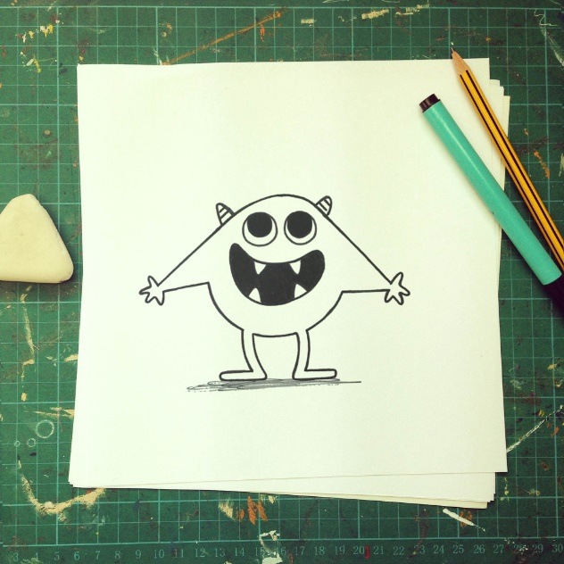
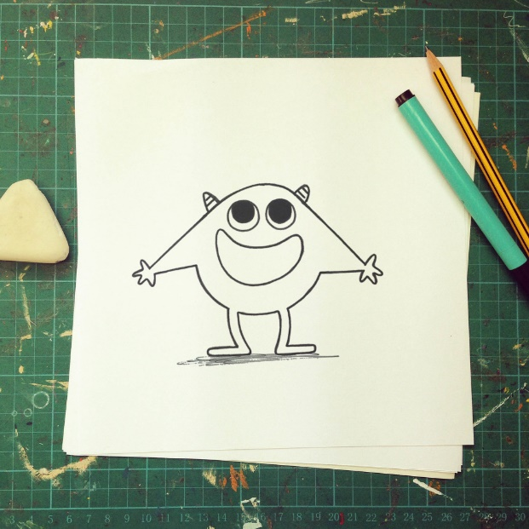

How to make a Nibbles Book Mark
https://www.emmayarlett.com/Nibbles-Book-Nibbling-Book-Monster-Book-Mark
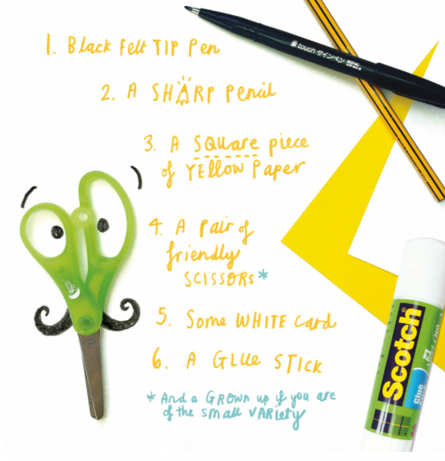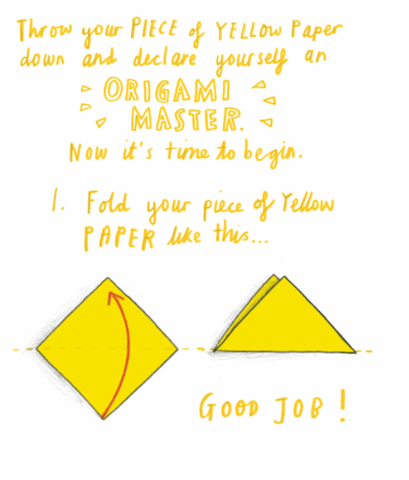
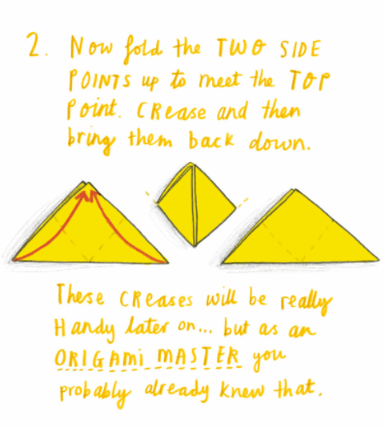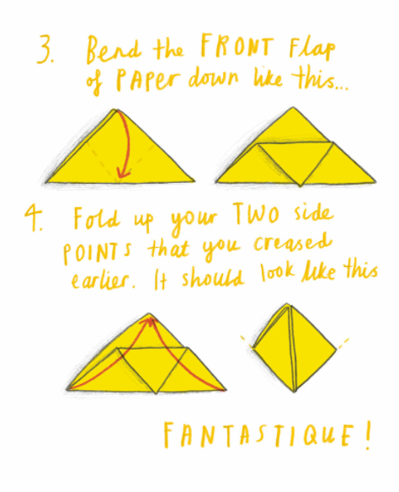
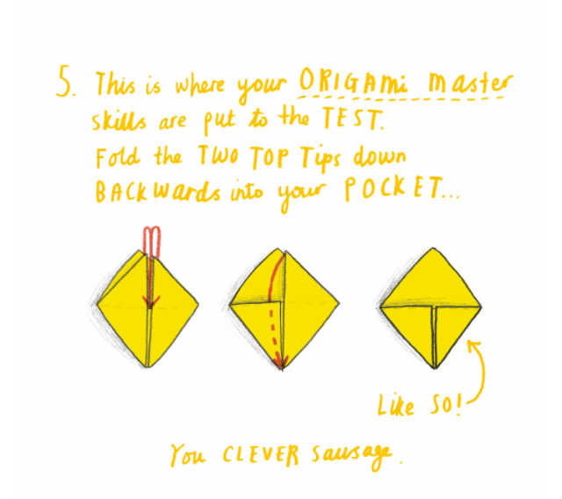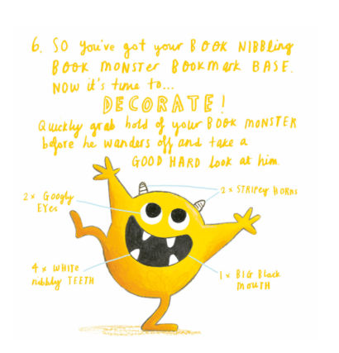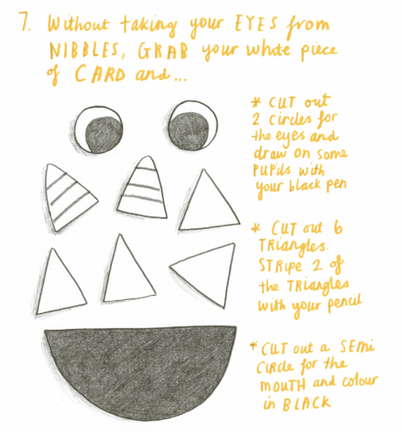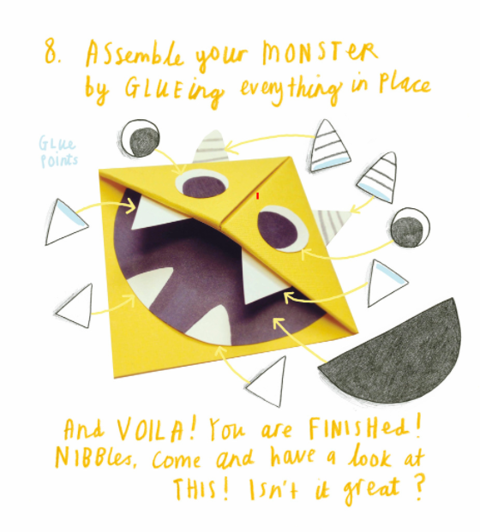

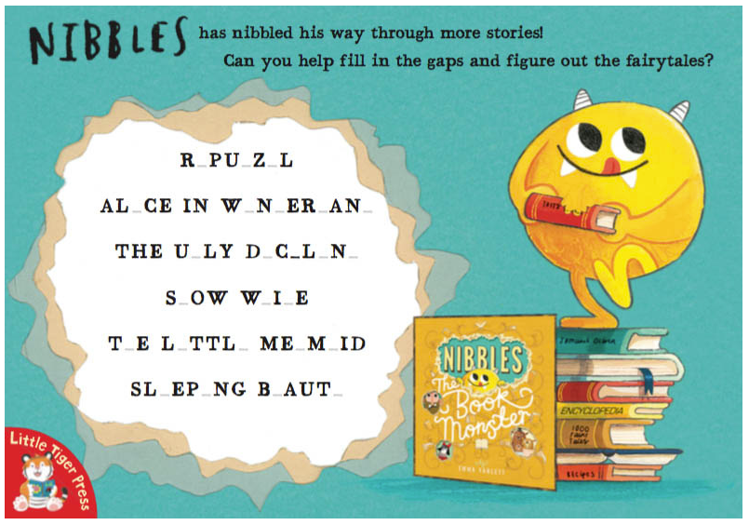
Colouring Page
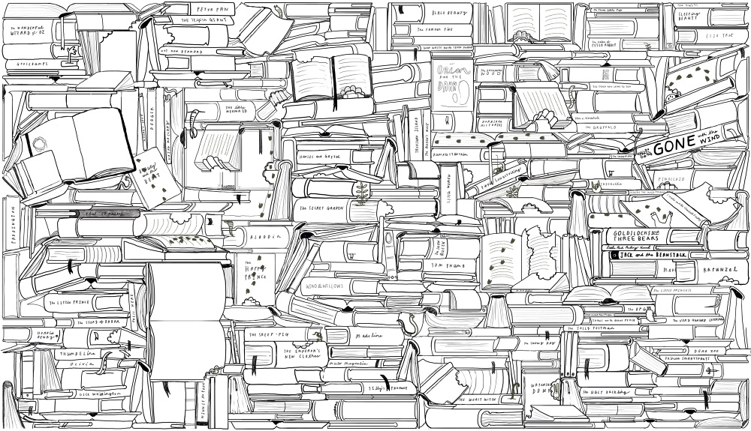

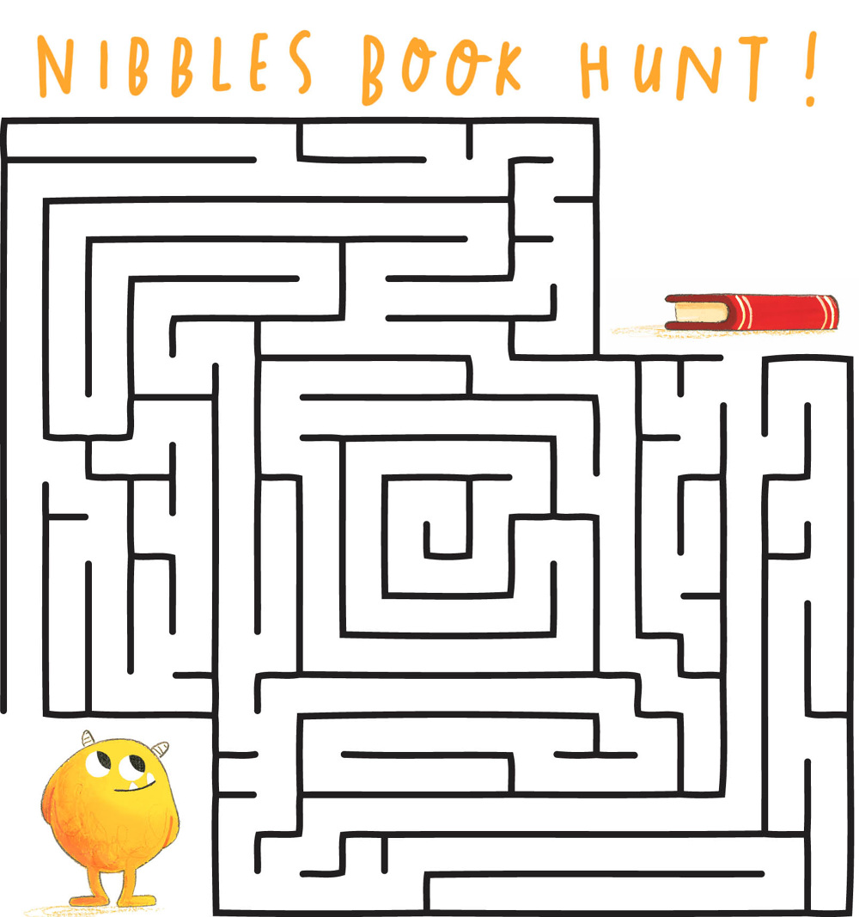

How to make a Nibbles hat.
https://www.emmayarlett.com/Nibbles-Hats

