Year 1/2 Reading Spine (B)
 | Autumn 1 |  | Autumn 2 | Spring 1 | Spring 2 | Summer 1 | Summer 2
Our Belief and Vison | At The Academy at St James we have books at the heart of learning. We use quality texts to inspire and drive all our learning.  We believe that children learn best when engaged with exciting and stimulating learning, allowing them to grow and develop into independent and resilient learners. In our school we support every child to reach their potential: Aspire, Achieve, Believe.  “The more that you read, the more things you will know. The more that you learn, the more places you’ll go.” Doctor Seuss
Our Values | Community  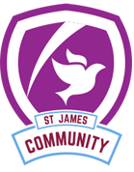 |  | Peace | Respect  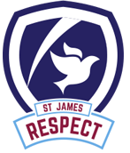 | Forgiveness  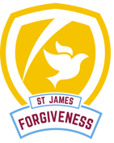 | Courage  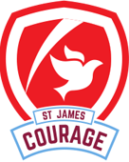 | Trust  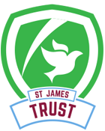
Themes | Little Explorers |  | Little Explorers | Dungeons and Dragon | Dungeons and Dragons | Adventures on the High Seas | Adventures on the High Seas
English |  |  | 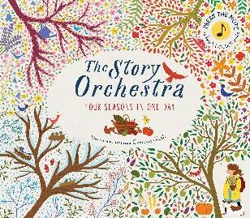 | 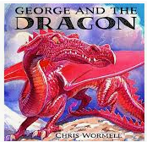 | 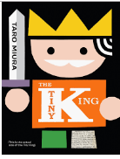 | 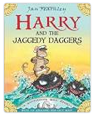 | 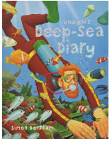
Whole Class Reading | 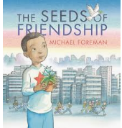 | 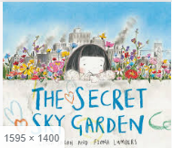 |  | 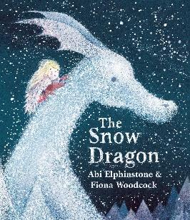 | 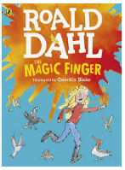 | 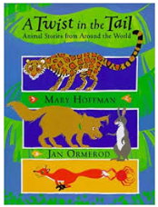 | 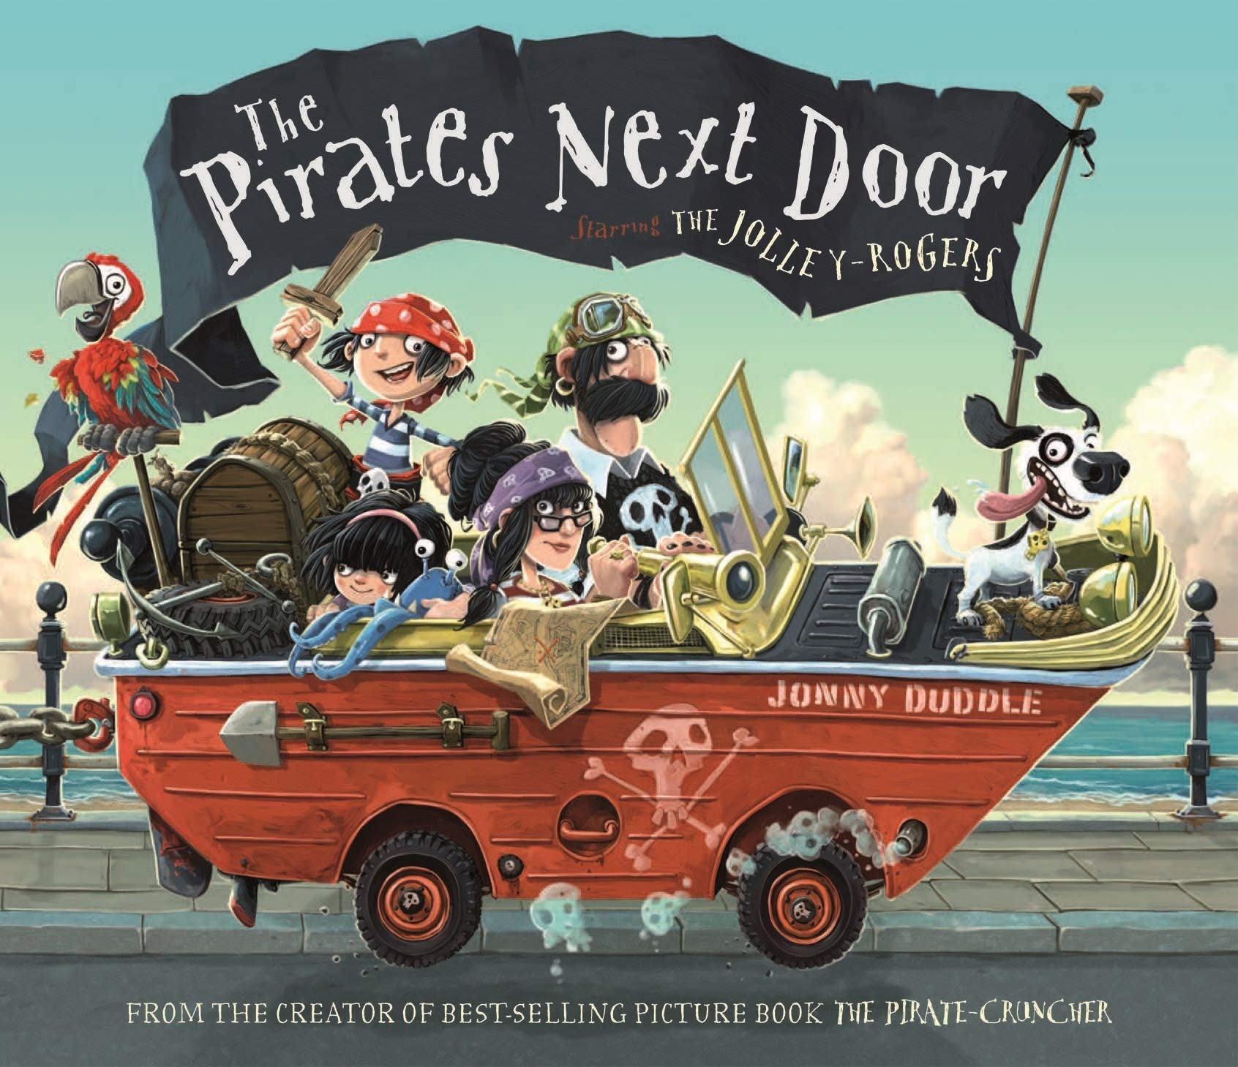
Writing Focus | Poetry: Our Wildlife  Fiction: Journey/Quest Narrative  Non Fiction: Diary Narrative |  | Poetry: Autumn Leaves – first book of nature.  Fiction: Four seasons in one day.  Non Fiction: Persuasive Writing | Poetry: Tell me a dragon  Fiction: Overcoming demon story  Non Fiction: Non chronological report – real life dragons | Poetry: The Queen of hearts  Fiction: Rags to Riches story  Non Fiction: | Poetry: Wandering water  Fiction: Quest Narrative  Non Fiction: Informal Letter/postcards | Poetry:  Fiction: Adventure  Non Fiction: Diary Entry
Curriculum Theme | Through the window, down the path and out of the gate.  To observe and understand what lives and grows in our local community.  We will use simple fieldwork and observational skills to study the geography of our school and its grounds and the key features of its surrounding environment. Identify seasonal and daily weather patterns in the United Kingdom.  Classifying animals, (mammals, insects, amphibians, fish and birds) plants and habitats. Each week we will be focusing on the animals, plants and trees and learning key facts about them.  We will be collating our information to create infographic boards to inform people about all the living things in our school grounds.  In history, we will Meet the Adventurers – David Attenborough and Agnes Arbour. We will be researching their lifetime of adventures. |  |  | Fantasy Dragons, real life dragons and cool castles.  Observe and describe dragons, ask questions,  compare dragons, make dragon collages using different materials - focus on the language associated with the material e.g. shiny, rough, flexible. We will have a weekly ‘Where is our dragon?’ slot where we receive postcards from our dragon. We have to find out where that place is on a map and talk about it.  We will also have a geography investigation station using jigsaws, maps, photos etc. |  | At the beach, On the water, deep, deep down.  Read ‘The Beach’ by Roland Harvey, write non-fiction postcards, find UK coast on a map, find seaside towns on a map,  describe the location and direction of places and objects using L, R, near, far, N,S,E,W  Describe the physical and human features of the coast, draw simple maps (continuous provision - map in a box). Observe, describe and compare animals and plants sea/coast - 10 minutes tell me time. Measure animals and plants of the sea/coast, ask questions and find information to answer them test out ideas (Wake up Jack - make a noisy shaker to wake up the lifeguard). Talk about what might happen, test out ideas and talk about why it happened  Safety at the beach  seaside art - consider the work of James Brunt/Andy Goldsworthy  Through the porthole - history of famous people associated with the high seas  Grace Darling  Ellen McArthur  Francis Drake  History of the RNLI
Curriculum Texts | 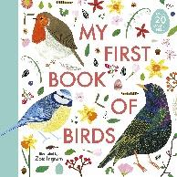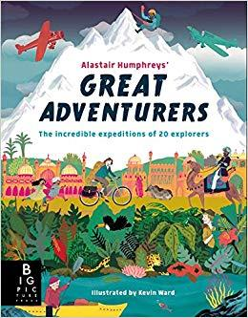 |  | 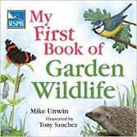  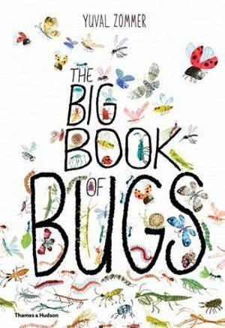 | 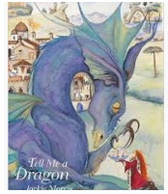 | 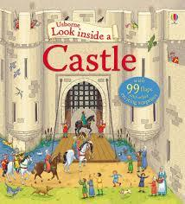  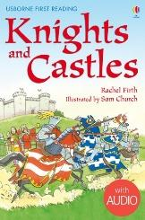 | 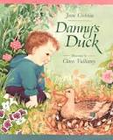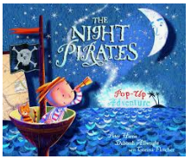 | 