Year 4 Reading Spine
 | Autumn 1 | Autumn 2 | Spring 1 | Spring 2 | Summer 1 | Summer 2
Our Belief and Vison | At The Academy at St James we have books at the heart of learning. We use quality texts to inspire and drive all our learning.  We believe that children learn best when engaged with exciting and stimulating learning, allowing them to grow and develop into independent and resilient learners. In our school we support every child to reach their potential: Aspire, Achieve, Believe.  “The more that you read, the more things you will know. The more that you learn, the more places you’ll go.” Doctor Seuss
Our Values | Community  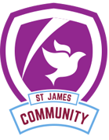 | Peace  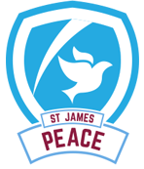 | Respect  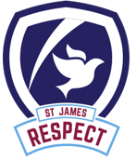 | Forgiveness  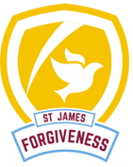 | Courage  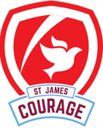 | Trust  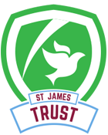
Themes | Save our world | Save our world | The Great Escape | The Great Escape | St James school of Wizards, Witches and Warriors | St James school of Wizards, Witches and Warriors
English | 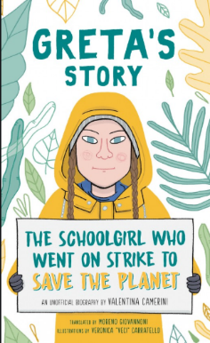 | 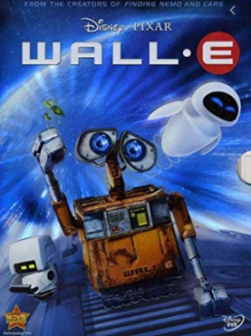 | 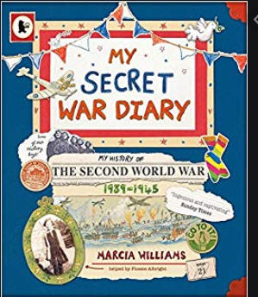 | 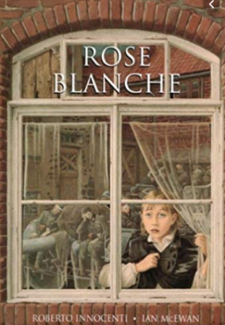 | 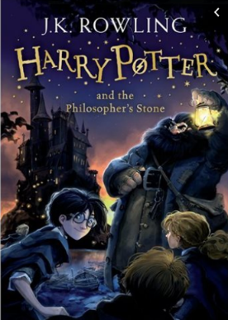
Whole Class Reading | 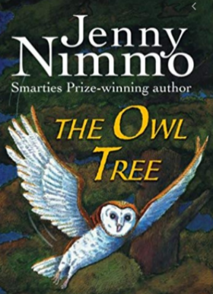 | 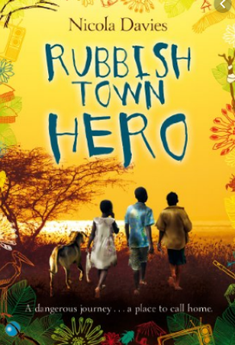 | 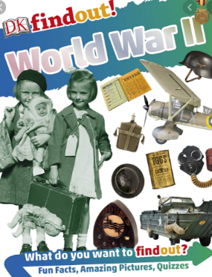 | 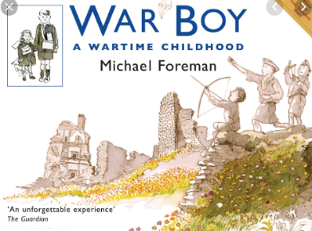
Writing Focus | Autumn 1: Acrostic  Poetry: Kenning  Non-fiction: Diary entry about Nell Bank/Phill Lowde  Fiction: Wall:E  Guided Reading: Owl Tree | Poetry: Kennings  Fiction: Dangerous Setting Narrative  Non Fiction: Persuasive letter | Poetry: What are we fighting for?  Fiction: Narrative- Unlikely hero narrative  Non Fiction: Diary | Poetry: Goodbye note  Fiction: Play script which is then adapted to a story  Non Fiction: Non-Chronological report. | Poetry: Potion poems (2 days)  Non-fiction: Newspaper report about Harry Potter receiving letters to go to Hogwarts  Fiction: Portal story | Poetry: The Magic Box  Fiction: Myonotor- Portal story  Non-fiction: Non-Chronological report (About mystical creatures)
Curriculum Theme | At the start of the year we investigate how we can save our world by researching Greta Thunberg and the positive impact she has had on the world.  We then learn Geography skills through learning the impact that our waste is on having on the world. We also explore the impact of deforestation and trophy hunting. |  | This term we take a step back in time to WW2.  We  We learn about WW2 and the impact it has had on our modern lives. We learn about rationing, evacuees and clothing. From there we learn about why WW2 started and key history figures such as Winston Churchill and Adolf Hitler. |  | To end the year, we travel to Hogwarts! This is where we transform into wizard, witches and warriors! We learn about states of matters and make our own potions!  We also travel back thousands of years and learn about the Ancient Greeks!
Curriculum Texts | 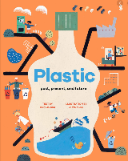  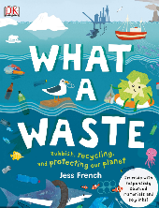 | 