Year 5 Reading Spine
 | Autumn 1 | Autumn 2 | Spring 1 | Spring 2 | Summer 1 | Summer 2
Our Belief and Vison | At The Academy at St James we have books at the heart of learning. We use quality texts to inspire and drive all our learning.  We believe that children learn best when engaged with exciting and stimulating learning, allowing them to grow and develop into independent and resilient learners. In our school we support every child to reach their potential: Aspire, Achieve, Believe.  “The more that you read, the more things you will know. The more that you learn, the more places you’ll go.” Doctor Seuss
Our Values | Community  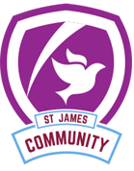 | Peace  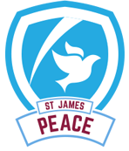 | Respect  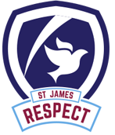 | Forgiveness  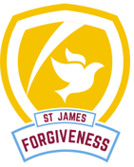 | Courage  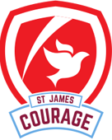 | Trust  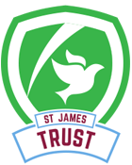
Themes | Out of this world | Out of this world | After the Heartbreak | After the Heartbreak | Magic, Monsters and Mayhem | Magic, Monsters and Mayhem
English | 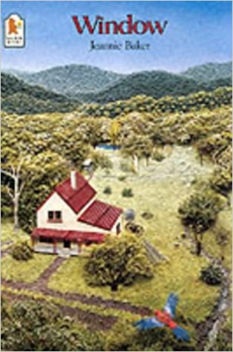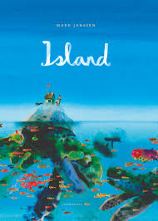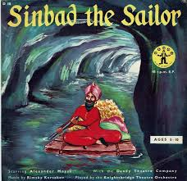 | 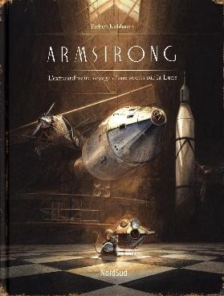 | 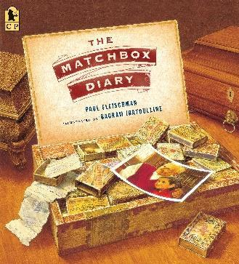 | 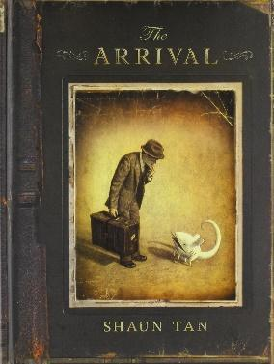 | 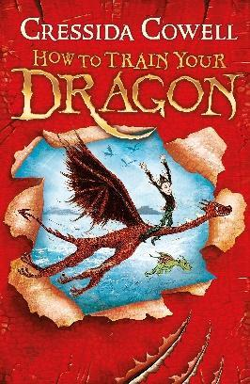
Whole Class Reading | Poetry: Outside my Window, Waiting at the window, Window Memory | 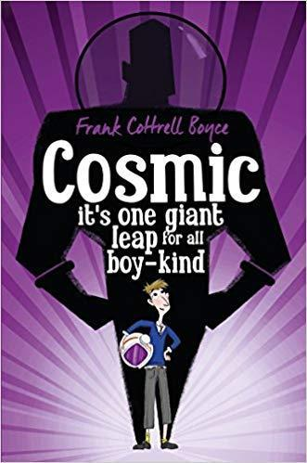 | 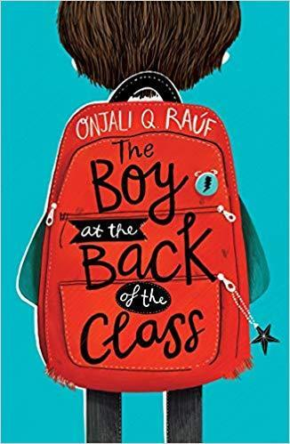 |  | 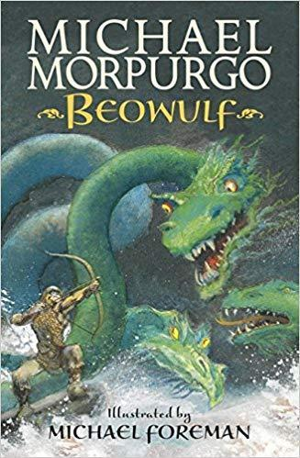 | 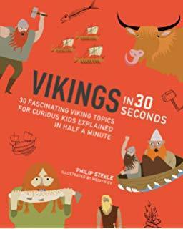
Writing Focus | Fiction: Sinbad and the Sailor – Journey story  Non Fiction: Letter from Sinbad to fellow shipmates | Poetry: Six ways to look at the moon  Fiction: Armstrong  Non Fiction: Newspaper Report - Armstrong | Poetry: Okay brown girl, Okay, On the Move  Fiction: Narrative- Rags to Riches  Non Fiction: Diary | Poetry: The Gift Wrap and The Jewel  Fiction: Rags to Riches story  Non Fiction: Balanced Argument | Poetry: Grendel Kenning  Fiction: Defeating the monster (Beowulf)  Non Fiction: Newspaper report | Poetry: Tell me a dragon  Fiction: How to Train Your Dragon  Narrative  Non Fiction: information booklet - Vikings (non-chron report)
Curriculum Theme | Early Islamic Civilisation - looking at trade across the Silk Road  As NASA is based in Florida, we will explore the state of Florida and its Human and physical features. e.g. Kennedy Space Centre  We will investigate forces and learn key information about the planets and the solar system. |  | At the start of this term, we learn what it is like to be a refugee and the difference between refugees and migrants.  We then learn about Bradford and why people want to migrate here – the industry and what Bradford has to offer. Local study of Saltaire  We then learn about what it’s like to grow old – how everything changes. |  | In this topic, we introduce the Anglo-Saxons and the Vikings.  We learn about when they came to Britain and what they brought to the country. We also learn about their impact on the country and what they left behind.  We also learn about their myths and legends, such as Beowulf.
Curriculum Texts | 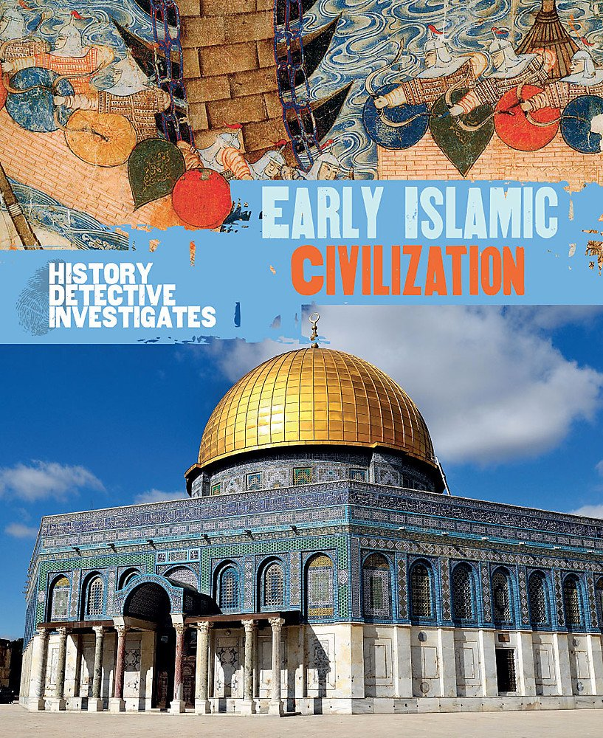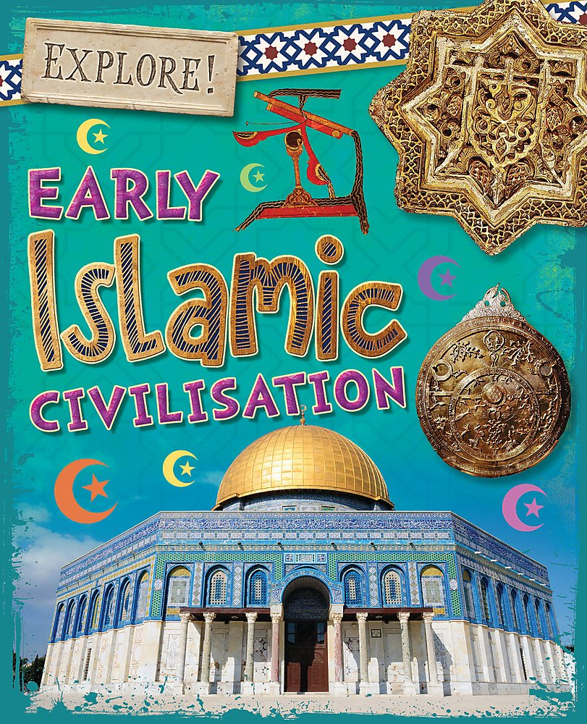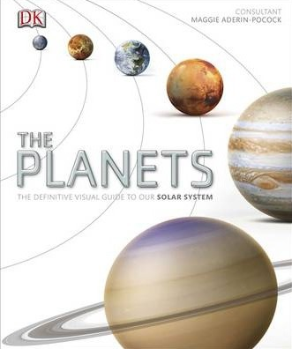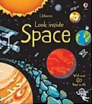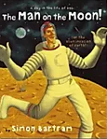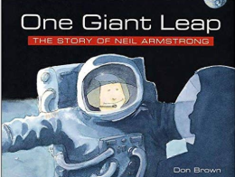 |  | 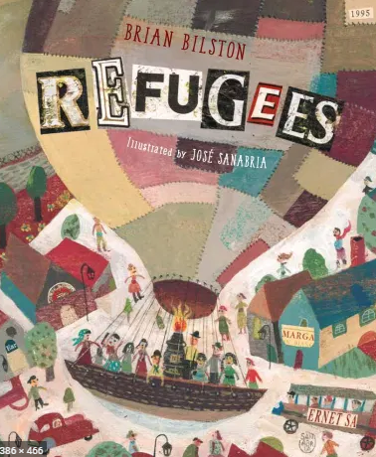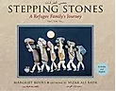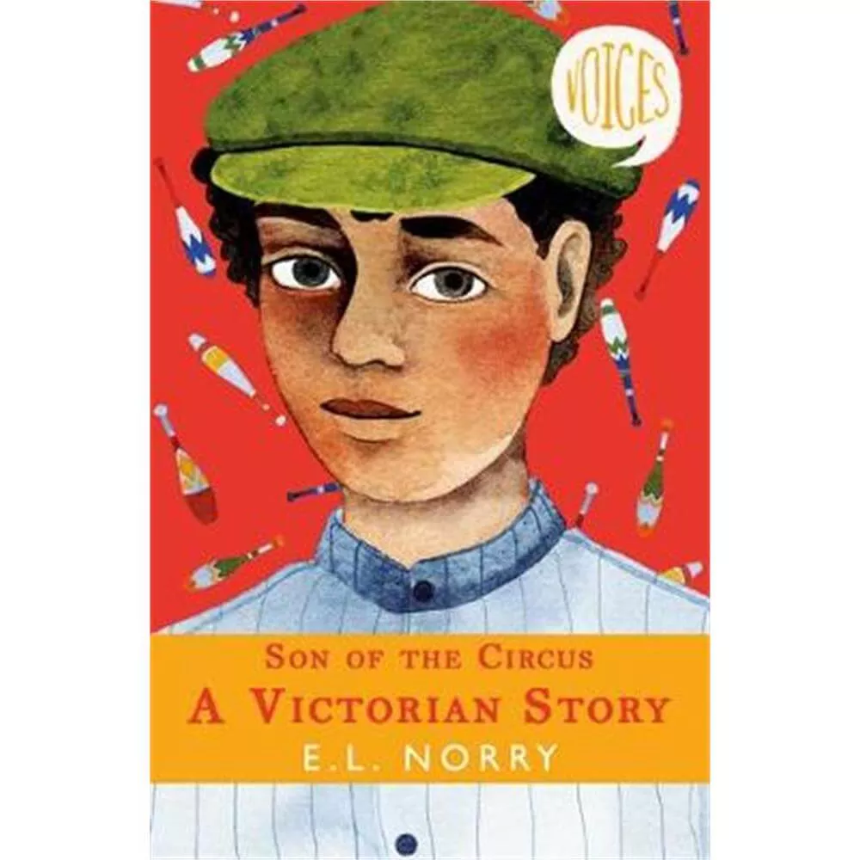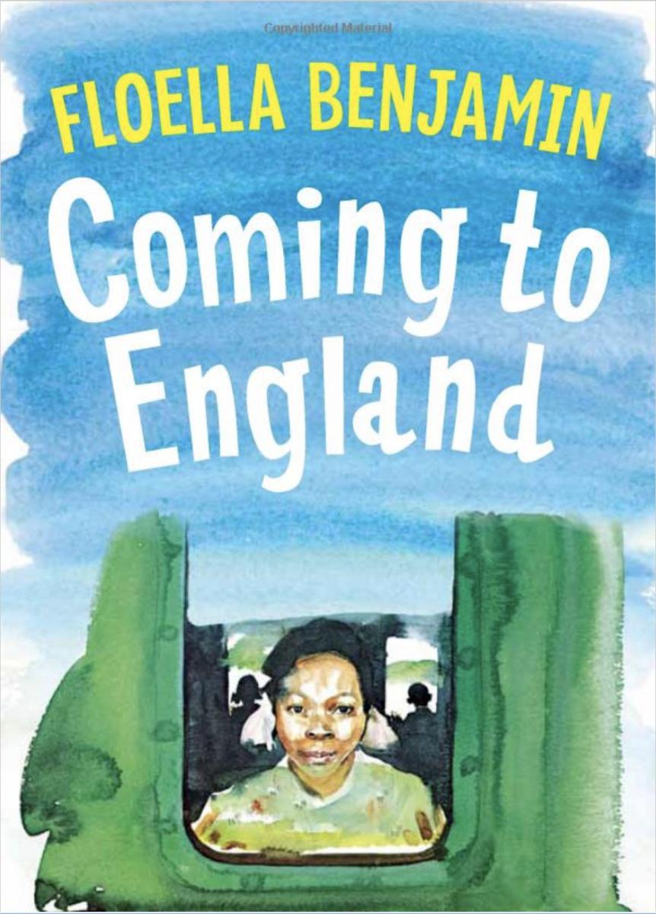 |  | 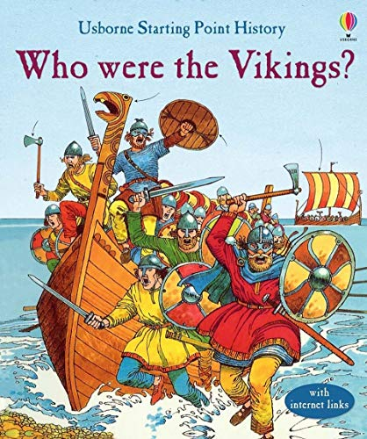  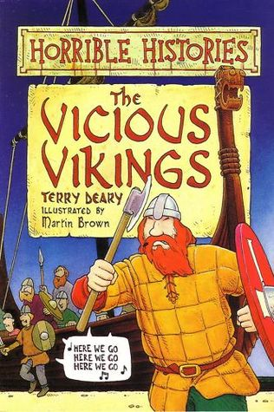 | 