Imagine that you're walking along the beach, a rather nice sandy beach with just a few small pebbles in little groups here and there. You start off by collecting just four pebbles and you place them on the sand in the form of a square. The area inside is of course just 1 square something, maybe 1 square metre, 1 square foot, 1 square finger ... whatever.
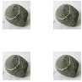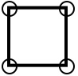
By adding another 2 pebbles in line you double the area to 2, like this:
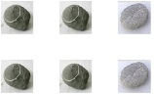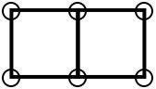
The rule that's developing is that you keep the pebbles that are down already (not moving them to any new positions) and add as FEW pebbles as necessary to DOUBLE the PREVIOUS area, using RECTANGLES ONLY!
So, to continue, we add another three pebbles to get an area of 4:
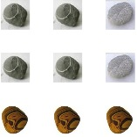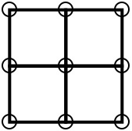
You could have doubled the area by doing:
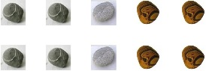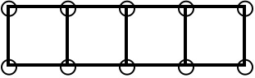
But this would not obey the rule that you must add as FEW pebbles as possible each time. So this one is not allowed.
Number 6 would look like this:
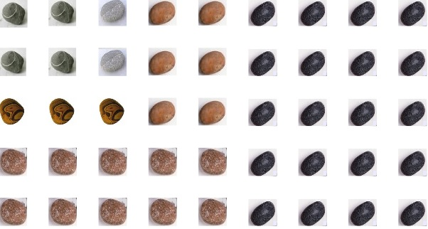
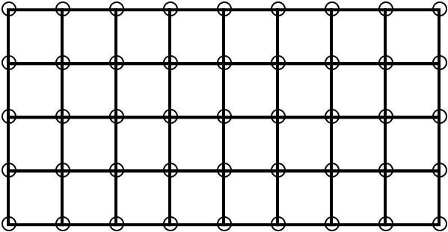
So remember:-

The rule is that you keep the pebbles that are down already (not moving them to any new positions) and add as FEW pebbles as necessary to DOUBLE the PREVIOUS area.
Well, now it's time for you to have a go.
"It's easy,'' I hear you say. Well, that's good. But what questions can we ask about the arrangements that we are getting?
We could make a start by saying "Stand back and look at the shapes you are getting. What do you see?'' I guess you may see quite a lot of different things.
It would be good for you to do some more of this pattern. See how far you can go. You may run out of pebbles, paper or whatever you may be using. (Multilink, pegboard, elastic bands with a nail board, etc.)
Well now, what about some questions to explore?
Here are some I've thought of that look interesting:
- How many extra pebbles are added each time? This starts off 2, 3, 6 ...
- How many are there around the edges? This starts off 4, 6, 8 ...
- How big is the area? This starts off 1, 2, 4 ...
- How many are there inside? This starts off 0, 0, 1, 3, 9 ...
Try to answer these, and any other questions you come up with, and perhaps put them in a kind of table/graph/spreadsheet etc.
Do let me see what you get - I'll be most interested.
Don't forget the all-important question to ask - "I wonder what would happen if I ...?''

