**Science** – Our Science theme is electricity, so we will be learning about circuits and how to conduct electricity. We will make a variety of circuits and investigate what happens when different components are missing.

We will also learn about keeping safe around electricity.

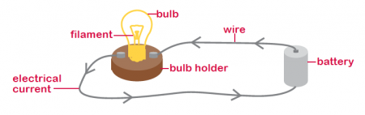

**RE** – In RE we are learning about Gospel then Creation and Fall. We will begin by learning what Gospels are and what we can learn from Jesus’ teachings. We will then learn about how God teaches us to look after his world and what happens when Humans choose not to do that.

Maths **–** In Maths, we will be developing our mental arithmetic strategies and mastering finding unit and non-unit fractions of amounts. We will also be adding and subtracting fractions with the same denominators.

In cross-curricular maths, we will be collecting, presenting and interpreting data in graphs.

PE – This term, after completing our gymnastics theme, we will spend some quality time developing our athletic skills. We will learn the skills needed to take part in track and field events such as javelin, long jump and distance running.

Art – This half term, we will be making Egyptian style pots using balloons, paper cups and paper mache. We will then paint them and decorate them to look like they would have done in Ancient times.

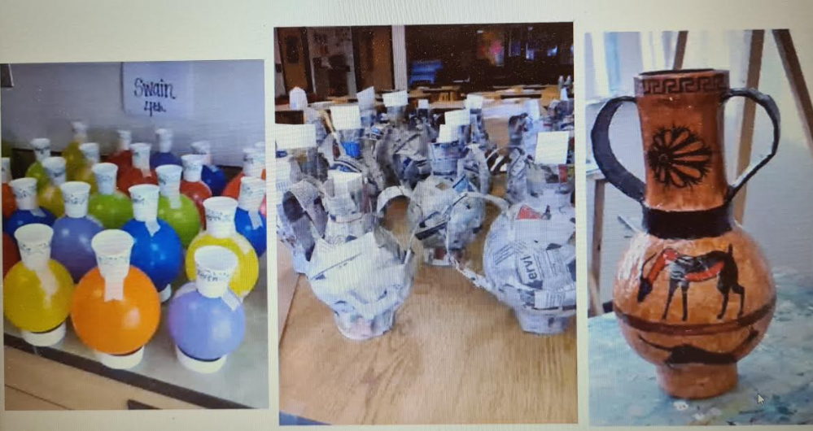

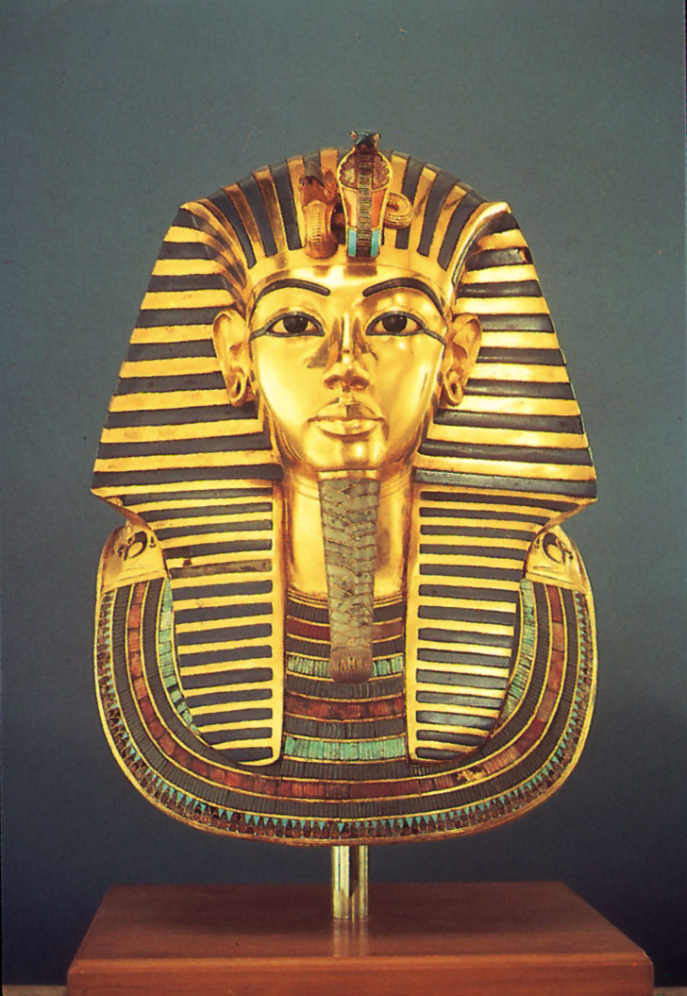

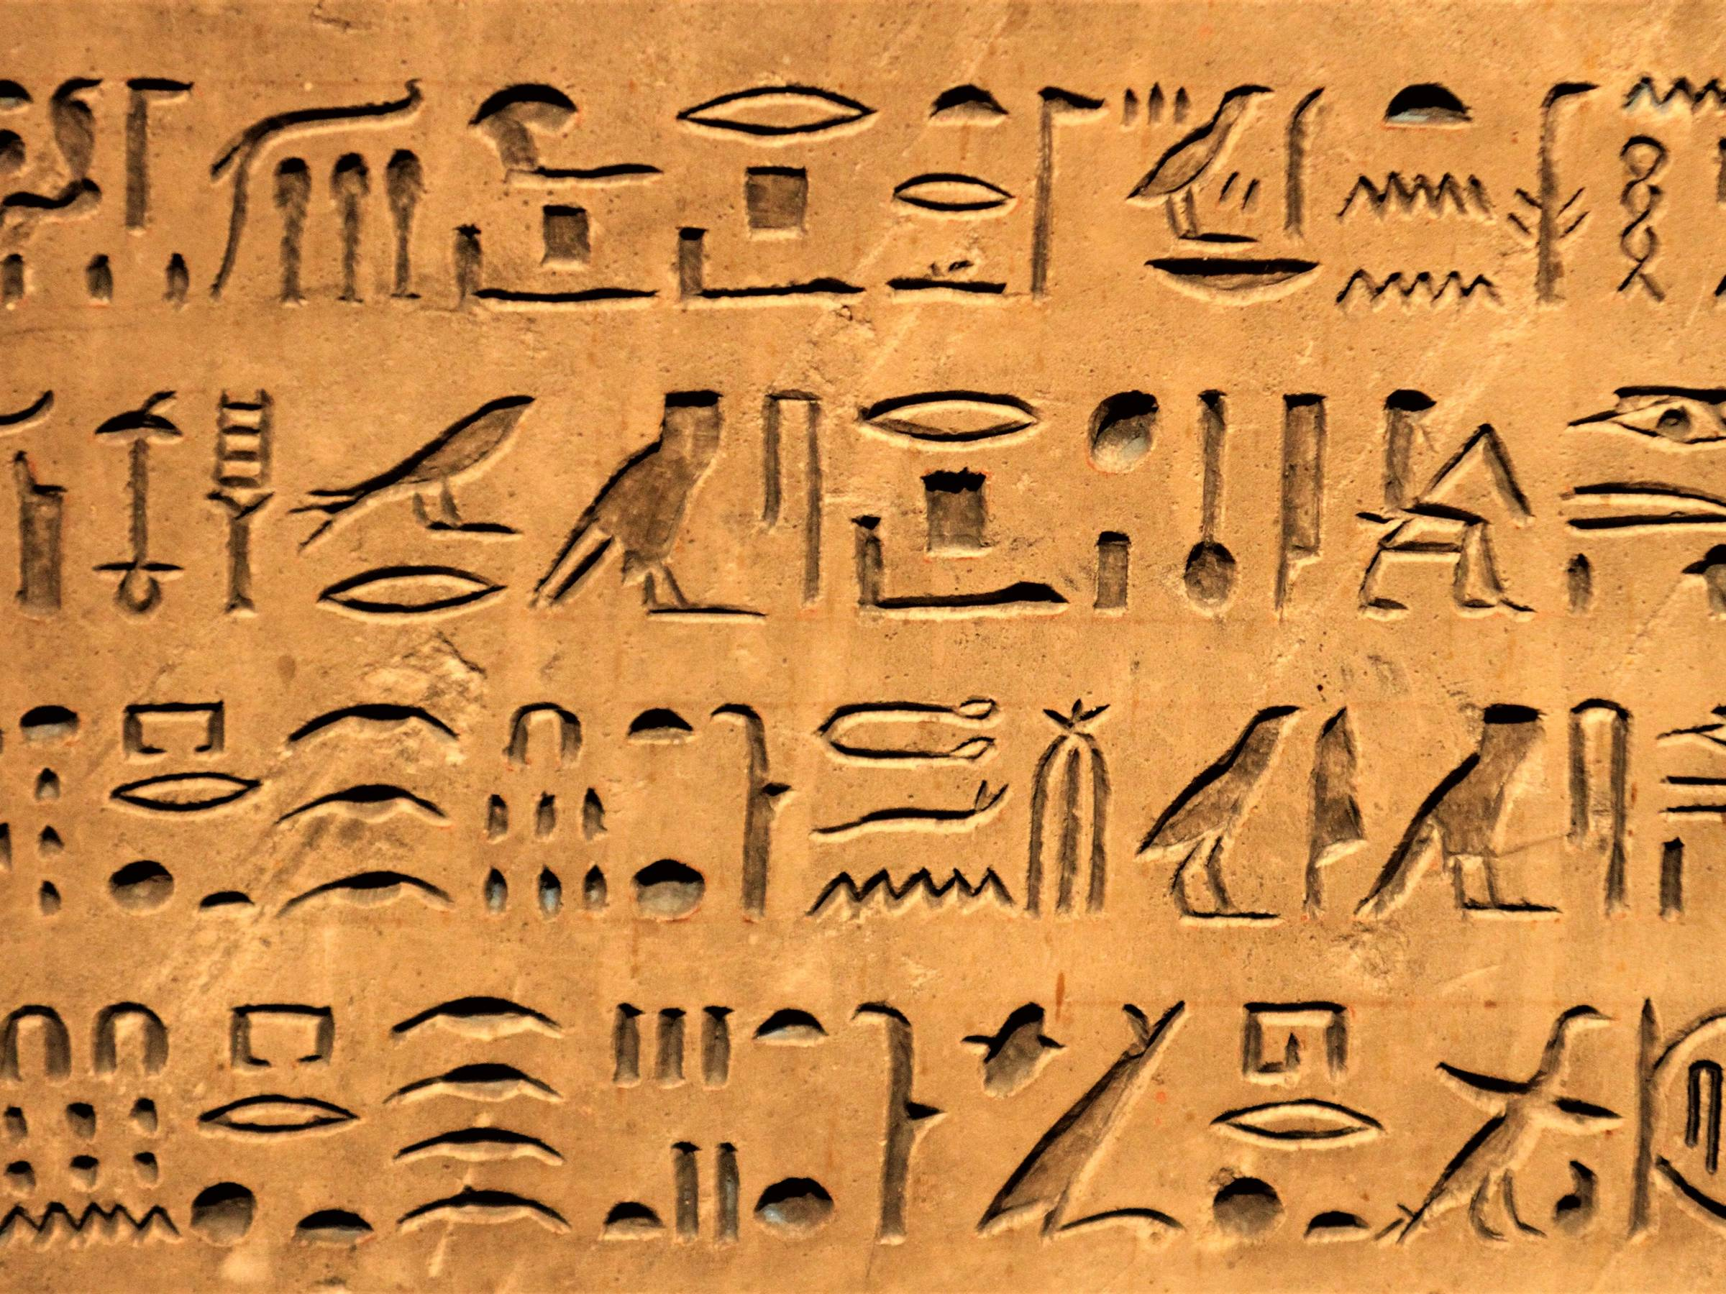

Computing – We will be using imovie and other apps to make animations of the mummification process.

**History** – Who were the Ancient Egyptians? Our learning journey will begin with a timeline to show when the Ancient Egyptian period was in relation to the Stone Age and the Romans. We will then learn about the Ancient Egyptian civilization, who they were, how they lived and what they believed in. Through Learning about Tutankhamun and mummification, we will dig up what it was like to live in the past.

**Geography** – Where is Egypt? We will be exploring maps to locate Egypt in its continent, and it’s capital city. We will explore which other countries it boarders and whether it is a country with a coast or not. We will also develop our understanding of tourism and why people visit Egypt, whilst we explore its human and physical features.

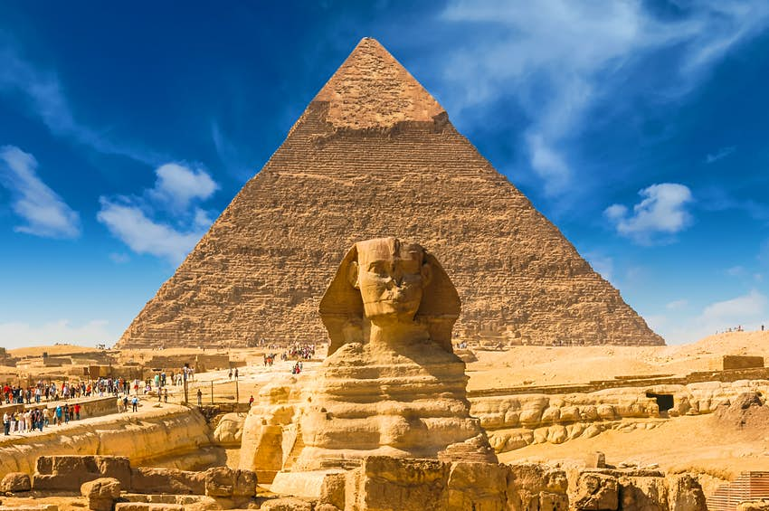

DT – In DT, we will be designing and making bread. The journey will begin with consumer research, before the product design. We will sample different breads and consider who our consumer would be. We will then design our own bread using different choices of flavour and then bake it.

Finally, our consumer will taste the bread and help us to evaluate it.

English – During the first half term, we will be learning to write diary entries and journey stories as well as performing poems about mummification.

In whole class reading, we will develop our reciprocal reading through reading a range of non-fiction texts about Ancient Egypt.

In spelling, we will continue to learn about prefixes and suffixes.

**Ancient Egypt – Y3/4**