**Art**

Draw an Egyptian style portrait of yourself

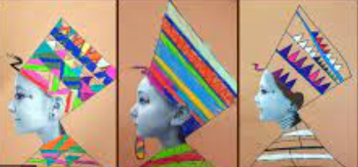

**RE**

Research creation stories from different religions and countries.

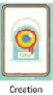

**D&T**

Bake Egyptian Bread

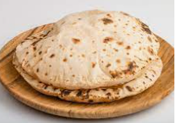

Complete as many tasks as you can.

Please bring into school any examples of work you have created over the holidays.

**Geography**

Create a map of Egypt.

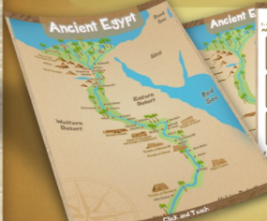

**Science**

Create a shadow puppet

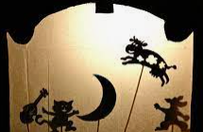

**Reading**

Write a book review for your favourite book.

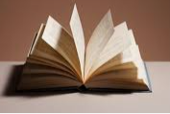

**Maths**

Complete 10 games of TTRockstars in studio and earn your rock status certificate.

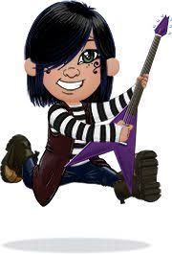

**English**

Create an instruction guide on mummification.

