RE – In RE, we will be recapping on who God is to us and what makes a ‘good’ God. We will also focus on incarnation and the embodiment of God on Earth.

Maths **–** In maths, we will be recapping on our knowledge of fractions, decimals and percentages and applying these to problem solving scenarios. We will also be looking at statistics and measure which will also link with our science work. Throughout our morning maths sessions, we will continue to develop our understanding of mental math strategies as well as our written methods for the 4 operations. We will also be checking our multiplication and division facts on a regular basis so that they can be applied every day.

Science – In Science, we will be exploring properties of materials. We will be investigating the hardness, electrical conductivity, thermal conductivity and suitability of a range of materials. We will also be looking at how to separate mixtures and solutions. We will put all of this together to know how to clean dirty Viking water after a battle!

PE – Our Summer 1 focus in PE will be invasion games. We will be developing our knowledge on attacking and defending, building on concepts such as interception/marking and how to keep possession successfully.

Art/DT – We will be focusing on the use of clay in our art lessons to create a tile of a Viking longboat. We will use the score, slip, stick and smooth technique to make sure our clay is sturdy and ready to paint. In DT, we will be designing, making and evaluating our own 3D Viking longboats. We will complete research before designing and constructing.

Computing – In computing, we will be building our own game for a given audience. We will build on our knowledge from Spring term on selection, variation and debugging on Scratch to programme a complex game.

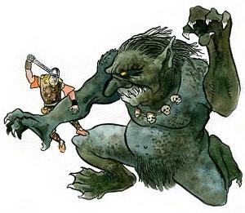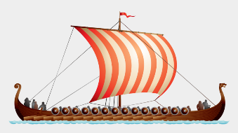

English – In English, we will be starting the term looking at kenning poems to describe the Vikings. We will then move on to the story of Beowulf (it gets a bit gory!) before writing our own defeating the monster story. We will also be producing a non-chronological report all about the Vikings.

Geography /History – Our theme for the summer term is Vikings and Anglo-Saxons. We will be looking at which countries they came from, invaded and settled in for our Geography before comparing to other countries we have learnt about so far this year. In History, we will be looking at chronology to tell us about the time period of the Vikings and how many of their ways of living are still seen in our lives today.

**Magic, Monsters and Mayhem – Y5**