Science – In Science we will looking at leavers, gears and pulleys. Pupils will explore the effects of friction on movement and find out how it slows or stops moving objects, for example, by observing the effects of a brake on a bicycle wheel. Pupils will also explore the effects of levers, pulleys and simple machines on movement.

RE – In RE, we will be asking the question: ‘What will make our city a better, safer and more respectful place’. Through discussion, we will look at the positives of Bradford but also question how we can improve it.

Maths **–** In maths, we will be recapping what we have learnt this year in Year 5 and fill any gaps that the children may have. This will give them the best preparation going into Year 6. We will also be having test at the end of the year, which is a great opportunity for every child, to show what they have learnt. Throughout our morning maths sessions, we will continue to develop our understanding of mental math strategies as well as our written methods for the 4 operations. We will also be checking our multiplication and division facts on a regular basis so that they can be applied every day.

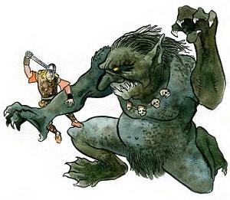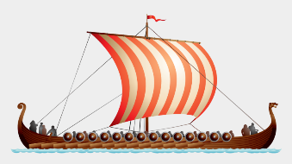

Art/DT – In art this term, we be creating a pop up art of Grendall or Beowolf based on Roy Lichtenstein’s work. In DT, they will be creating a Viking meal, where the children will have a chance to practice preparing, making, cleaning and eating their own meal.

PE – Our Summer 2 focus in PE will be alternative activities, disability sport and Year 5 will also be trialling a new P.E. resource due to be rolled out internationally. We will be working with people from Leeds Beckett University in taking a lead role in the new set of lessons.

Geography /History – For History and Geography, we are carrying on with the Anglo Saxons and Vikings with a focus on the Vikings. We will explore the impact they had on British society and then do a case study on York, a well renound Viking city. We will also be going to Malham in North Yorkshire, which fits in with work we have done previously on rivers.

Computing – In computing, we will focusing on PowerPoints, how to create, improve and present it to an audience.

English – To start our last half term, we look at the poem ‘Tell me a dragon’. We then move onto or narrative text which is ‘How to train a dragon before finishing with our non-fiction section, which this time will be a newspaper report. For whole class reading, we will be carrying on the text we have started in class, which is ‘Vikings in 30 seconds’ by Phillip Steele.

**Magic, Monsters and Mayhem – Y5**