Create your own cave painting. 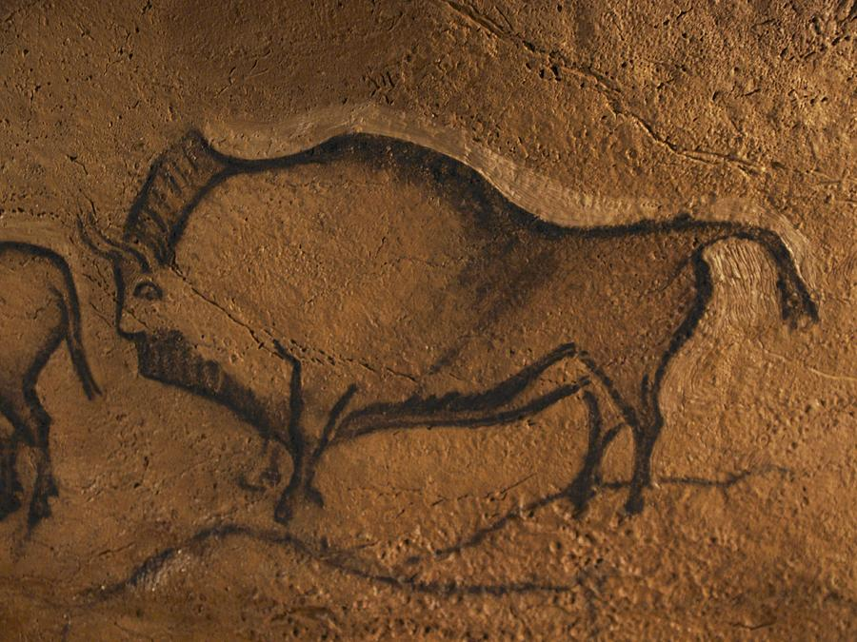

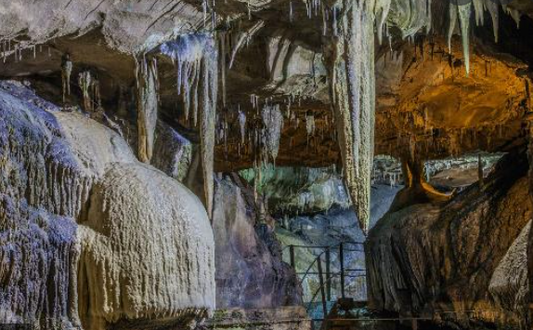

Practice your 2,5,10 times table and learn your 3 and 4 times tables.



Write a story about a time traveller who found himself or herself in a cave.

Make a model of ***a cave*** and find out key facts about caves.

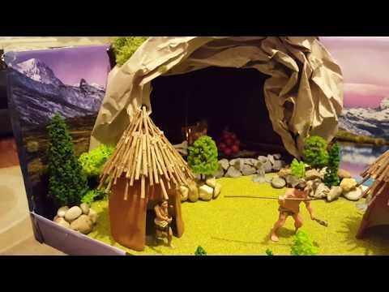

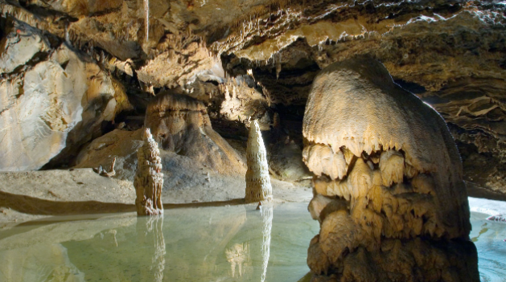

Make a fact file about **stalactites** and **stalagmites.**

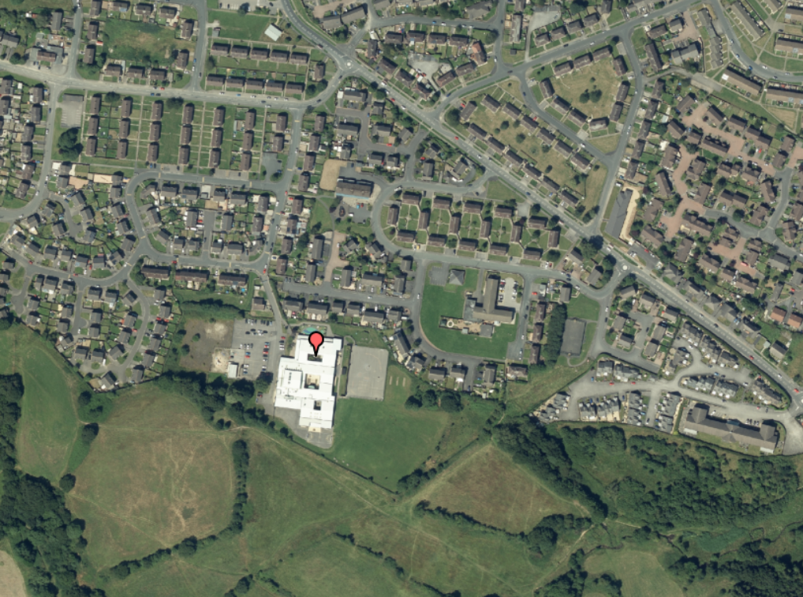

Make a map of your local area. Label any key landmarks/ important buildings.

Read a book with an adult at home and talk about it together.

Complete as many of the homework tasks as you can during the Summer holidays.

We will look forward to seeing your work in person in September, but in the meantime, you can upload pictures of your work to dojo or twitter @y3church or @y4church_prim

Learn the spellings from the Year 3 and 4 word list.

Write a list of **10 questions** you would ask one of the Stone Age settlers if you could meet one.

**Year 3 & 4 Transition Homework Menu**