Year 1/2 Reading Spine (A)
 | Autumn 1 |  | Autumn 2 | Spring 1 | Spring 2 | Summer 1 | Summer 2
Our Belief and Vison | At The Academy at St James we have books at the heart of learning. We use quality texts to inspire and drive all our learning.  We believe that children learn best when engaged with exciting and stimulating learning, allowing them to grow and develop into independent and resilient learners. In our school we support every child to reach their potential: Aspire, Achieve, Believe.  “The more that you read, the more things you will know. The more that you learn, the more places you’ll go.” Doctor Seuss
Our Values | Community  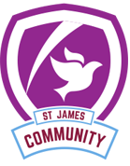 |  | Peace | Respect  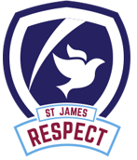 | Forgiveness  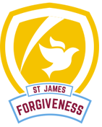 | Courage | Trust  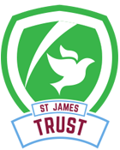
Themes | Great Food Journey |  | Great Food Journey | The Great Fire of London | Inspirational Women | Just the Ticket | Just the Ticket
English | 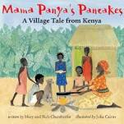 |  | 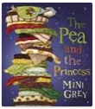 | 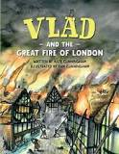 | 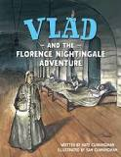 | 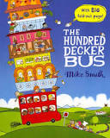 | 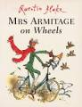
Whole Class Reading | 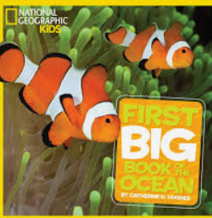 | 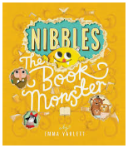 |  | 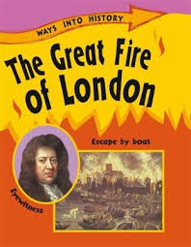 | 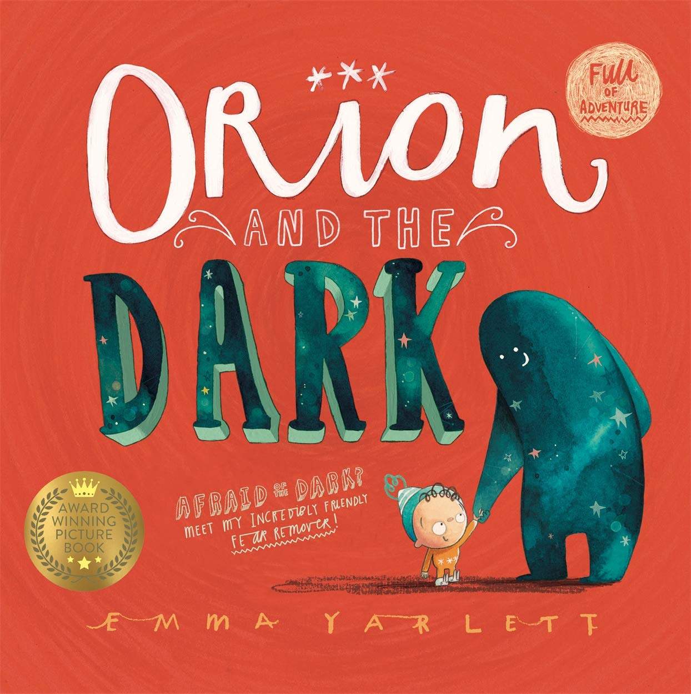 | 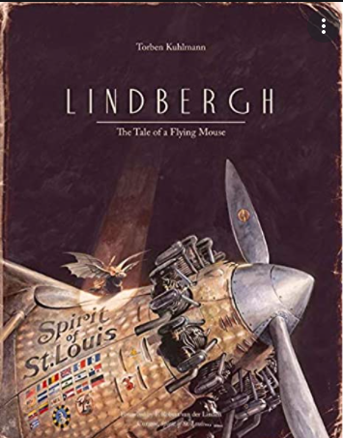
Writing Focus | Poetry: Peas and Carrots Poem  Fiction: Rags to riches  Non Fiction: Instructions- Recipe |  | Poetry: Food glorious food  Fiction: Quest Story  Non Fiction: Informal letter | Poetry: Fire fire  Fiction: Overcoming the monster story  Non Fiction: Newspaper Report | Poetry:  Fiction: Adventure Story  Non Fiction: Biographies | Poetry:  Fiction: Journey Story  Non Fiction: Non-chronological report | Poetry:  Fiction: Adventure Story  Non Fiction: Biographies
Curriculum Theme | Great Food Journey  To observe and understand what lives and grows in our world.  We will use simple fieldwork and observational skills to study the geography of our school and its grounds and the key features of its surrounding environment.  Classifying animals, (mammals, insects, amphibians, fish and birds) plants and habitats. Each week we will be focusing on the animals, plants and trees and learning key facts about them. We have made links with a school in Kenya and share and compare our similarities and differences. |  |  | The Great Fire of London  We will be learning about the four countries of the UK and their capital cities. We will be creating our own Tudor style London in DT and focusing on why what houses are built from is important. We will learn about the diary of Samuel Peyps and write stories in the past tense. | Inspirational Women | Just the ticket  This is where we learn about the Jowett brothers and their manufacturing which links to our geography work learning about Bradford/ Allerton.  We also design,create and evaluate our own car in DT.  We learn about different materials and understand which material is most suitable for each part of a car.  In ICT we learn about algorithms, programs and debuggin.
Curriculum Texts | 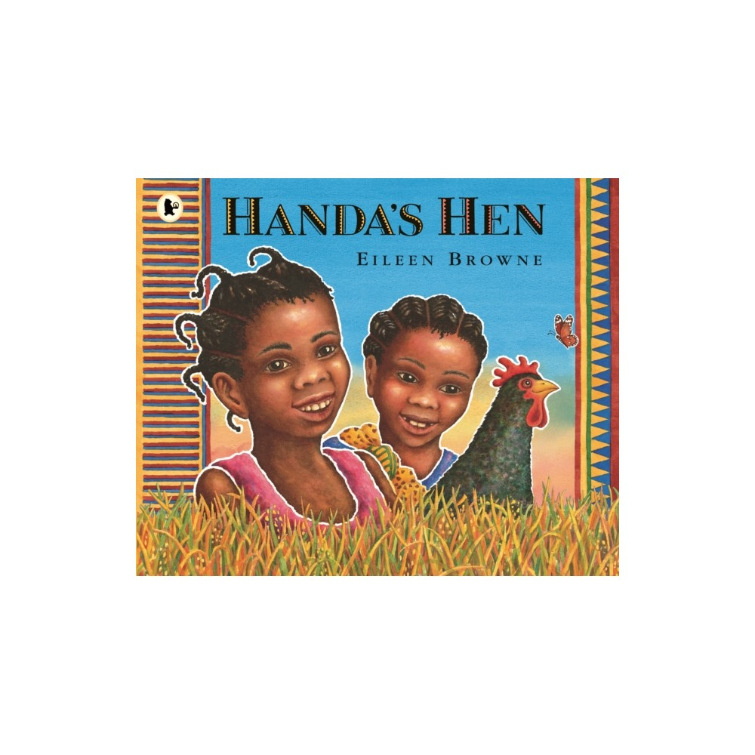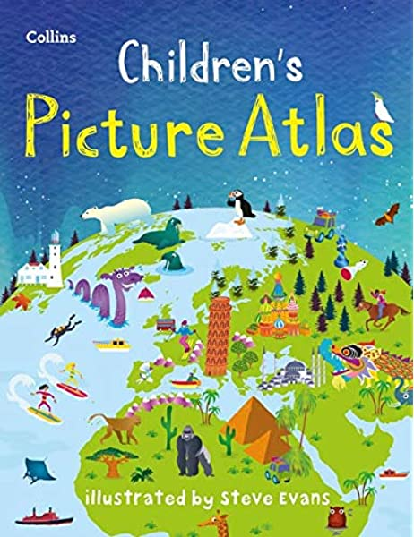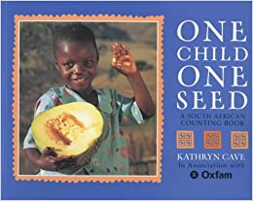  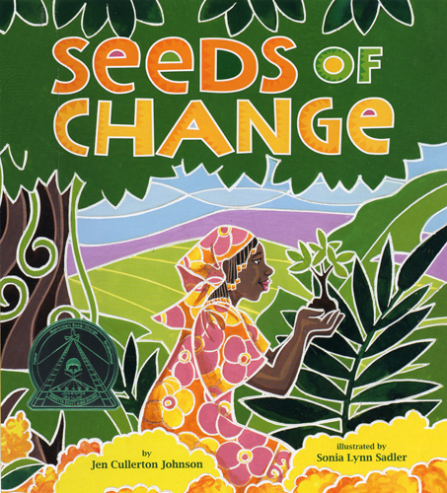 |  |  | 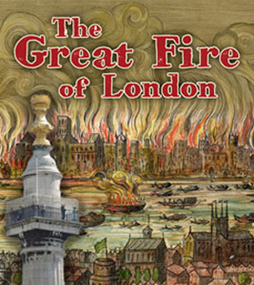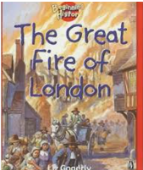  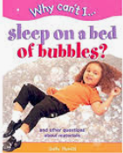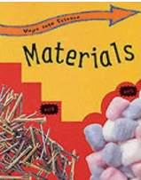  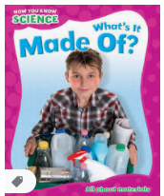 | 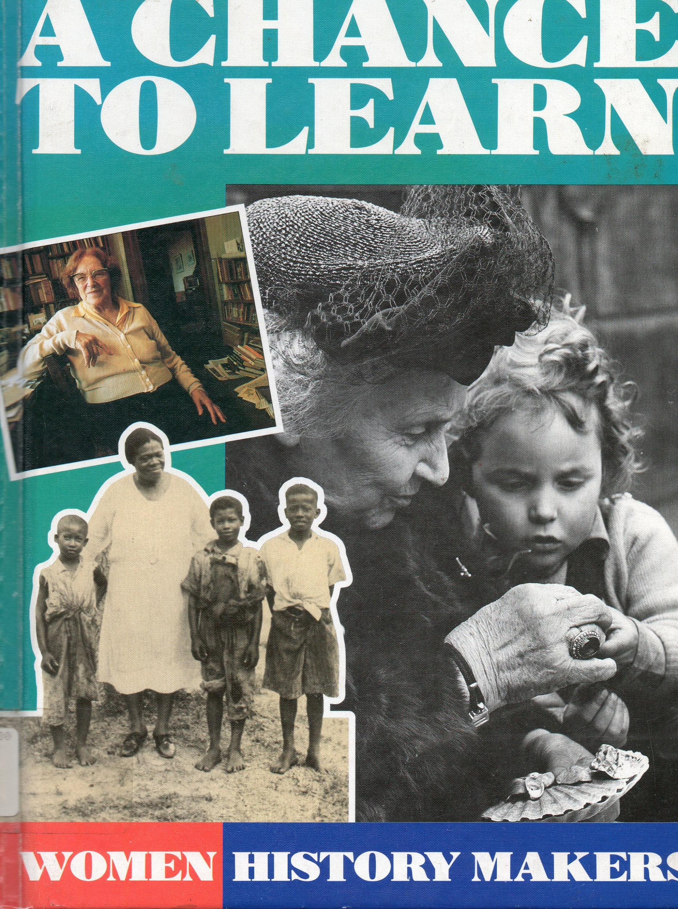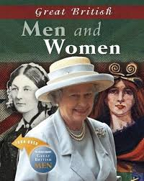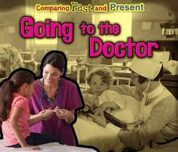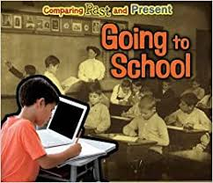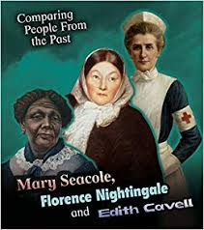 | 