Year 3/4 Reading Spine
 | Autumn 1 | Autumn 2 | Spring 1 | Spring 2 | Summer 1 |  | Summer 2
Our Belief and Vison | At The Academy at St James we have books at the heart of learning. We use quality texts to inspire and drive all our learning.  We believe that children learn best when engaged with exciting and stimulating learning, allowing them to grow and develop into independent and resilient learners. In our school we support every child to reach their potential: Aspire, Achieve, Believe.  “The more that you read, the more things you will know. The more that you learn, the more places you’ll go.” Doctor Seuss
Our Values | Community  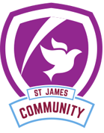 | Peace  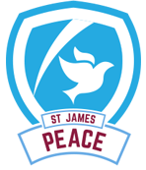 | Respect  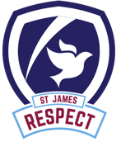 | Forgiveness  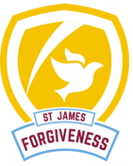 | Courage  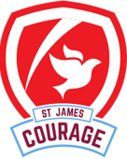 |  | Trust  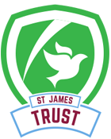
Themes | Prehistoric Park | Prehistoric Park | Under the surface | Under the surface | Beneath the Sands |  | Beneath the Sands
English | 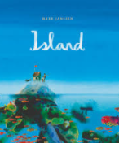 | 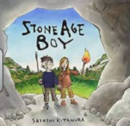 | 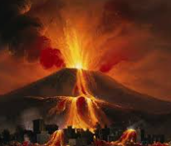  The Hero of Pompeii | The Hero of Pompeii | 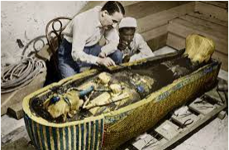  The Search for Tutankhamun | The God and The Pharaoh
Whole Class Reading | 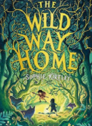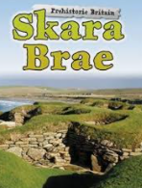 |  | 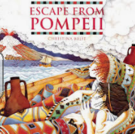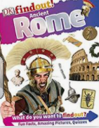 | 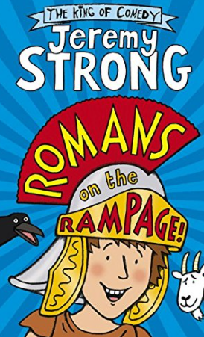 | 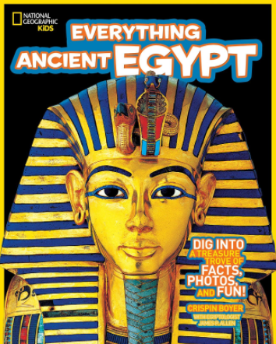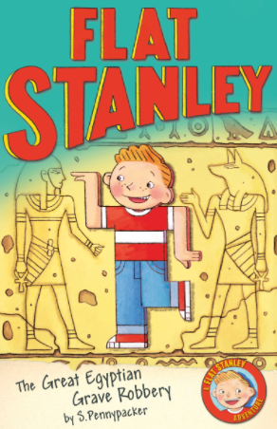
Writing Focus | Poetry: Island  Fiction: Journey Story  Non Fiction: Information Leaflet  Guided Reading: The Wild Way Home | Poetry: We will rock you  Fiction: Portal Story  Non Fiction: Diary Entry  Guided Reading: The Wild Way Home | Poetry: The Volcano  Fiction: Rags to Riches Story  Non-Fiction: Information Leaflet  Guided Reading: Escape from Pompeii  DK Find Out! Ancient Romans | Poetry: I am a Roman Soldier  Fiction: Warning Story  Non Fiction: Newspaper Report  Guided Reading: Romans on Rampage | Poetry: The Mummy  Fiction: Journey Story  Non-fiction: Diary Entry  Guided Reading: Everything Ancient Egypt  Flat Stanley and The Great Egyptian Grave Robbery |  | Poetry: The River Nile  Fiction: Conquering the monster Story  Non-Fiction: Balanced Argument
Curriculum Theme | At the start of the year we take a trip to the past to explore the Stone Age.  We investigate this fascinating time period and use it to inspire our History and Geography learning. In this term we also investigate the different types of rocks and soils as well take a look at our digestive system. |  | In this term we are transported into the ancient world of the Romans.  We look at the city of Pompeii and its unfortunate end due to Mount Vesuvius. The Roman invasion of Britain will be the focus of our History and in Geography we will be investigating mountains and taking a close look at the volcano which destroyed Pompeii. |  | To finish the year, we delve beneath the sands to uncover the amazing world of the Ancient Egyptians. We investigate all about their society and we even hold our own criminal investigation into who killed Tutuankhamun. Geography focus on the country of Egypt, its location and climate.
Curriculum Texts | 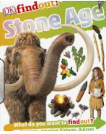 | 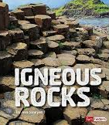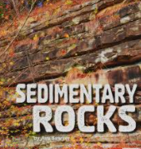  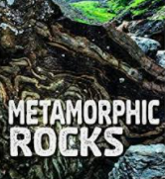 | 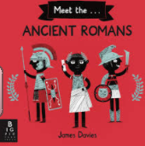 | 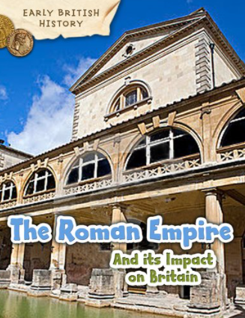 |  |  | 