Year 6 Reading Spine
 | Autumn 1 | Autumn 2 | Spring 1 | Spring 2 | Summer 1 | Summer 2
Our Belief and Vison | At The Academy at St James we have books at the heart of learning. We use quality texts to inspire and drive all our learning.  We believe that children learn best when engaged with exciting and stimulating learning, allowing them to grow and develop into independent and resilient learners. In our school we support every child to reach their potential: Aspire, Achieve, Believe.  “The more that you read, the more things you will know. The more that you learn, the more places you’ll go.” Doctor Seuss
Our Values | Community  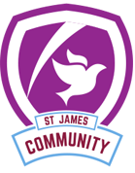 | Peace  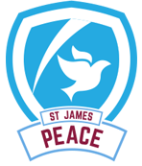 | Respect  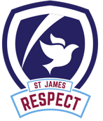 | Forgiveness  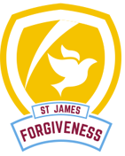 | Courage  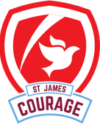 | Trust  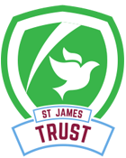
Themes | Only the Brave | Only the Brave | Impressions in Time | Impressions in Time | Mission Impossible  Was Hitler’s mission always impossible? | Mission Impossible  Was Hitler’s mission always impossible?
English | 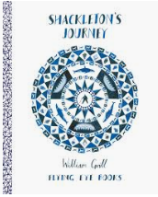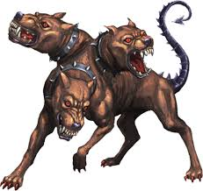 |  | 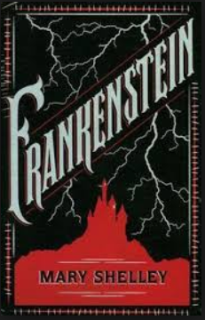 | 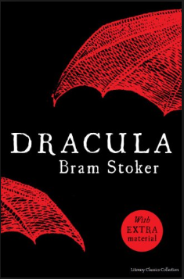 | 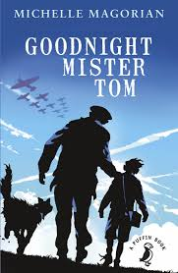 | 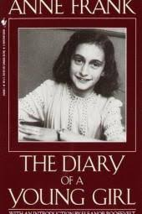
Whole Class Reading | 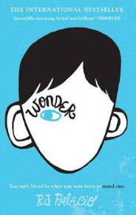 | 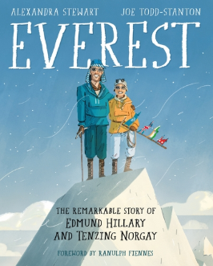 | 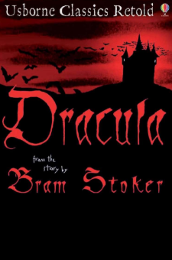 |  | 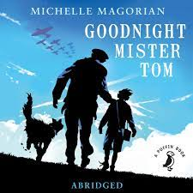 | 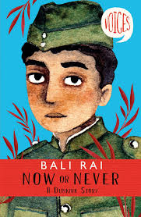
Writing Focus | September: Island (whole school focus)  Poetry:  Fiction: Unlikely hero tale  Non Fiction: Report writing | Poetry: Still I Rise  Fiction: Ancient Greek myth  Non Fiction: Non chronological reports. | Poetry: The Highway Man  Fiction: Dual Narrative- Warning Story  Non Fiction: Persuasive Letter | Poetry: The Raven  Fiction: Conquering the Monster Narrative  Non Fiction: Balanced Argument | Poetry: VE poems  Fiction:  Non Fiction: Biographies - Anne Frank | Poetry: War poetry  Fiction: Good over bad - Goodnight Mr. Tom.  Non Fiction: Diary writing
Curriculum Theme | At the start of the year we investigate Bravery and the different ways it looks.  During the term we explore Antarctica and how the people and specialist animals survive in this hostile environment.  We then travel back to Ancient Greece, to discover the civilisations of Athens and Sparta, the geographical features and myths.  In Evolution and Inheritance we explore how Charles Darwin changed the way we view the world. |  | This term we take a step back in time to the Gothic Period, a period of new ideas and supernatural elements.  We also learn about Whitby in Geography (a central location of Dracula) as a coastal town, and will research coastal processes and the ways in which erosion is being combatted.  In Science, we will discover the reasons for and historical learning we can do from fossils.  In Electricity and The Human Body, we develop our scientific understanding of these subjects, linking them to our Gothic protagonists. |  | Moving to the Second World War, we will first investigate what life was like for people in Bradford, particularly children. We will also learn about the persecution involved in the Holocaust, with an emphasis on Anne Frank.  Thereafter, we will look into the reasons for the invasion.  In Science, we will explore the impact of diet, exercise and drugs on the human body.
Curriculum Texts | 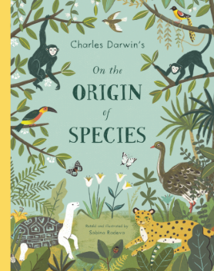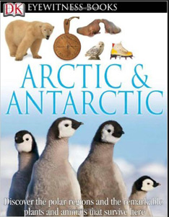  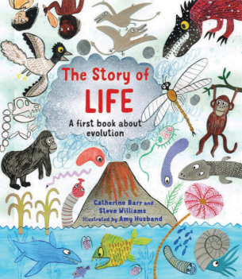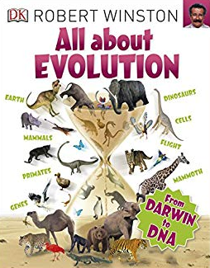 | 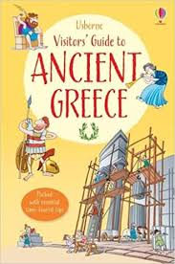 | 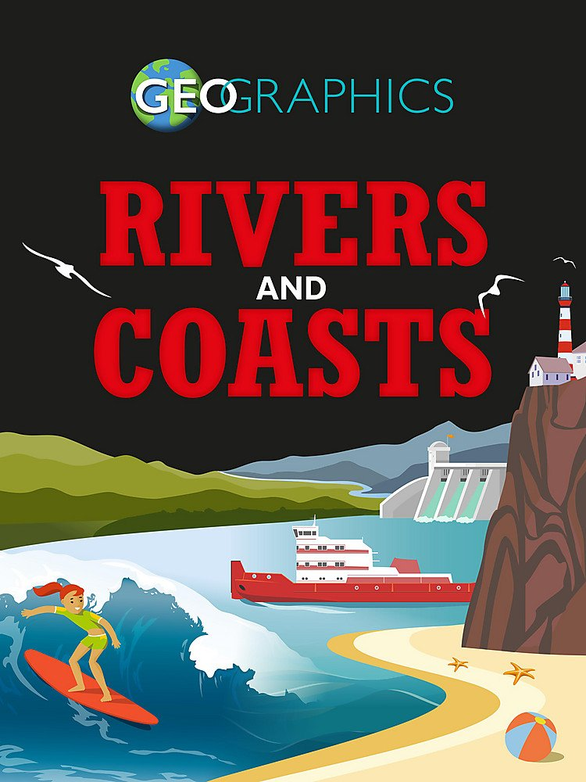  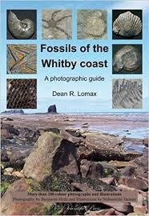 | 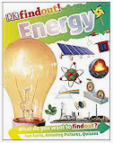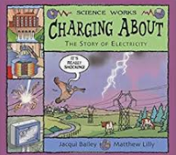 | 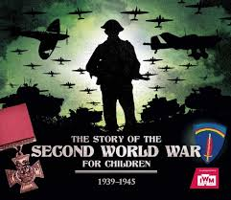 | 