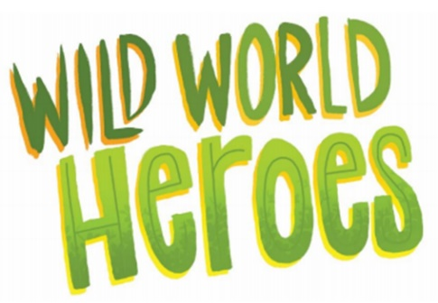

Go wild for reading with the Summer Reading Challenge!
Read books, collect rewards and learn all about our planet.
With exclusive incentives to collect and plenty of brilliant books to enjoy, the Challenge is the perfect summer activity to build young readers’ skills and confidence during the long break from school. The Challenge is available in libraries across the UK this summer.
Children can also take part online through the official digital Challenge platform wildworldheroes.org.uk.
How to join:
