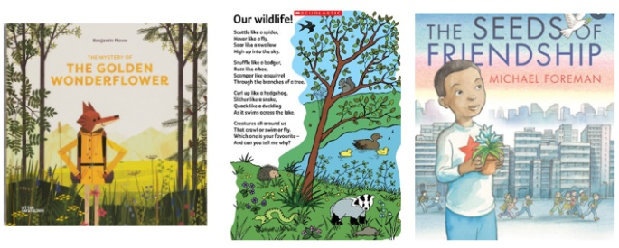

**P.E** : In P.E. Mr O’Brien will be teaching us the skills we need for invasions games by learning how to move and stop our bodies in a variety of different ways.

**Maths-** In our maths lessons we will be learning about place value of a 1 digit number and a 2 digit number. We will also be learning how to partition.

**History/ Geography**

In history and geography we will be learning about Allerton/Thornton. We will be learning about the history of our school, has there always been a school there…? In geography, we will be developing our map reading skills by following how to get from school to Pity Beck.

**Design Technology** We will be focussing on structures. This is where we will design, create and evaluate our own 3D planter to used in our outdoor area.

**English:** We will be using the text ‘The Golden Wonderflower’ where we will focus on the writing skills of letter formation, capital letters and full stops to write our own adventure story!

**Reading**: In Whole Class Reading, we are reading a fiction book titled ‘The seeds of friendship.’ We will be doing lots of book talk which will support our inference and retrieval skills.