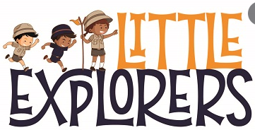

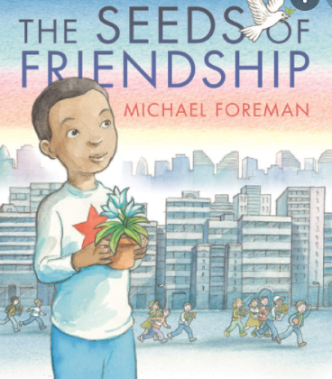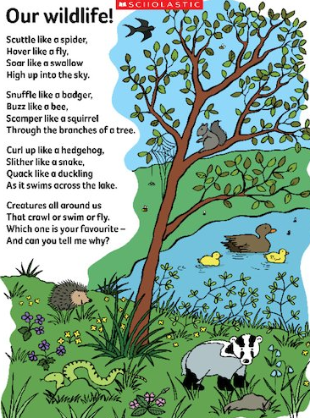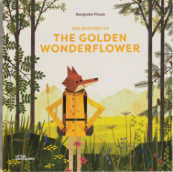

English outcome:

Fiction: An adventure story

Non- fiction: Wild flower identification leaflet

Curriculum outcome:

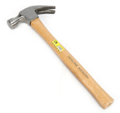**DT**- A 3D planter.

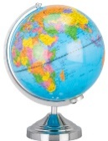

**Geography** – Travel brochure on why people should visit Allerton.

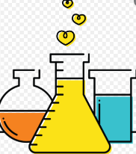**Science-** A pic collage to create a field guide on British flowers.