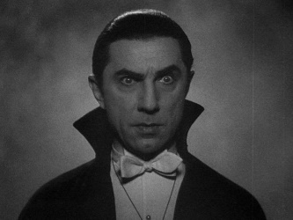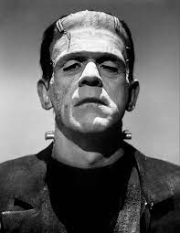

Year 6 – Spring Term

g

**Journey Home**

**Computing**

Our ICT this term will focus on the use of databases. We will develop our knowledge of using spreadsheets as well as linking our science learning to creating graphs.

PE

The children will continue their PE lessons with Mr O’Brien on a Tuesday afternoon. They will be improving their understanding of modified athletic activities. Some children will also develop their technique in Jujitsu.

**Topic**

In curriculum, we will have a focus on Geography and will be learning all about Whitby. This links to our story of Dracula. We will look at where Whitby is on a map in comparison to Bradford, look at its physical and human features as well as focusing on the question:

How has global warming effected the coastal erosion and deposition?

**Science**

In Science, we are learning about living things. We will be learning about classification of animals, plants and microorganisms. We will also have a focus on Carl Linnaeus.

**RE**

In R.E we will be continuing our work on understanding Christianity. We will be discussing the different beliefs people have of God. We will look at, and compare, the thoughts of Theists and Atheists.

**PSCHE**

In PSCHE this half term the children will be working with Miss Guest learning all about keeping safe and managing risk.

**English**

In whole class reading we will be reading ”Dracula” and “Room 13” by Robert Swindells. We are focusing upon answering inference questions and ensuring that the children include the necessary detail.

Our Fiction unit is based on the theme of Frankenstien and we will be making sure that we use our whole grammar tool box to help us write a dual narrative.

In non-fiction we are going to be writing a balanced argument focusing on the question – **‘Is Dracula friend or foe?’**

**Maths**

This term we are focusing upon geometry, number and calculations and fractions.

The SAT’s are fast approaching us and we will be continuing to practise our arithmetic and problem solving skills.

Please help your child by completing their maths homework and continue to practise their times table knowledge by using times table rock stars.

