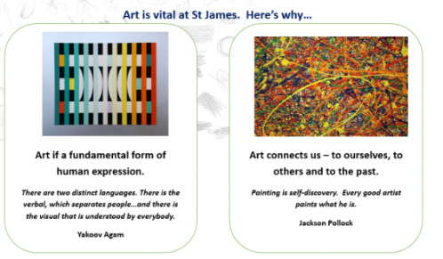
Christian values, Cultural Capital and Pupil Premium enhancements.
At The Academy at St James, we are committed to broadening the horizons of our pupils. Through our art provision, children have the opportunity to learn about artists and designers, both male and female and coming from a range of backgrounds, including artists from our local area. We aim for our children to develop their understanding of artists and the value of art itself. We want our children to understand this value is not monetary, it is a sense that having this creativity and spirituality makes you a better person.
We provide our children with opportunities that they may not have outside of school. This includes collaboratively with others, meeting artists, visiting galleries and developing hobbies and interests which aids their positive mental health and well-being.
We aim to nurture and celebrate each child’s spirituality and individuality by ensuring we provide opportunities for the children to express themselves as they reflect on the sort of people they are, their morals and consider the people they wish to be in the future, representing this through their own, original pieces of art. Through our use of sketchbooks, we aim for each child to have a place where they can express themselves.
Our Art curriculum aims to make a difference in each pupil’s life through developing resilience as, like many artists, they will have to learn from mistakes and learn to celebrate what they have gained from them. Our children will also be able to develop pride in themselves and their own artwork as it will be valued on displays and on Twitter and Class Dojo.
Visits to museums, galleries and places that will inspire the children’s own products are organised to ensure all children develop their sense of belonging and knowledge of the wider world. We strive for each child’s sense of belonging to deepen because feeling that you belong is most important in seeing the value of life and coping with intense emotions. Our curriculum ensures children learn about artists who have faced their own challenges and how they have used these experiences to create something new and positive, just as we hope our children will do in their lives.

