Diversity Reading Spine
Year 1 & 2 - Cycle A
Text | PHSE Concept
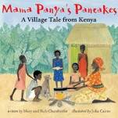  Mama Panya’s Pancakes by Mary and Rich Chamberlin | - Diversity  - Equality  - Identity  - Relationships  - Rights  - Responsibilities  - Resilience
Summary
On market day, Mama Panya's son Adika invites everyone he sees to a pancake dinner. How will Mama Panya ever feed them all? This clever and heart-warming story about Kenyan village life teaches the importance of sharing, even when you have little to give.
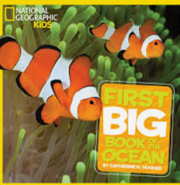  First big book of the ocean by National Geographic | - Diversity  - Rights  - Responsibilities  - Resilience  - Change
Summary
National Geographic Kids First Big Book of the Ocean is an adorable animal reference that includes the sea's high-interest animals, such as dolphins, sharks, sea otters, and penguins, and introduces kids to some of its lesser-known creatures.
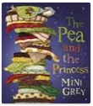  The Pea and the Princess by Mini Grey | - Identity  - Diversity  - Rights  - Consent  - Relationships  - Equality  - Responsibilities
Summary
Once upon a time there was an enchanting fairytale about a prince who was looking for a real princess to be his bride. The only way to tell whether the many princesses who applied for the post were really royal, legend had it, was to see if they would be able to feel a tiny little pea through dozens of luxurious mattresses as they slept. All well and enchanting, but has anyone stopped to think about how all this might have felt for the pea in question? No. So here, for the first time, straight from the pea, is the truth about this much-loved, oft-repeated fairytale.
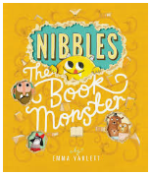  Nibbles the Book Monster by Emma Yarlett | - Identity  - Diversity  - Responsibilities  - Consent  - Rights  - Relationships
Summary
Nibbles is a very naughty book monster – he's chomping, munching and nibbling his way through fairytales that don't belong to him! Can you help catch him and put him back in his own story?
Vlad and the Great Fire of London by Kate Cunningham | - Identity  - Diversity  - Equality  - Relationships  - Risk  - Resilience  - Change  - Rights  - Responsibilities
Summary
It's 1666 and Vlad the flea and his friend Boxton the rat, love eating and biting their way around London. But one night in Pudding Lane they are caught up in a fire that threatens to destroy them, along with most of the City of London. Through Vlad's story and full colour illustrations it shows how the fire is believed to have started, how it spread and what Londoners did to fight it and escape it.
Ways into History: The Great Fire of London | - Identity  - Diversity  - Equality  - Relationships  - Risk  - Resilience  - Change  - Rights  - Responsibilities
Summary
Ways into History: The Great Fire of London looks at what happened that fateful night in 1666 and how it gave birth to a brand new London.
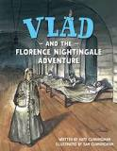  Vlad and the Florence Nightingale Adventure by Kate Cunningham | - Identity  - Diversity  - Equality  - Relationships  - Risk  - Resilience  - Change  - Rights  - Responsibilities  - Power
Summary
Vlad the flea and Loxton the rat are perfectly at home in the dirt and filth of Scutari Hospital. But the arrival of Florence Nightingale and her strange companion changes everything. Will the friends be driven out or can they save the day? Find out about Florence, her nurses and Scutari Hospital through the eyes of Vlad the flea and Loxton the rat. Vlad narrates the tale as the nurses take charge and clean ... with soap! But there are other people in the hospital who are not happy with this new arrangement, and the friends will soon come up against both their nemesis and a shadowy thief in their midst. Who will win and who will have to leave?
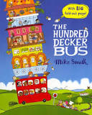  The Hundred Decker Bus by Mike Smith | - Identity  - Relationships  - Diversity  - Equality  - Resilience  - Change  - Rights  - Responsibilities
Summary
Every day, the bus driver finishes his cup of tea, puts on his jacket and sets off on his route. Every day, the man with the big red tie gets on at the roundabout, the lady with the pram gets on at the library and the noisy children get on at Clover Drive.

But what if one day the driver turned down a new and exciting road, and picked up new and exciting people? So many people that the bus simply wouldn't be big enough? Well, there would only be one solution . . .
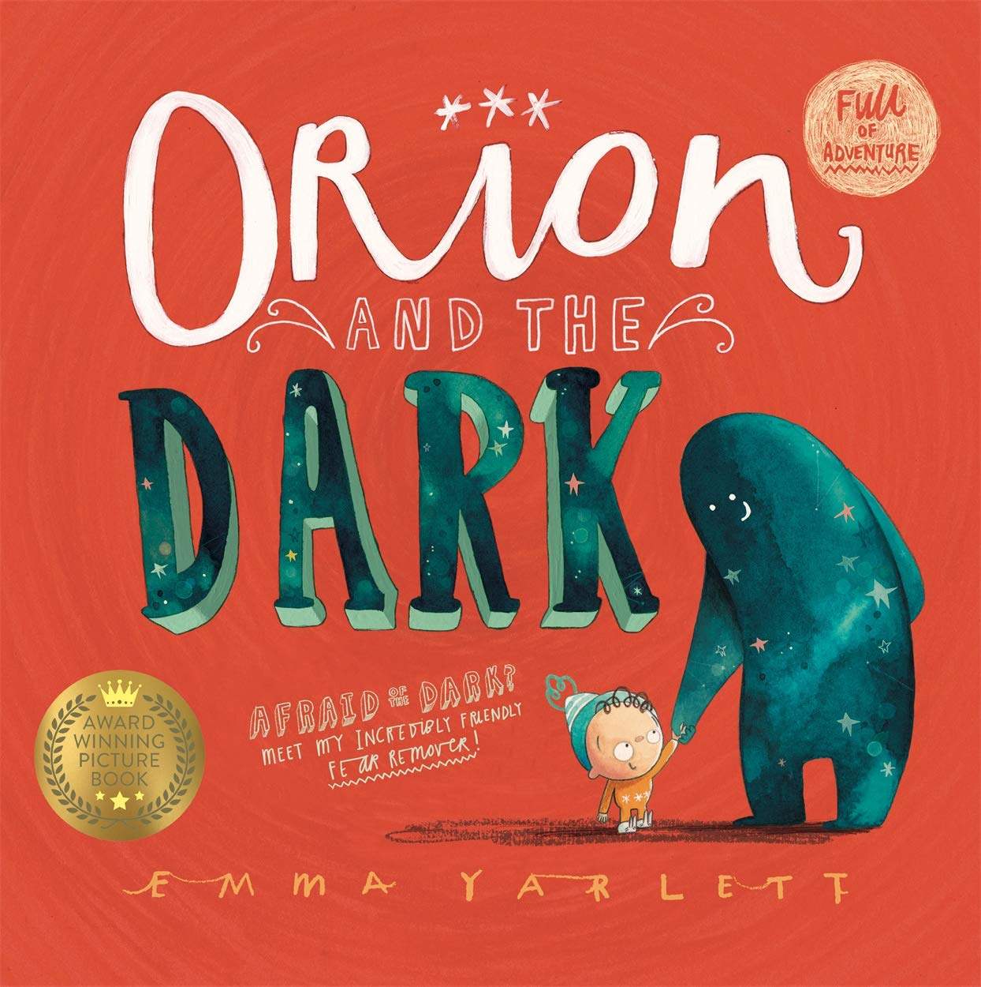  Orion and the Dark by Emma Yarlett | - Identity  - Relationships  - Resilience  - Diversity  - Equality  - Risk  - Change  - A healthy balanced lifestyle
Summary
Orion is scared of A LOT of things, but most of all he's scared of the dark. So one night Dark decides to take Orion on an adventure.
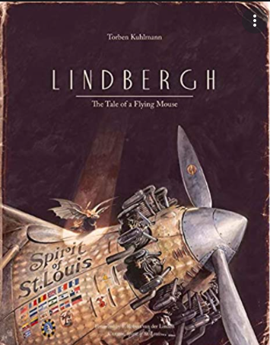  Lindbergh and The Tale of the Flying Mouse by Torben Kuhlmann | - Identity  - Diversity  - Risk  - Change  - Equality  - Resilience  - Relationships  - Rights  - Power
Summary
One small step for a mouse; one giant leap for aviation. These are dark times. . . for a small mouse. A new invention—the mechanical mousetrap—has caused all the mice but one to flee to America, the land of the free. But with cats guarding the steamships, trans-Atlantic crossings are no longer safe. In the bleakest of places. . . the one remaining mouse has a brilliant idea. He must learn to fly!
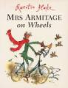  Mrs Armitage on Wheels by Quentin Blake | - Identity  - Diversity  - Relationships  - Equality  - Resilience  - Change  - Rights
Summary
Mrs Armitage sets off for a quiet cycle with her faithful dog, Breakspear, but she just can't help thinking of ways to improve her bicycle. Before very long she has added three very loud horns, a bucket of water to wash her hands, a complete tool kit. And by the time she has also added a seat for Breakspear, two umbrellas, a cassette player and a mouth-organ, Mrs Armitage is riding a very eye-catching contraption. But it is when she finally adds the mast and sail, that Mrs Armitage really runs into trouble. . .
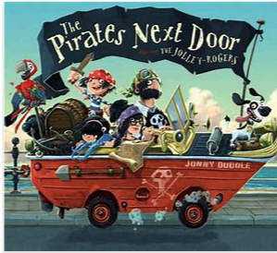  The Pirates Next Door by Jonny Duddle | - Diversity  - Relationships  - Identity  - Rights  - Equality  - Resilience  - Power  - Change
Summary
The Jolley-Rogers - a pirate family, are moving to Dull-on-Sea, a quiet seaside town. Stopping to fix up their ship, this unusual family get the whole neighbourhood spreading rumours. Defying the grown-ups, Matilda from next door decides to become friends with the youngest pirate son.

