Diversity Reading Spine
Year 1 & 2 - Cycle B
Text | PHSE Concept
The Golden Wonderflower by Benjamin Flouw | - Identity  - A healthy, balance lifestyle  - Diversity  - Resilience  - Risk  - Safety
Summary
Fox is an avid botanist. He loves all flowers and trees! One evening, whilst flicking through his books, he discovers the Golden Wonderflower.
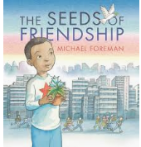  The Seeds of Friendship by Michael Foreman | - Relationships  - Identity  - Equality  - Diversity  - A healthy, balanced lifestyle  - Resilience
Summary
A powerful fable about friendship transforming the world.
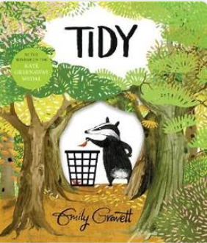  Tidy by Emily Gravett | - Identity  - Relationships  - A healthy, balanced lifestyle  - Responsibilities  - Consent
Summary
Pete the badger likes everything to be neat and tidy at all times, but what starts as the collecting of one fallen leaf escalates and ends with the complete destruction of the forest! Will Pete realise the error of his ways and set things right?
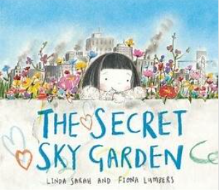  The Secret Sky Garden by Linda Sarah | - Identity  - Relationships  - Diversity  - A healthy, balanced lifestyle  - Responsibilities  - Equality
Summary
A startlingly original picture book about a little girl who creates a garden on a disused car park rooftop
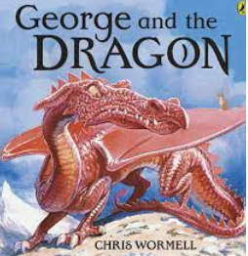  George and the Dragon by Chris Wormell | - Identity  - Relationships  - Diversity  - Resilience  - Responsibilities  - Rights
Summary
He was an awesome and frightening creature, terrorising whole armies, destroying castles, demolishing forests and kidnapping princesses. But this mighty dragon had a deep, dark secret. . . .

Uncover a charming tale of adventure, a dragon, and an unlikely hero.
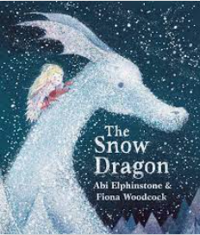  The Snow Dragon by Abi Elphinstone | - Identity  - Relationships  - Equality  - Diversity  - Resilience  - Rights  - Power
Summary
In Griselda Bone's gloomy orphanage, daydreaming is banned, skipping is forbidden and Christmas is well and truly cancelled. But for Phoebe and her sausage dog Herb, is it possible that, just when things seem at their bleakest, magic awaits in the swirling, snow-filled air?
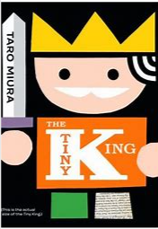  The Tiny King by Taro Miura | - Identity  - Relationships  - Equality  - Diversity  - Resilience  - Change  - Rights
Summary
A tiny, lonely king welcomes big changes.
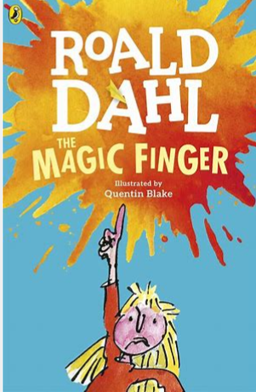  The Magic Finger by Roald Dahl | - Identity  - Relationships  - Diversity  - Equality  - Resilience  - Rights  - Power
Summary
The Magic Finger is narrated by an unnamed eight-year-old girl, who is growing up on a farm in the English countryside, next door to the Gregg family who has a passion for hunting animals and birds.
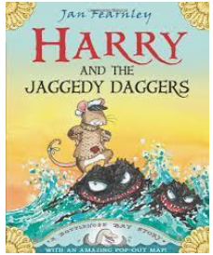  Harry and the Jaggedy Daggers by Jan | - Identity  - Resilience  - Diversity  - Change
Summary
Harry the harbour mouse is heartbroken when his boat is dashed and smashed on the dangerous, mean old rocks—the terrible Jaggedy Daggers! But just as the sea brings mischief, it brings surprises too. . .
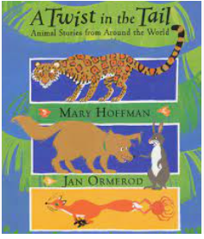  A Twist in the Tail by Mary Hoffman | - Identity  - Relationships  - Equality  - Diversity  - Resilience
Summary
Mary Hoffman's vibrant retellings capture the fun, wisdom and rich character of the diverse cultures from which they spring. Every story involves a battle of strength or cunning, with a surprise outcome.
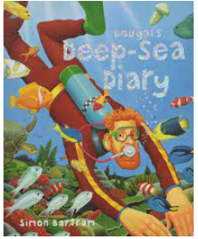  Dougal’s Deep Sea Diary by Simon Bartman | - Identity  - Resilience  - Career  - Diversity  - A healthy and balanced lifestyle
Summary
Written in diary format with the text divided into timed sections the reader accompanies Dougal on his entertaining holiday adventure to find the lost city of Atlantis at the bottom of the ocean.
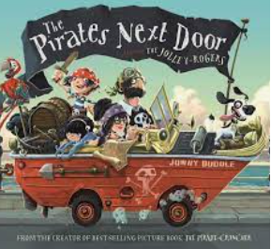  The Pirates Next Door by Jonny Duddle | - Identity  - Diversity  - Equality  - Relationships  - Rights  - Resilience  - Responsibilities
Summary
The Pirates Next Door tells the tale of Matilda, a little girl who lives in a gloomy seaside town, Dull-on-Sea. One day, new neighbours move in next door - a family of pirates. Matilda thinks it's fantastic to have such exciting neighbours. However, her mum, dad and the other neighbours are not so impressed with these new residents.

