Diversity Reading Spine
Year 3 & 4 - Cycle A
Text | PHSE Concept
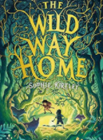  The Wild Way Home by Sophie Kirtley | - Diversity  - Relationships  - Identity  - Resilience  - Equality  - Change  - Responsibilities
Summary
A wild, big-hearted adventure as Charlie and the Stone Age boy set out together to find what they have lost - their courage, their hope, their family and their way home.
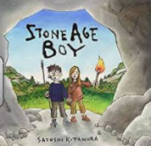  Stone Age Boy by Satoshi Kitamura | - Relationships  - Identity  - Resilience  - Diversity  - Rights  - Responsibilities
Summary
One day a little boy is walking along when he trips, stumbles and falls ... into the Stone Age! But when a furious cave bear attacks, he wakes up back in his own time where everyone tells him it was only a dream. But was it?
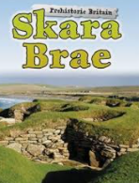  Skara Brae by Dawn Finch | - Diversity  - Relationships  - A healthy balance lifestyle  - Resilience  - Change  - Identity
Summary
A fascinating book all about Skara Brae, a prehistoric Stone Age site in the Orkney Islands, Scotland.
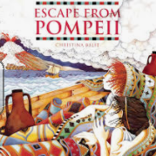  Escape from Pompeii by Christina Balit | - Diversity  - Relationships  - Risk  - Resilience  - Change  - Responsibilities  - Identity  - Equality
Summary
Travel back in time to the days of the Roman Empire and join Tranio, the son of an actor, and his friend Livia, the baker's daughter, in witnessing the eruption of Mount Vesuvius in AD79.
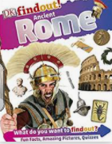  Dk Find Out Ancient Rome by DK | - Diversity  - Identity  - Relationships  - A healthy balanced lifestyle  - Change  - Resilence
Summary
DKfindout! Ancient Rome takes kids back in time to discover what life was like in Ancient Rome.
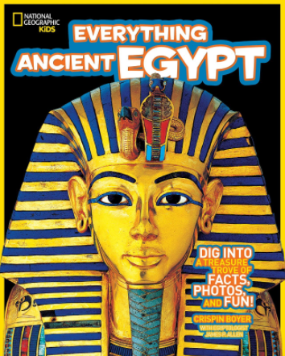  Everything Ancient Egypt by National Geographic | - Diversity  - Identity  - Relationships  - A healthy balanced lifestyle  - Change  - Resilience
Summary
Packed with facts and tantalising anecdotes from experts and bursting with colour photographs, learn all about Ancient Egypt in this fresh take on the subject.
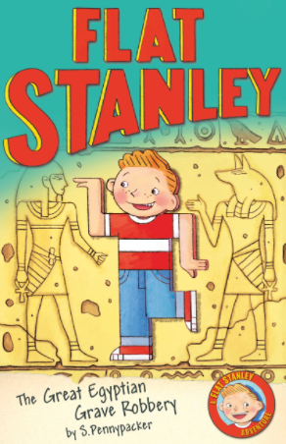  Flat Stanley and the Great Egyptian Robbery by Sara Pennypacker | - Identity  - Relationships  - Diversity  - Equality  - Resilience  - Risk  - Safety  - Rights  - Consent
Summary
Asked to travel to Egypt to help with an urgent archaeological expedition, Flat Stanley suspects that he might be helping grave robbers and must rely on his quick thinking, unique flatness and new friends to make things right.

