Diversity Reading Spine
Year 3 & 4 - Cycle B
Text | PHSE Concept
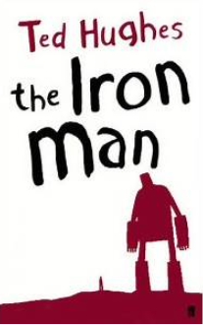  The Iron Man by Ted Hughes | - Identity  - Relationships  - Equality  - Diversity  - Rights  - Responsibility  - Change  - Resilience
Summary
Mankind must put a stop to the dreadful destruction by the Iron Man and set a trap for him, but he cannot be kept down. Then, when a terrible monster from outer space threatens to lay waste to the planet, it is the Iron Man who finds a way to save the world.
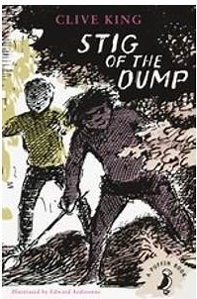  Stig of the Dump by Clive King | - Identity  - Relationships  - Equality  - Diversity  - Resilience  - Responsibilities  - Rights
Summary
Barney is a solitary little boy, given to wandering off by himself. One day he is lying on the edge of a disused chalk-pit when it gives way and he lands in a sort of cave. Here he meets 'somebody with a lot of shaggy hair and two bright black eyes' wearing a rabbit skin and speaking in grunts. He names him Stig. Of course nobody believes Barney when he tells his family all about Stig, but for Barney cave-man Stig is totally real.

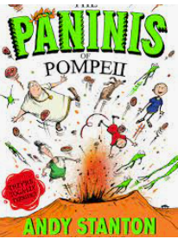  Paninis of Pompeii by Andy Stanton | - Identity  - Relationships  - Diversity  - Resilience
Summary
Welcome to the last days of Pompeii as you've NEVER imagined them before! Join fart-trader Caecilius, his wife, Vesuvius, and their ten-year-old son, Filius, in a bizarre world of accidental gladiators, pizza-emitting volcanoes and the legendary Ma-wol-n-f.
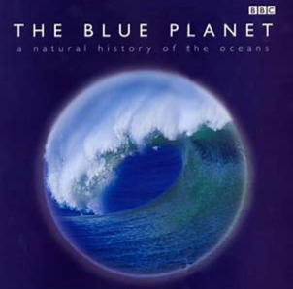  The Blue Planet by David Attenborough | - Rights  - Responsibilities  - Change  - Resilience
Summary
From space Planet Earth is blue. It floats like a jewel in the inky black void. The reflection of the suns light from the vast expanse of water covering its surface creates its gem-like blue colour. The Blue Planet is the first complete and comprehensive portrait of the whole ocean system.
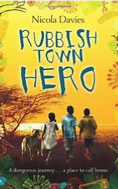  Rubbish Town Hero by Nicola Davies | - Identity  - Relationships  - Equality  - Diversity  - Rights  - Responsibilities  - Change  - A healthy balance lifestyle
Summary
Chipo and his little sister Gentle live on Papa Fudu's dumpsite in Rubbish Town, searching for valuable things amongst the rubbish to try to stay alive. Life isn't easy - luckily, Chipo has spirit, courage and lots of imagination! And now, he has a plan...
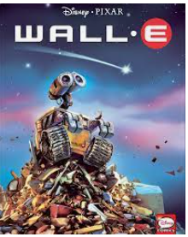  Wall-E | - Identity  - Relationships  - Diversity  - Rights  - Responsibilities  - Equality  - Resilience
Summary
After hundreds of lonely years of doing what he was built for, WALL-E (short for Waste Allocation Load Lifter Earth-Class) discovers a new purpose in life (besides collecting knick-knacks) when he meets a sleek search robot named EVE. EVE comes to realize that WALL-E has inadvertently stumbled upon the key to the planet's future, and races back to space to report her findings to the humans.
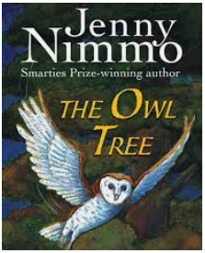  The Owl Tree  By Jenny Nimmo | - Identity  - Relationships  - Resilience  - Rights  - Diversity  - Equality
Summary
The owl-tree is not like any tree Joe has ever seen. It's huge and leafy and shivers like a person; it even seems to speak. Granny Diamond once saw an owl perched among its branches and she has loved the tree ever since. It means the world to her. But her neighbour, Mr Rock, wants to cut it down. Why does he dislike the owl-tree so much? Does it have a secret to tell Joe? And how can he, a boy too scared even to climb the tree, be the one to save it?
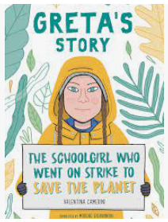  Greta’s Story by Valentina Camerini | - Identity  - Equality  - Diversity  - Rights  - Responsibilities  - Consent  - Resilience  - Risk  - Safety
Summary
It’s 20 August 2018, late summer in Stockholm, and it feels incredibly hot in the city. The TV news reports rising temperatures, and there have been numerous fires throughout Sweden. Fifteen-year-old Greta Thunberg decides she can’t wait any longer: politicians have to do something to save the environment. Instead of returning to school, Greta takes a placard and goes on strike in front of Sweden’s parliament building.
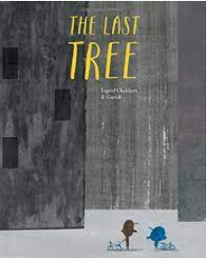  The Last Tree by Ingrid Chabbert and Guridi | - Identity  - Relationships  - Diversity  - Rights  - Resilience  - Equality
Summary
This poignant picture book with a futuristic feel offers a powerful environmental message about the critical importance of conserving the natural world.

