Diversity Reading Spine
Year 5 & 6 - Cycle A
Text | PHSE Concept
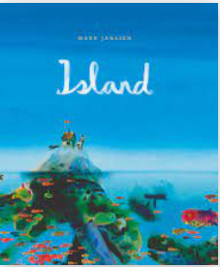  Island by Mark Janssen | - Identity  - Relationships  - Diversity  - Responsibilities  - Rights  - Resilience
Summary
Shipwreck! A father, daughter and their dog wash up on a small island. Little do the castaways know that the island isn’t what it seems at all. The island shows the family the wonders of life at sea.
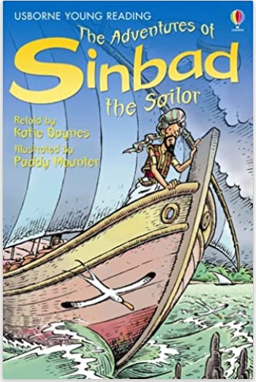  The Adventures of Sinbad the Sailor by Katie Daynes | - Identity  - Relationships  - Diversity  - Equality  - Responsibilities  - Rights
Summary
Sinbad is the most fearless sailor on the seven seas, facing trolls, giants, whales and wild storms on his adventures. But is his luck about to run out?
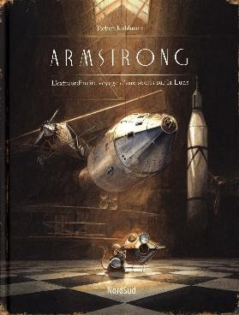  Armstrong by Torben Kuhlmann | - Identity  - Equality  - Diversity  - Rights  - Responsibilities  - Resilience
Summary
A long time ago a mouse learned to fly . . . and crossed the Atlantic. But what happened next? The Tale of a Flying Mouse comes Armstrong: A Mouse on the Moon where dreams are determined only by the size of your imagination and the biggest innovators are the smallest of all.
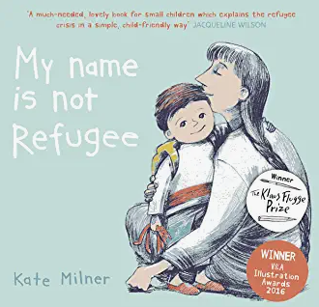  My Name is not refugee by Kate Milner | - Identity  - Relationships  - Diversity  - Equality  - Rights  - Responsibilities  - Change  - Resilience
Summary
A young boy discusses the journey he is about to make with his mother. They will leave their town, she explains, and it will be sad but also a little bit exciting. They will have to say goodbye to friends and loved ones, and that will be difficult. They will have to walk and walk and walk, and although they will see many new and interesting things, it will be difficult at times too.
Cosmic by Frank Cottrell-Boyce | - Identity  - Relationships  - Diversity  - Equality  - Resilience  - Career
Summary
Long-legged Liam makes a giant leap for boy-kind by competing with a group of adults for the chance to go into space. Is Liam the best boy for the job? Sometimes being big isn't all about being a grown-up.
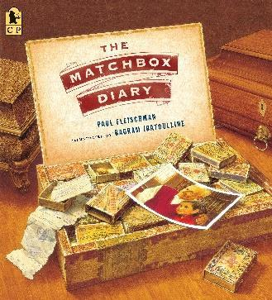  The Matchbox Diary by Paul Fleischman | - Identity  - Relationships  - Equality  - Diversity  - Rights  - Responsibilities  - Resilience  - Change
Summary
When a little girl visits her great-grandfather, she asks about the collection of matchboxes harboring objects she can hold in her hand, each one evoking a memory. Together they tell of his journey from Italy to a new country.
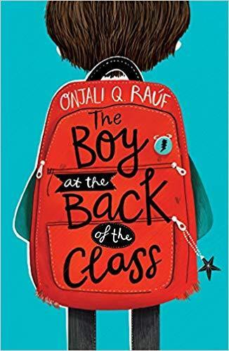  The boy at the back of the class by Onjali Rauf | - Identity  - Relationships  - Equality  - Diversity  - Rights  - Responsibilities  - Resilience  - Change
Summary
The Boy at the Back of the Class is a child's perspective on the refugee crisis, highlighting the importance of friendship and kindness in a world that doesn't always make sense.
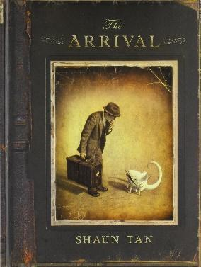  The Arrival by Shaun Tan | - Identity  - Relationships  - Equality  - Diversity  - Rights  - Responsibilities  - Resilience  - Change  - Power
Summary
The Arrival tells a universal story of immigration. The story is about a man leaving his home to find work and support his family, whose home has apparently become unsafe.
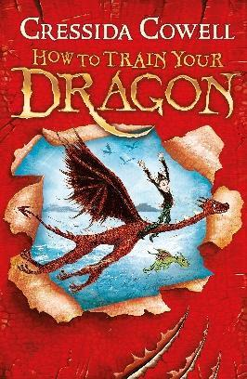  How to Train you Dragon by Cressida Cowell | - Identity  - Relationships  - Equality  - Diversity  - Resilience  - Rights  - Responsibilities  - Change  - Power
Summary
Hiccup Horrendous Haddock the Third is a smallish Viking with a longish name. Hiccup's father is chief of the Hairy Hooligan tribe which means Hiccup is the Hope and the Heir to the Hairy Hooligan throne - but most of the time Hiccup feels like a very ordinary boy, finding it hard to be a Hero.
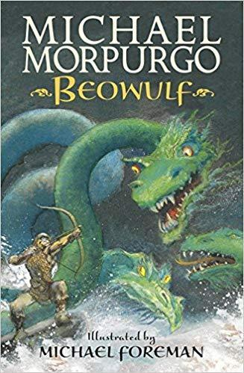  Beowulf by Michael Morpurgo | - Identity  - Relationships  - Equality  - Diversity  - Resilience  - Rights  - Responsibilities  - Change  - Power
Summary
In fifth-century Denmark, a murderous monster stalks the night, and only the great prince of the Geats has the strength and courage to defeat him.
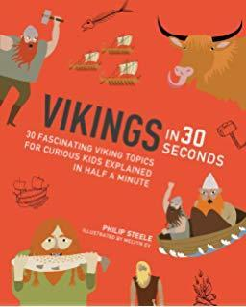  Vikings in 30 Seconds by Philip Steele | - Identity  - Diversity  - Equality
Summary
Vikings in 30 Seconds is an introduction to one of the world’s most fascinating cultures. Children will discover all about these amazing warriors, including where they came from, their incredible skill as boat builders and seafarers and how they traded with and settled in other lands.
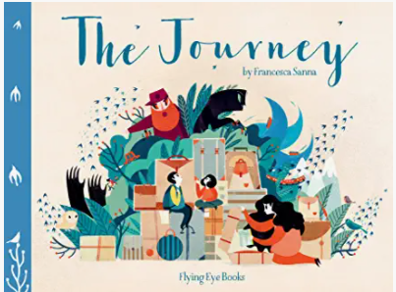  The Journey by Francesa Sanna | - Identity  - Relationships  - Equality  - Diversity  - Rights  - Responsibilities  - Resilience  - Change  - Power
Summary
What is it like to have to leave everything behind and travel many miles to somewhere unfamiliar and strange? A mother and her two children set out on such a journey; one filled with fear of the unknown, but also great hope.

