Diversity Reading Spine
Year 5 & 6 - Cycle B
Text | PHSE Concept
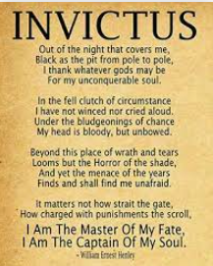  Invictus by William Ernest Henley | - Identity  - Diversity and Equality  - Rights and Responsibilities  - Resilience  - Power
Summary
This poem is about courage in the face of death, and holding on to one's own dignity despite the indignities life places before us.
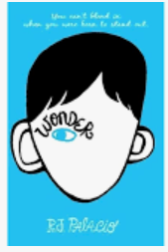  Wonder by R.J Palacio | - Identity  - Diversity and equality  - Relationships  - Rights and responsibilities  - Resilience  - Power
Summary
August, a boy with a facial disfigurement, begins school for the first time. We follow his trials and tribulations as he navigates friendship and bullying.
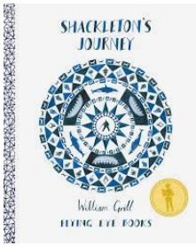  Shackleton’s Journey by William Gill | - Identity  - Resilience  - Risk and safety  - Relationships  - Career
Summary
A non-fiction text detailing the inspirational adventure of Ernest Shackleton as he tries to explore Antarctica whilst keeping himself and his crew alive.
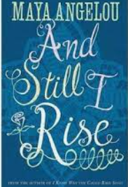 Still I Rise by Maya Angelou | - Identity  - Diversity and equality  - Resilience  - Rights and responsibilities  - Power
Summary
A powerful poem about self-love and self-acceptance. The speaker celebrate their ability to ‘rise up’ despite facing difficulties.
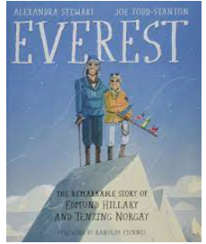  Everest by A. Stewart and T. | - Identity  - Risk and Safety  - Relationships  - Diversity and equality  - Career
Summary
A non-fiction text about the first 2 men to conquer Mount Everest, Tenzing Norgay and Edmund Hillary.
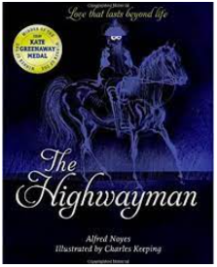  The Highwayman by Alfred Noyes | - Identity  - Relationships  - A healthy balanced lifestyle  - Risk and safety  - Power
Summary
A tragic love story between two people.
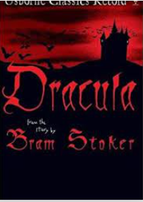  Bram Stoker’s Dracula by Usborne Classics Retold | - Identity  - Relationships  - Risk and Safety  - Resilience  - Power
Summary
A classic tale about the defeating the forces of evil and holding true to each other.
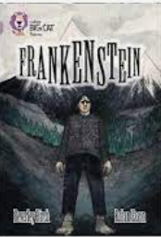  Mary Shelley’s Frankenstein by Big Cat Books | - Identity  - Relationships  - A healthy balanced lifestyle  - Diversity and equality  - Rights, responsibilities, and consent  - Power
Summary
Frankenstein by Mary Shelley looks at what happens when one man decides to play God. His actions ultimately lead to his own downfall.

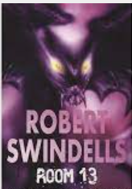  Room 13 by Robert Swindells | - Identity  - Relationships  - Resilience  - Power
Summary
A group of Bradford school children on a trip to Whitby discover an evil presence in their hotel and try to defeat it.
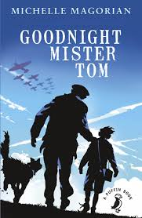  Goodnight Mister Tom by Michelle Magorian | - Identity  - Relationships  - Rights and Responsibilities  - Diversity and Equality  - Resilience  - Power
Summary
A young boy is sent away to the countryside during WW2 where he placed in the care of an elderly man.
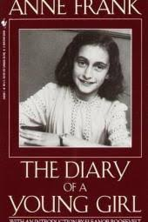  Diary of a Young Girl bu Anne Frank | - Identity  - Power  - Diversity and Equality  - Relationships  - Risk and Safety  - Resilience  - Rights and Responsibilities
Summary
A young girls diary detailing her life in Nazi occupied Netherland’s during WW2.
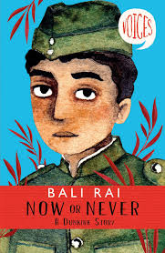  Now or Never by Bali Rai | - Diversity and Equality  - Identity  - Relationships  - Resilience  - Power  - Rights and Responsibilities
Summary
A young Indian soldier experience during WW2 as he faces danger and prejudice.
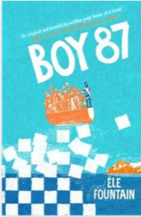  Boy 87 by Ele Fountain | - Identity  - Relationships  - Diversity  - Equality  - Rights  - Change  - Resilience  - Power
Summary
Set in an unnamed country, this is a timely and important book which illuminates the realities of life as a refugee
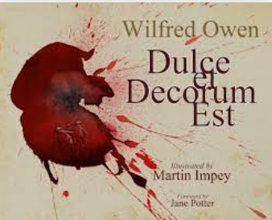  Ducle es Decorm est by Wilfred Owen | - Identity  - Relationships  - Rights  - Responsibilities  - Resilience
Summary
Illustrating the brutal everyday struggle of a company of soldiers in WW1. The poem focuses on the story of one soldier's death, and discusses the trauma that this event left behind.
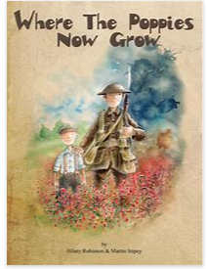  Where the poppies now grow by Hilary Robinson | - Identity  - Relationships  - Resilience  - Rights  - Responsibilities  - Diversity  - Equality
Summary
Childhood friends, Ben and Ray, find their innocent war games become real as the Great War rages around them. Set during the First World War, Where the Poppies Now Grow takes readers on a journey of friendship set against a changing landscape of innocence, of war and then finally, of peace.
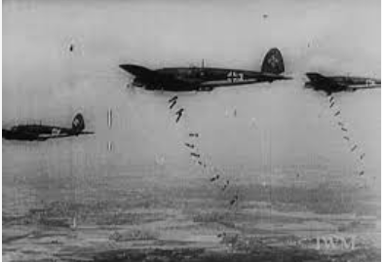  Black Saturday by Len Smith | - Relationships  - Resilience  - Safety  - Diversity  - Equality
Summary
A poem based around the Blitz of London during WW2. A descriptive poem describing the peoples perspective as they live through one terrifying evening.
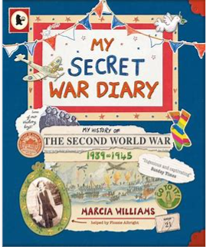  My Secret War Diary by Marcia Williams | - Identity  - Relationships  - Resilience  - Rights  - Diversity  - Equality
Summary
A fascinating diary account of the Second World War, as seen through the eyes of a young girl.

