EYFS | 30-50 months:  - Uses various construction materials.  - Realises tools can be used for a purpose.  40-60 months:  - Understands that different media can be combined to create new effects.  - Constructs with a purpose in mind, using a variety of resources.  - Selects appropriate resources and adapts work where necessary.  - Selects tools and techniques needed to shape, assemble and join materials they are using.
 | Autumn | Spring | Summer
Nursery | Helping Hands – colours  Finger prints , hands – messy play  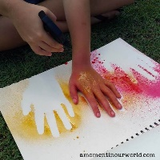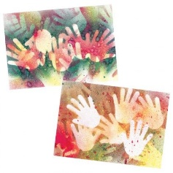  - Exploring painting with hands creating different effects – hand prints and hand stencils using sprays with readymix  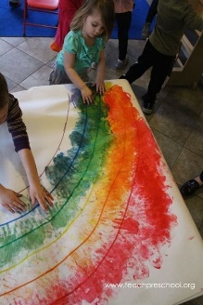  - NHS rainbows – Children look at the colours in the rainbow and discuss – do they know how to make different colours?  - Explore mixing a colour using hands by overlaying two primary colours  - Drawing rainbow shapes using different tools – colouring pencils, charcoals, pastels etc  - copying the colours they can see in the rainbow and creating a rainbow collage  - Large canvas children create a handprint rainbow  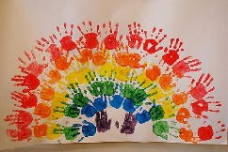 | • Move It – Jackson Pollok inspired splatter art  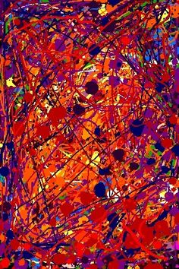  • Colour mixing through splatting, flicking, and mark making  • Exploring warm and cold colour palettes through moving paint  • Explore monochrome through moving paint  • Marble painting- rolling | Secret Garden - Bees  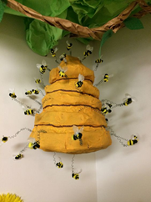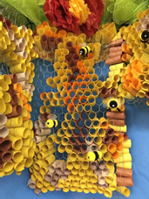  - Bee drawing – oil pastel colours  - honeycomb printing with bubble wrap- yellows, oranges – browns  - Class group activity- making paper mâché beehive  - rolling paper and weaving into chicken wire – with support to make honeycomb  - individual – paper mâché bees using yellow tissue paper  - Painting black on bees  - adding to hive using wire  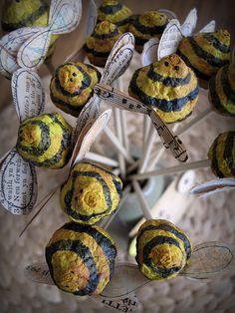

EYFS | 40-60 months:  - Understands that different media can be combined to create new effects.  - Constructs with a purpose in mind, using a variety of resources.  - Selects appropriate resources and adapts work where necessary.  - Selects tools and techniques needed to shape, assemble and join materials they are using.  ELG:  - They safely use and explore a variety of materials, tools and techniques, experimenting with colour, design, texture, form and function.
 | Autumn | Spring | Summer
Reception | Helping Hands – people- hands- artist – Andy Warhol printing 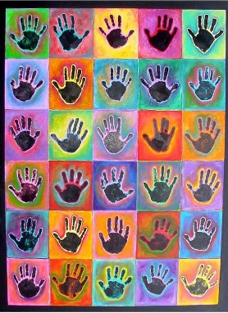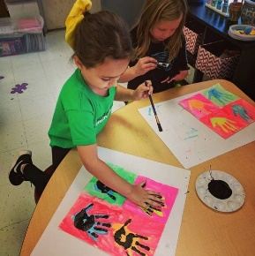  - Drawing round hands  - Exploring painting with brushes – how to hold a paintbrush – experimenting with brush strokes lines and patterns  - Exploring colours looking at Andy Warhol POP art- painting background of tile – let dry  - Differentiate here- some children may be able to draw round their hand on painted background and then paint a different colour inside their drawing using small brushes or they can paint their hand and create a handprint on their background instead  - Paint hand black and print black handprint on tile laying on top of coloured handprint | - Move It- Alexander Calder Kinetic art  - 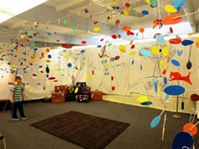  - Children explore how to create different patterns and marks through actions using paint  - Spin painting on turning wheel  - Bottle swinging painting  - Marbling  - Exploring the primary colours and mixing secondary colours  - Teacher and children work together to create a moving mobile using pieces of their work cut into shapes | Secret Garden – butterfly  Artist - Damien Hirst  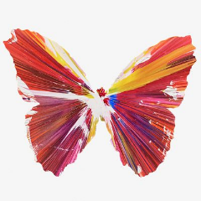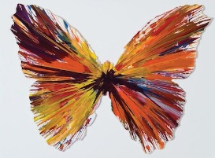  - Drawing butterfly wings close up focusing on lines and shapes in wings  - Explore Damien Hirst symmetry- butterfly painting through folding paper and printing and exploring mark making tools and creating butterflies by dragging paint- using symmetry  - Close up wing drawings using black oil pastels and watercolour 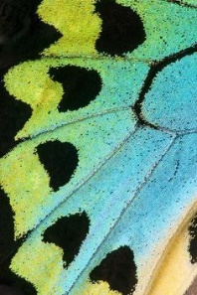  - Cutting butterflies out of wing paintings (photocopies) 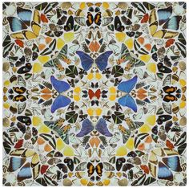  - Damien Hirst patterns – create giant collage on A2 class canvas using butterfly wings sticking down with PVA

KS1 | Use drawing, painting and sculpture to develop and share their ideas, experiences and imagination, using a range of materials creatively to design and make products. Develop a wide range of art and design techniques in using colour, pattern, texture, line, shape, form and space. Learn about the work of a range of artists, craft makers and designers, describing the differences and similarities between different practices and disciplines, and making links to their own work.
 | Autumn  The Great Food Journey | Spring  Great Leaders | Summer  Just the tickert
Year 1 & 2  Cycle A | Collage and Watercolour painting 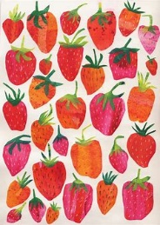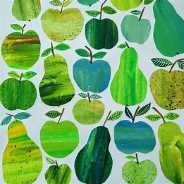  - Observational drawing of different fruits and vegetables  - Explore making different shades od watercolour using less and more water  - Explore different water colour techniques such as- wax resit, wash, wet on wet, wet on dry, cling film, salt, blotting  - Create different sheets of abstract watercolour experiments  - Combine different coloured papers cut out shapes to make fruit collage  Artist: Tracy English | Painting  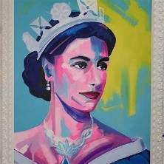.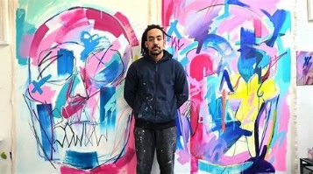  - Observation drawing of crown exploring shape and line  - Exploring colour theory – primary, secondary and complementary colours through mark making  - Pop art painting of crown – using painting techniques style of artist create background  - Paint crown on top in complementary colour using mark making techniques  Artist/Designer: Tim Fowler | Printing  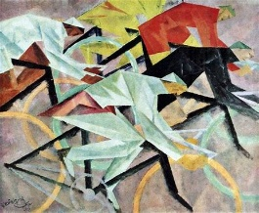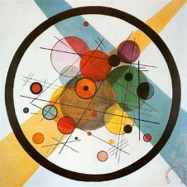  - Drawing bike wheels – different kinds of transport and movement in art  - Exploring circles through printing with recycling  - Monoprint circles  - Drawing into polystyrene and cut out to make a stamp then repeat print  - Create an abstract repeat print combining monoprint and stamping -representing movement  Artist: Lionel Feininger/ Kandinsky
Art  1/ 2  Cycle B | Little explorers- Marbling and painting  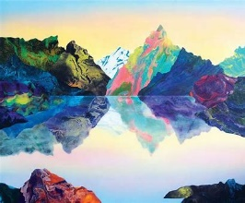  - Observational drawing landscapes  - Exploring warm colours and cold colours through mark making  - Experimenting with marbling  - Using abstract pieces to create landscape using collage  Artist- Kate Shaw | Dungeons and Dragons  Sculpture  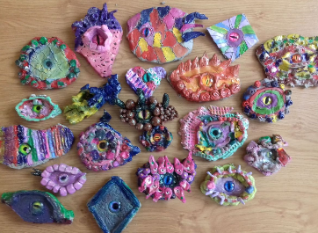  - Drawing close up dragon eyes and apply shade  - Experimenting creating low relief textures in clay using mark making and clay tools  - Build scales using score and slip onto clay base around marble eye  - Add textures using mark making tools  - Paint details onto clay eyes  Artist – Tim Jeffs | Adventures on the high seas  Printing  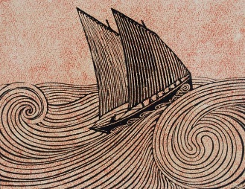  - Using line drawing to create crashing waves  - Drawing waves into polystyrene tile to create wave impression in printing plate  - Creating wave print in style of artist  - Artist – Rene Quillivic
Ongoing | Planning, developing and reviewing.  - Ask and answer questions about your starting points  - Try things out and change your mind  Say what you are pleased with in your work and what you would change another time.  Drawing  - Draw using pencils, crayons, chalks, felt tips.  - Experiment with colouring over areas to make darker.  - Show pattern and texture using lines, dots and make rubbings using pencil and wax crayon.  - In observational drawings make careful choices about size and colour.

KS2 | Create sketch books to record their observations and use them to review and revisit ideas. Improve their mastery of art and design techniques, including drawing, painting and sculpture with a range of materials. Find out about great artists, architects and designers in history.
 | Autumn  Stone Age | Spring  Romans | Summer  Ancient Egypt
Year 3 & 4  Cycle A | Painting  - Use a range of brushes sizes purposefully  - Use black to create tones and white to create tints with control  - Produce textures using brush techniques  - Use colour to create mood.  - Use thinner and thicker paint for effect  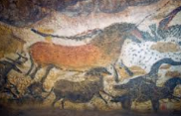  Artist: cave painting at Lascaux | Collage figures  - Drawing figures- proportions / figures in movement  - Research artist create mood board exploring figurative drawing and collage using limited colour palette  - Prepare materials for collage by painting washes over newsprint, collecting magazines, cardboard and paper packaging and by collecting rubbings of textures. Collect fabric (e.g. old clothes)  - Cut and tear papers and fabric and arrange before gluing down.  Artist: Nancy Spero  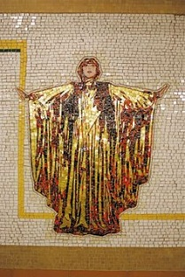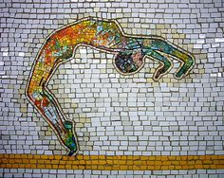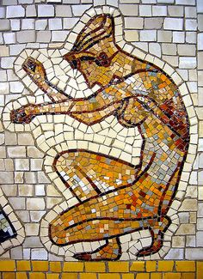 | Sculpture  - Drawing from Egyptian pots- patterns and shapes  - Build base using balloon and cup- masking tape  - Apply paper mache smoothly over base  - Paint using bold colours in style of Grayson Perry  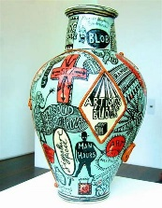  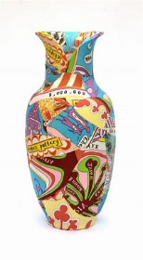  Artist: Grayson Perry
3 / 4  Cycle B | Prehistoric park- Clay and watercolour painting 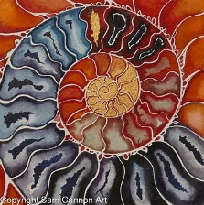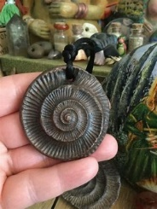  - Drawing spiral ammonites and applying shade  - Exploring watercolour techniques  - Applying watercolour to spiral  - Adding colouring pencil details  - Rolling clay and twisting into ammonite fossil  - Using tools to draw details into fossil  - Varnish using PVA  Artist- Sam Cannon | Save Our Planet  Drawing - Perspective drawing trees  - Observational drawing branches and trees  - Creating texture using shading techniques  - Exploring creating distance in a drawing through shading  - Creating forest drawing in style of Antony Browne  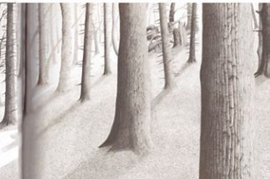  Artist – Antony Browne | The Gift of the Nile  Printing  - Drawing Egyptian patterns  - Drawing Klimt inspired patterns into polystyrene tile  - Printing in metallics onto fabric and paper  Artist- Gustav Klimt  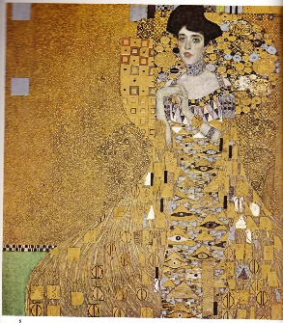
Ongoing | Planning, developing and reviewing.  - Use sketch books to explore the work of artists and crafts people and to practise and refine techniques  - Plan work, review work and make changes as you work.  - Use artistic language: portrait, still life, seascape, landscape, city scape, abstract  - Ask and answer questions about your starting points  - Try things out and change your mind  - Say what you are pleased with in your work and what you would change another time.  Drawing  - Use light lines for initial sketch so lines do not need to be rubbed out in order to make changes.  - Use a range of pencil grades to create line, tone and texture.  - Use tone to show light and shadow  - Show accuracy in size and proportion in observational drawings.

KS2 | Create sketch books to record their observations and use them to review and revisit ideas. Improve their mastery of art and design techniques, including drawing, painting and sculpture with a range of materials. Find out about great artists, architects and designers in history.
 | Autumn  Space | Spring  After the heartbreak  Refugees | Summer  Magic, monsters and mayhem  Vikings and Anglo Saxons
Year 5/6  Cycle A | Collage and Print  - Drawing lunar landscapes experimenting with shading techniques to create texture  - Creating abstract backgrounds using monoprint techniques  - Using monoprints to create lunar landscape  Artist: Max Ernst  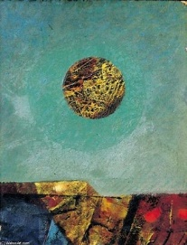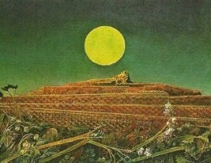 | Painting  - Continue using the 2 pot method of watercolour  - Experiment with watercolour, exploring intensity of colour to develop shades.  - Know how to show reflections.  - Choosing the appropriate brush or tool for the task.  - Using the appropriate colours to reflect the mood/purpose of the painting-  - Apply techniques to coffee painting inspired by Refugee Art Project  Artist: L. S. Lowry  Refugee Art Project  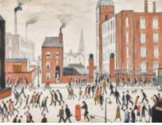  Cityscapes – local architecture | Clay  - Roll clay using pieces of wood to ensure even thickness.  - Make a tile and add decorative pieces joining by score and slip method using water.  - Make and use slip to join smaller, delicate pieces.  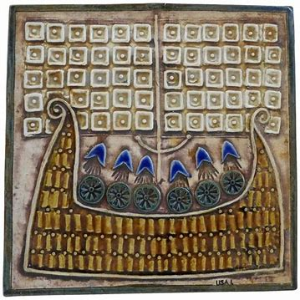
Ongoing | Planning, developing and reviewing.  - Develop and imaginatively extend ideas, collecting ideas, sketches and resources and present imaginatively in a sketch book.  - Comment on artworks using visual language.  - Begin to use terms for art movements.  Drawing  · Use tone to show light falling in different directions.  · Show perspective in objects in the foreground and background.  · Using line, tone, shape and colour to represent figures and forms in movement.

KS2 | Create sketch books to record their observations and use them to review and revisit ideas. Improve their mastery of art and design techniques, including drawing, painting and sculpture with a range of materials. Find out about great artists, architects and designers in history.
 | Autumn  Portraits  Onnly the brave | Spring  Friend or foe?  3d sculpture masks | Summer  World War 2
Year 5/6  Cycle B | Shackleton – Printing, drawing and painting  Antarctica map  - Using shading techniques to create a value chart exploring tone  - Research artist Derek Lerner and create a mood board experimenting with lines, shapes and tone in blue colouring pencils, oil pastels and blue pens  - Mix a blue monochromatic colour palette using tempera paint  - Experiment with shapes and patterns through mono printing  - Create a mono print background  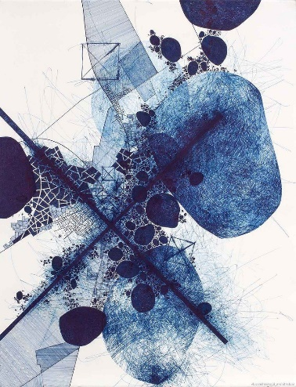  - Apply drawing skills in paint and pens to create their own Antarctica map  - Evaluate the process  Artist – Derek Lerner | Sculpture – Creating 3d masks.  - Research Paula De Prado and their use of design to create a variety of masks –  - create a mood board.  - Create and build the base for the mask.  - Build mask using a frame and mod roc  - Add additional features using cardboard and wire.  - Use acrylic paint to add details to the mask.  - Evaluate the product.  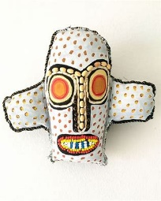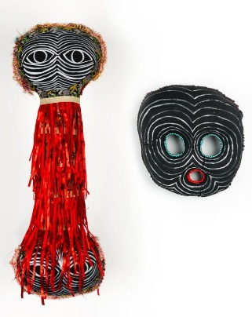 | Painting/ digital art  Perspective painting  - Create distance in a drawing using vanishing point  - Research war artists and how they create atmosphere and mood in their work- what are they trying to say through their work- such as Henry Moore, Paul Nash, Jacqueline Hurley, Guy Catling  - Discuss how Jacqueline Hurley has use perspective in her paintings  - Explore monochrome colour palette in watercolour  - Create distance in a painting  - Apply medium to paint to thicken and use this to build out poppy details of painting  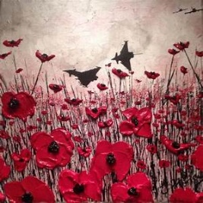  OR Roman Halter ? Hallocaust portraits ??  Digital art- Guy Catling – could this be an enritchment day?  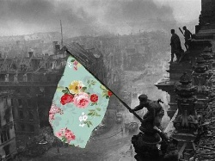
Ongoing | Planning, developing and reviewing.  - Develop and imaginatively extend ideas, collecting ideas, sketches and resources and present imaginatively in a sketchbook.  - Comment on artworks using visual language.  - Begin to use terms for art movements.  Drawing  · Use tone to show light falling in different directions.  · Show perspective in objects in the foreground and background.  · Using line, tone, shape and colour to represent figures and forms in movement.

