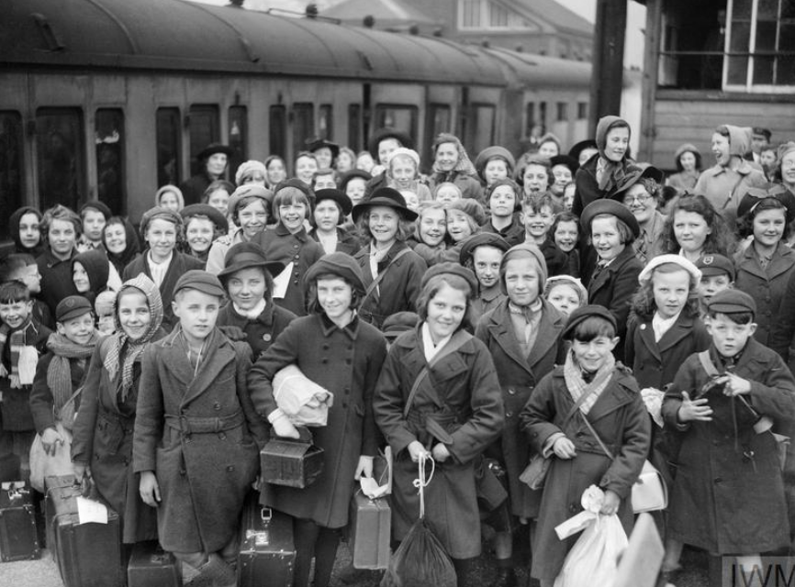

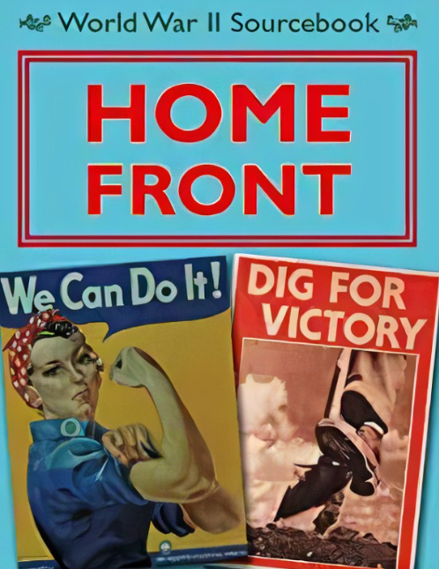

History/ Geography

In Geography we will focus on the geographical locations of countries involved in WW1 and WWII.

In History, we will focus on how WWII changed the UK. This will begin with a focus on the effect of WWI on Europe, how Hitler rose to power, what life was like on the home front, and what life was like for evacuees.

We will also learn about the Holocaust.

**PSHCE – Consent and healthy relationships**

The main focus will be earning about what consent is. We will also learn about marriage and civil partnerships. Later in the term we will learn about puberty and how we change.

**Maths**

As well as continuing to develop our mental arithmetic skills and building on our knowledge of Fractions, Decimals and Percentages, we will be learning about position and directions, shape and statistics.

Y6 children will complete their SATs assessments WC 9th May.

**English**

In whole class reading, we will be reading Goodnight Mr Tom – a book about an evacuee in WWII. We will be developing our ability to make inferences.

We will be performing poetry about WWII and writing portal stories with a historical context.

Our non-fiction focus next half term will be diary writing and we will focus on Anne Frank’s diary and write dairy entries set in WWII.

**Art / DT**

In art we will research Jaqueline Hurley and create some greyscale poppy paintings. In DT, we will design and make Anderson shelters with a programmed air raid siren.

**Science - light**

We will learn about how we see and how light travels. We will also investigate which material is best for a blackout blind. In Summer 2, we will do a Science project to help us revisit prior learning and consolidate it.

**PE**

This half term, we will be developing our gymnastic skills in PE. In Summer 2, we will be developing our dance skills.

**RE – Kingdom of God and What would Jesus do?**

We will be making connections between texts and the concept of the kingdom of God. We will study the Lord’s prayer, The Parable of the Great banquet and hymns such as The Lord of the Dance. We will also learn about Christian interpretations of biblical texts and how they use this to influence their way of life.

**Computing**

In Computing, we will be learning about inputs and outputs and using them to simulate and control physical systems. We will be programming microbits. We will also learnt to create simple 3D graphics using a CAD app.

Year 5/6 – SummerTerm

World War II

g

**Journey Home**