Maths **–** One of our main focuses in Maths will be on learning mental strategies to add and subtract. As well as this, we will be learning developing our understanding of adding and subtraction number up to one million. We will start the term with a focus on place value. We then move on to adding and subtraction using a range of physical resources and formal written methods. We finish the term by starting to look at multiplication and division with a focus on formal written methods such as bus stop method.

**Science** – In autumn 1, we are looking at forces. We will investigate gravity and how things fall to the ground. In addition, we will look at friction and what causes it. In Autumn 2, we are looking at Space. We will look at the different planets and their orbit around the sun.

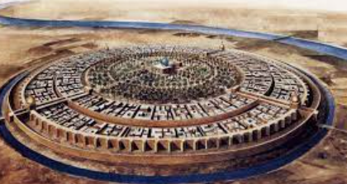

English

We will start the term developing vocabulary through the poem: ‘I am a Muslim Woman’by Jenn Zaghloul. We will be reading a nonfiction text around the History of the Islamic civilization. In reading, we will be reading Cosmic.

**– Y5/6 Autumn Term**

Computing – IN computing, we are going to be creating a learning guide. They will make a welcome screen as well as adding in messages and broadcasting in Sprites

Art – Our Art links to our space topic in Science. We will be cerating lunar paintings using different shading skills. We will have a focus on the Artist Max Ernest.

DT – In DT, we will be making moon buggies.

**Geography** – Our big focus this term is on Iraq. We will looking at the capital city of Baghdad as well as the physical and human features of the country compared to Bradford. We will also be finding out where Baghdad is in the world on a range of maps.

**History** – We are looking at the history of the Islamic Civilisation. We will look at the importance of the Silk road and how they impacted the development of science and medicine.

Music – IN music we will be developing the skills of tempo with instruments. We will discuss different terminologies such as Largo and Allegro

**RE** – In Religious Education, we will be looking at Islam in Autumn 1. Our question is **‘What does it mean for Muslims to follow God?’**. In Autumn 2, we are looking at the creation and Fall in Christianity. Our question is **‘Creation or Science: conflict or complimentary’.**

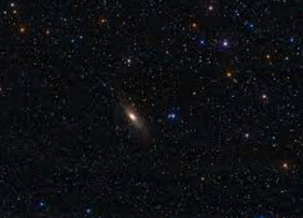

PE – Throughout our whole curriculum work, we will be aiming to be as active as possible to help us stay healthy. We will be developing this through invasion games