School Visits Policy

Chris Tolson

Introduction

Purpose:
School visits enrich and enhance learning opportunities for the children in school. They allow children to experience different contexts and settings that stimulate their imagination. School trips make a major contribution to the acquisition of knowledge and development of skills. Studies of the natural and man-made world, the present and past, science and arts, language and music can all be enhanced outside the classroom. Adventure activity and sports skills form the foundation of life-long interests, as well as addressing the issues of good health and obesity. It also helps pupils become more risk aware and prepares them for their future working lives.

Aim(s):
- Keep all children and staff safe at all times.
- Allow children the opportunity for visits to enhance learning.
- Bring learning to life.

Procedures and practice

Local area activities
- For local area visits – within walking distance or a ten minute minibus journey of school, staff will complete the local area visit form and risk assessment, on Evolve a week before the visit.
- Staff should ensure pupils understand their responsibility in taking reasonable care for their health and safety.
- They must take firm action to ensure pupils use equipment appropriately and are not allowed to jeopardise their own safety or that of others.
- Staff must ensure the building and grounds are secure at all times with particular reference to doors and gates.
- Any hazards must be reported immediately to the school office.

Out of school activities

- Staff must follow the 1st part of Educational visits flow chart and complete the administrative tasks, at least four weeks ahead of the trip. They must then follow the complete flow chart, which can be found in electronic form in educational visits folder on the school network. All documents must be uploaded to evolve for checking by the EVC and then the HT for final approval. Approved documents will be saved on Evolve.
- This must be authorised and approved by the Head Teacher or in the case of residential visits, the Chair of Governors and designated person from the Academy Trust.
- All parents must sign a local visit consent form to consent to their child attending the organised visit.
- Where there are additional behavioural, medical or health needs parental support for the trip may be requested and individual risk assessments for the child must be completed and attached to the Evolve form.
- Additional consent forms are required for visits out of the local area and residential visits – these must also be attached to forms on Evolve.

Roles and responsibilities
Governors:
Will support the school in requesting parental support for visits where there are children with additional behavioural, medical or health needs. Approve visits through the use of Evolve.

Headteacher:
The Headteacher will authorise all visit applications on Evolve before allowing any visit to go ahead.

Subject Lead (EVC):
EVC will check the risk assessments and the completed Evolve forms before forwarding them to the Headteacher for authorisation on Evolve.

Teachers:
Teachers will complete the risk assessment applications on time and make any changes as requested before resubmitting them. All risks will be considered. Where there are additional behavioural, medical or health needs further advice will be taken from SLT regarding parental support on the visit and individual risk assessments will be carried out. Teachers will share authorised risk assessments and arrangements with any staff that are attending a visit before the day of the visit.
Pupils:
Pupils will take care to avoid risk and behave as they would in school, at all times. Pupils of St James’ are expected to treat people, who they might meet on a visit, with respect and courtesy.

Parents:
Parents will support school and attend visits if requested to support their child with additional behavioural, medical or health needs.

Concluding notes
Monitoring and review:
All risk assessments will be evaluated within one month of return from the visit.

Appendix 1 – flow chart to be followed when organising an educational visit
Appendix 2 – Risk Assessment example

This policy will be reviewed on a two yearly basis or earlier if legislation should change.

Date for review: January 2025

Appendix 1
Non-residential Educational Visit Proposal Form
This flow chart will be followed by any staff arranging an educational visit.
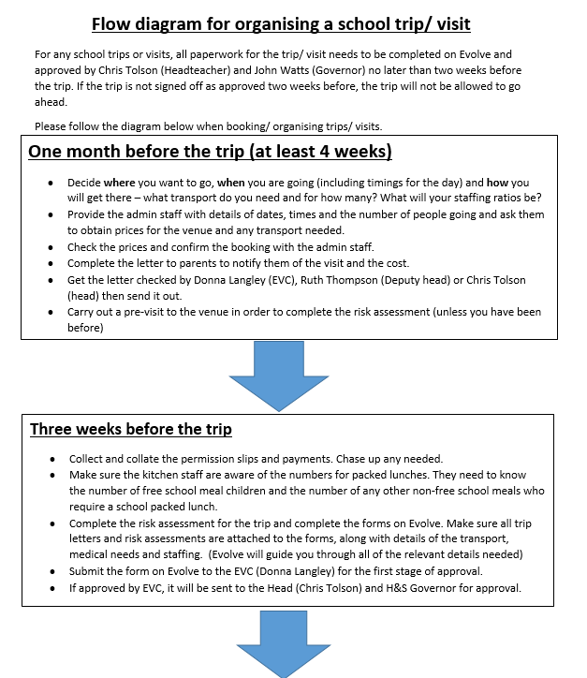
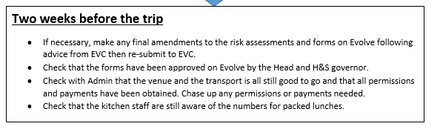
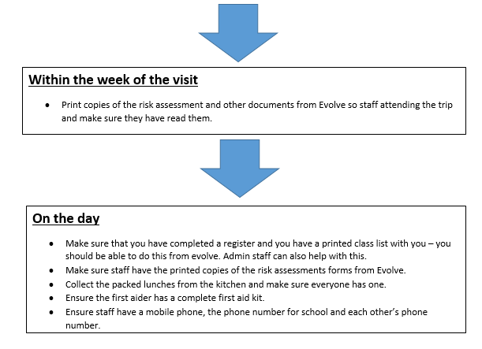

Appendix 2
Risk Assessment

Costs:
Proposed total cost of trip:
Amount to be taken from parent contributions:
Proposed cost of visit to school:

Pupils:
Special considerations: (e.g. SEN, N2E, Medical etc.)

 | Likelihood
Consequence |  |  | Unlikely | Possible | Likely
 | Slightly harmful |  | 1b Trivial | 2b Acceptable | 3b Moderate
 | Harmful |  | 1c Acceptable | 2c Moderate | 3c Substantial
 | Extremely harmful |  | 1d Moderate | 2d Substantial | 3d Unacceptable
Risk level |  | Control
Trivial and Acceptable |  | No action required – Keep note that the risk has been identified as trivial in case it is brought up in a civil claim.
Moderate |  | If it is reasonably practicable to undertake some action to reduce the level of risk, then this should be done.  If the risk is moderate because the consequences are extremely harmful it is unlikely that there can be any further reduction without significant effort.  Ensure that there is a suitable system in place.
Substantial and Unacceptable |  | Action must be taken to remove or reduce the risk.  If action cannot reduce the level or remove the risk, the activity should not be undertaken.  If this level arises as a result of a Decision Making assessment, the activity should cease immediately.

Hazard | Effect (e.g. Head injury, fatal, injury) | Risk Rating (e.g. 1C) | Control (What will you do?) | Responsibility

Assessment by: |  | Signature: |  | Date:

