Science Policy

Overview

At Academy St James we love science because it teaches our children about the world around them. Our children are naturally curious and we harness their sense of wonder to drive our science learning.

Aims/Objectives

We live in an increasingly scientific and technological age where children need to acquire the knowledge, skills and understanding to prepare them for life in the 21st century. Through the framework of the National Curriculum 2014, science aims to:

- help children make sense of the world around them
- develop our children’s curiosity
- develop our children’s ability to notice, observe, describe, compare, measure and explain
- encourage our children to form their own opinions based on evidence and communicate this to others
- encourage wondering and questioning
- create learners who are comfortable with science and excited by discovery
- be purposeful and relevant to our children
- give children regular opportunities to work practically
- encourage our children to learn through investigations and enquiries
- engage and enthuse our children in STEM subjects
- teach children the skills and knowledge that could be used in a future career
- give our children the chance to explore and test new ideas
- give children opportunities to work collaboratively with other year groups, schools and companies
- access the world of science via the internet, films, books, museums, visits from scientists and outdoor experience

Foundation Stage

We teach Science in the Reception and nursery classes as an integral part of the topic work covered during the year. As the reception class is part of the Foundation Stage of the National Curriculum, we relate the scientific aspects of the children’s work to the objectives set out in the Early Learning Goals (ELGs), which underpin the curriculum planning for children aged three to five. Science makes a significant contribution to the objective in the ELGs of developing a child’s knowledge and understanding of the world, e.g. through investigating what floats and what sinks when placed in water.

Key stage one and two

In Key Stage 1 we teach Science as an integral part of the themed work covered during the year.

In Year 1 children learn about Seasonal Change, Plants, Animals and Everyday Materials across the year as well as focusing on each area in depth at different points in our themes. For example, in our Dungeons and Dragons topic we have a strong focus on materials and a secondary focus on animals through our study of real life dragons.

In Year 2 children learn about Living things and their habitats, plants, animals including humans and uses of everyday materials across the year as well as focusing on each area in depth at different points in our topics. For example, in our Great Food Journey topic we have a strong focus on Humans and Plants.

In KS2, science is taught as a discrete lesson and as part of our cross curriculum topics as appropriate.
Science has links with other areas of the curriculum including Geography, DT, English and M
Reading, Writing and Applying Maths in Science

At the Academy at St James, reading is at the heart of our curriculum and we encourage teachers to use high quality non-fiction and fiction texts to support learning and engagement. There is also a strong focus on teaching specialist scientific vocabulary throughout school and children are encouraged to use it when talking and writing about their learning in science. They should also apply their mathematical knowledge to their understanding of science, including collecting, presenting and analysing data.

We will encourage children to use academic talk within Science lessons that broadens and extends their scientific vocabulary – helping them to ‘talk like a scientist’. This will include vocabulary that is repeated across school e.g. compare, observe, explore as well as topic specific vocabulary e.g. inheritance, natural selection, insulator, conductor.

Assessment in Science

Assessment for learning is continuous throughout the planning, teaching and learning cycle. Our assessment of science is underpinned by Teacher Assessment in Primary Science (TAPs) guidance and resources developed by The Primary Science Teaching Trust. At the end of each year teacher’s make formal comment on each pupil’s progress in science on their end of year report.

In Science we use summative and formative assessment to support our judgements. We assess science every half term using a combination of:
- work in books
- understanding shown in each lesson
- Oral explanation of key concepts
- use of the correct vocabulary
- success in low stakes quizzing

Throughout school, we have adopted an evidence based approach to assessment which revolves around memory and retrieval practice. At The Academy at St James, we want children to successfully retrieve key knowledge, articulate concepts clearly and apply content across the curriculum and wider areas. We will use knowledge organisers to help collate and teach key knowledge to children which helps to structure progression across year groups. In addition, we will use low stakes quizzing and other retrieval practice activities at the beginning of each science lesson to recall and build on information.

Health and Safety

Practical work is at the heart of our Science curriculum. We want to make sure our children both have fun and are safe when they are learning. We refer to the ‘Be Safe Health and Safety’ book produced by the ASE and CLEAPSS when necessary.

- A risk assessment will be made, as part of the planning process, before any potentially dangerous scientific activity is undertaken.
- Children will be informed of any risks or hazards but will also be encouraged to assess and identify risks for themselves.
- Children will be shown how to use scientific equipment safely.
- Safety glasses will be used where appropriate.

What you do makes a difference and you have to decide what kind of difference you want to make” Jane Goodhall
Position:- Science Leaders
Date:- June 2022
Next review date:- June 2023

Reviewed and Approved by:- Governors
Date of meeting:- June 2022
Signature:- Miss H Rosenberg

Appendix 1

An example of our knowledge organisers used to help plan and deliver our science lessons across school. These have been developed with the support of Dixons Teaching School which incorporates evidence based practice from the EEF.
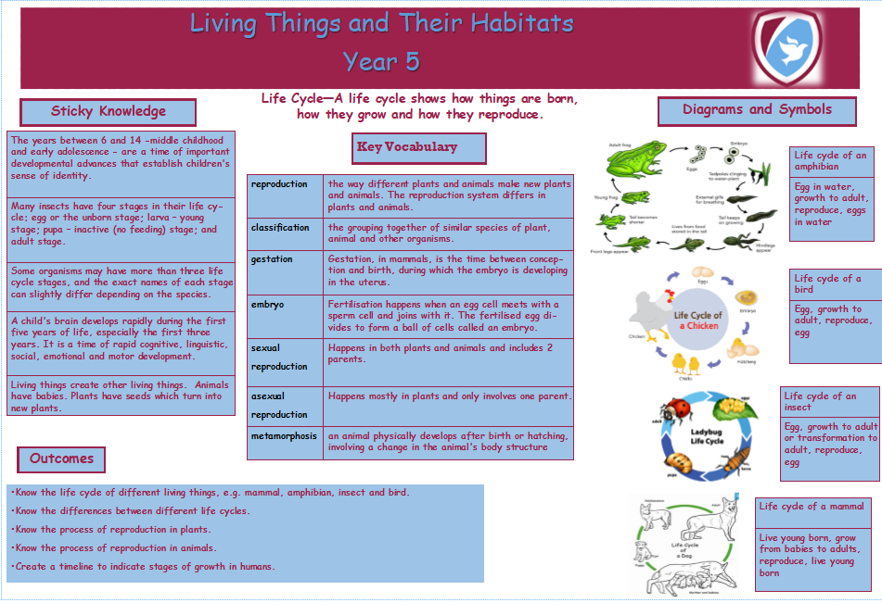

Appendix 2

Examples of our low stake quizzing activities to enhance memory and retrieval in out Science themes. These are supported by EEF evidence based research, Aiden Severs and Rosenshines Principles.
