Science – In Science, we will be exploring properties of materials. We will be investigating solids, liquids and gases. We will also be looking at how to separate mixtures and solutions. We will put all of this together to know how to clean dirty Viking water after a battle!

RE – In RE, we will be recapping on who God is to us and what makes a ‘good’ God. We will learn about how Christians show God’s characteristics in places of worship such as cathedrals.

Maths **–** In maths, we will be recapping on our knowledge of fractions, decimals and percentages in morning maths, alongside practising the 4 operations. We will also have a focus on measuring and drawing angles.

We will be applying all of our maths learning to reasoning and problem solving.

PE – Our Summer 1 focus in PE will be invasion games. We will be developing our knowledge on attacking and defending, building on concepts such as interception/marking and how to keep possession successfully.

Art/DT – We will be focusing on the use of clay in our art lessons to create a tile of a Viking longboat. We will use the score, slip, stick and smooth technique to make sure our clay is sturdy and ready to paint. In DT, we will be designing, making and evaluating our own 3D Viking longboats. We will complete research before designing and constructing.

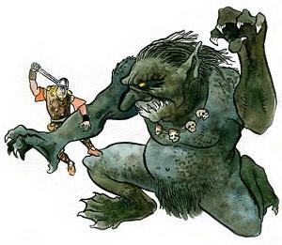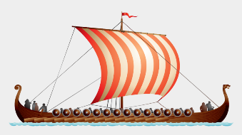

Computing – In computing, we will be writing our own algorithms and learning to program micro bics.

**Magic, Monsters and Mayhem – Y5/6**

English – In English, we will be starting the term looking at kenning poems to describe the Vikings. We will then move on to the story of Beowulf (it gets a bit gory!) before writing our own defeating the monster story. We will also be producing a non-chronological report all about the Vikings.

Geography /History – Our theme for the summer term is Vikings and Anglo-Saxons. We will be looking at which countries they came from, invaded and settled in for our Geography before comparing to other countries we have learnt about so far this year. In History, we will be looking at chronology to tell us about the time period of the Vikings and how many of their ways of living are still seen in our lives today.