Year 3&4 Reading Spine Cycle A
 | Autumn 1 | Autumn 2 | Spring 1 | Spring 2 | Summer 1 |  | Summer 2
Our Belief and Vison | At The Academy at St James we have books at the heart of learning. We use quality texts to inspire and drive all our learning.  We believe that children learn best when engaged with exciting and stimulating learning, allowing them to grow and develop into independent and resilient learners. In our school we support every child to reach their potential: Aspire, Achieve, Believe.  “The more that you read, the more things you will know. The more that you learn, the more places you’ll go.” Doctor Seuss
Our Values | Community  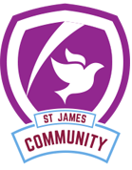 | Peace  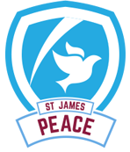 | Respect  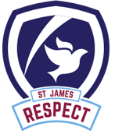 | Forgiveness  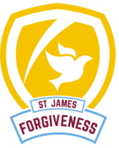 | Courage  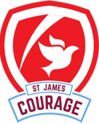 |  | Trust  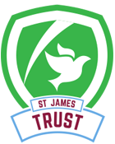
Themes | Prehistoric Park | Prehistoric Park | Under the surface | Under the surface | Beneath the Sands |  | Beneath the Sands
English | 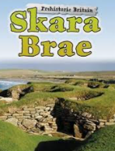 | 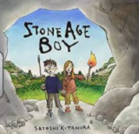 | The Hero of Pompeii | The Hero of Pompeii | 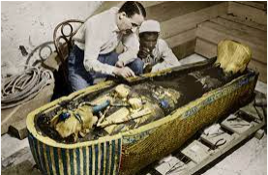  The Search for Tutankhamun | The God and The Pharaoh
Whole Class Reading | 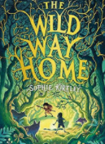 |  | 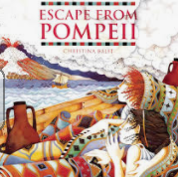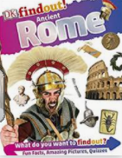 | 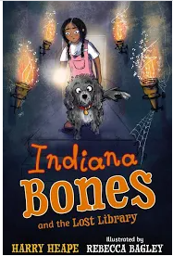 | 