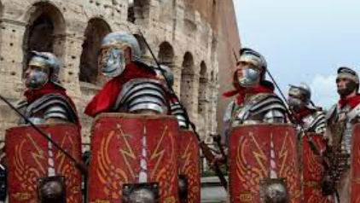

**Science** – IN Science we will be looking at states of matter. What a solid, liquid and gas is.



Maths – In maths we will have a small focus on place value, with a focus on rounding before moving onto Fractions. In fractions, we will be looking at what a fraction is, before moving onto fraction of numbers and fraction of objects.

**RE** – In R.E we will be carrying on with Gospel before starting our new work which is around salvation and the build up to Easter. Our key question is why do Christian call the day Jesus died as Good Friday.

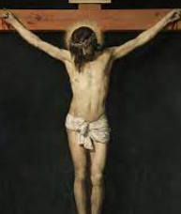

Computing- IN computing we will be creating a news report on fake news.

DT – In DT, we creating a pneumatic volcano.



Art – This half term, we will be creating a piece of Art that gives a sense of distance. We will use natural materials to build an idea of how to create the sense of distance in our drawings. Our Artist Link is Emily Carr.

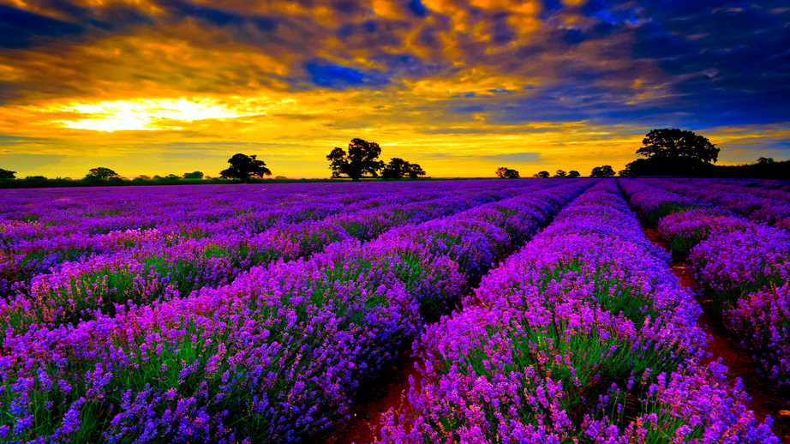

**Geography** – In Geography, we will be looking at where Rome is on a map and why it was a good place to build an empire. We will then move onto deforestation. We will discuss what it is, why it is happening and how we can stop it. 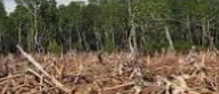

English – Our fiction is a conquer a monster story and we will be focusing on using:

* Show not tell sentences.
* Fronted Adverbs
* Setting description

This is on top of maintaining our focus on sentence structure and handwriting presentation.

In reading, our text is Paninis of Pompeii.

PE – IN P.E, we will be looking at modified striking a fielding games. We will fosses on ball hitting, catching and game play decision making. Year 4 will also carry on with swimming. Mr Wallis’s class will begin after February half term.

**History** – In History we will be having a focus on the Romans. We will learn about:

* How they started
* The impact they had on the UK
* What their society was like

This will be underpinned with work we do in reading around the way of life in Roman society.

**The Romans – Y3/4**