Curriculum Learning Guide
Maths

How is Maths taught at The Academy at St James?

Curriculum Intent
What do we want to achieve with our Maths curriculum?

At The Academy at St. James, we recognise that Maths is a creative and highly inter-connected discipline that is essential to everyday life and employment, as well as to the development of Science, technology and engineering. Our Maths teaching offers all learners a fun, practical, problem solving and reasoning approach to Maths, so that they become skilled, resilient, confident and curious mathematicians who care and are happy to discover things for themselves.
We believe that our carefully sequenced Maths curriculum provides learners with a foundation for understanding the world, the ability to reason mathematically and an appreciation of the beauty and power of mathematics.
Through a variety of arithmetic, reasoning and problem solving activities, we aim to develop:
- A positive attitude to Mathematics as an interesting and valuable subject
- Mathematicians who can calculate confidently using a variety of efficient mental and written strategies
- Quick recall of key facts
- An understanding of all areas of mathematics through a process of enquiry, reasoning and problem solving
- Confidence to express ideas fluently and to talk about mathematics using mathematical language
- Opportunities to explore and apply mathematics in depth in everyday life situations
Implementation
How will this be achieved?
Early Years Foundation Stage:
In EYFS the majority of learning takes place through provision. Adults develop children's next steps through planned enhancements and high-quality interactions which continually move the children's learning forwards. Adults facility play to support children to develop core concepts in a meaningful and purposeful manner. For example, developing comparative language whilst making snakes using playdough. Adults are able to identify and target misconceptions in the moment.

In Reception, the children have a daily maths lesson. This begins with a mental and oral starter. Following this the children then complete a Mr Muddle challenge. Mr Muddle is a wizard puppet who often gets in a muddle and needs the children's help. The Mr Muddle challenge is often linked to prior learning or a misconception which has been identified. The children are then able to discuss and articulate their knowledge and understanding. The main input is then delivered following the I do, we do, you do (in pairs) model.
Teaching Sequence Key Stage 2:
At the start of every lesson, the children will complete a set of arithmetic fluency questions which will focus on gaps identified in previous lessons and assessments, before taking part in daily mental Maths sessions, teaching and learning the key mental Maths strategies and key instant recall facts. The main lesson input will then consist of teacher input (I do, we do, you do model) using the relevant sentence stems and vocabulary before the children independently complete a task and reasoning challenges. Work will be marked according to the marking policy and the children will be given immediate feedback and intervention support when necessary.
Teaching Sequence Key Stage 1:
In KS1, the children take part in daily, whole class mental arithmetic sessions where they learn key counting skills and other key instant recall facts. The main lesson input consists of teacher input (I do, we do, you do model) using the relevant sentence stems and vocabulary. Any children who need provision are then able to develop the skills from this input through provision in the areas inside or outside the classroom. Other children will work independently or with an adult on fluency, reasoning and problem-solving tasks related to the input. 1:1 feedback will be provided in the lesson and any child with a misconception, will receive support to address it as quickly as possible.
Planning and Teaching
Each class teacher is responsible for the planning of weekly lessons in Mathematics for their class (using the provided planning format); ensuring written methods for calculations (following the calculation policy) are regularly practised in order for the children to become secure and confident in this.
Delivery of the Mathematics curriculum should provide children the opportunity to engage in practical activities, mathematics games and problem solving investigations. These activities can be done individually, in small groups or as a whole class if appropriate for all children. Opportunities to use ICT as a mathematics tool should be provided.
Lessons should be interactive and take into account the children’s different learning styles. Learning in the lessons should be clearly differentiated to meet the needs of the children. Where required, lessons and resources are adapted and scaffolded to ensure that every learner can access every aspect of our wide ranging, challenging and engaging mathematical offering.
In the Foundation Stage, a range of Mathematics activities should be provided for the children to access independently. All children should have access to daily adult led Mathematics Activity, in order to develop and strengthen their understanding of Mathematics. It is important for the children to see and use Mathematics in as many practical contexts as possible.
Throughout the whole school Curriculum, teachers should take advantage of cross-curricular links to Mathematics wherever possible.
Working Walls
Each classroom will display a working wall for Mathematics to support the children with their learning. The display will include key vocabulary, calculation posters and modelled examples of the current topic work. The purpose of the working wall is to support the children’s learning and to be a reminder of previous learning. It develops independent learning and it is not a traditional display.
Skills
In addition to a secure understanding of number, calculation and mental maths, there are other essential skills for high quality Mathematics learning, which include:
- Problem solving – developing strategies to solve a problem.
- Communicating – being able to explain their results verbally and in written form.
- Reasoning – being able to think logically and justify their ideas.
Regular opportunities to practise these outside the Mathematics lessons should be built in to other areas of the curriculum, as well as in the lessons themselves. They will also be included in Friday Flashback sessions.

Assessment
Our assessment of progress in Maths is robust to ensure that all children make progress and achieve their potential. Pre-unit assessments are carried out at the start of a unit to establish what the children know already and what they need to be taught next.
Through marking and feedback, teachers assess children’s understanding and provide the children with intervention where needed. Lessons are planned based on the assessment for learning.
Once a term, children in years 2 to 6 complete NFER or SATs papers, which generate a scaled score. Scores are tracked on FFT and used alongside teacher assessment to monitor progress. Question Level Analysis of the papers also enables teachers to identify gaps in learning as well as any misconceptions which need addressing.
Pupil progress is discussed with teachers in a meeting with SLT and progress is shared with parents/carers at Parents’ Evenings throughout the year. End of Year reports inform parents of progress in July.
Year 2 and Year 6 SATS results are analysed and appropriate measures will be taken to address any issues, which may have arisen.

Monitoring
SLT and the subject leader will monitor mathematics regularly throughout school. Monitoring will be carried out through:
- Learning walks
- Lesson drop ins
- Lesson observations
- Book scrutiny – in conversation with teachers
- Planning scrutiny – in conversation with teachers
- Assessment and analysis of data
Equal Opportunities
Mathematics at The Academy at St. James is taught with equal opportunities for all children throughout the school. It is important that:
- Our expectations do not limit pupil achievement.
- We set targets to meet the individual needs of each child and for them to be aware of their next steps in their learning.
- We aim to challenge and extend children to help them increase the need for independent thinking.
We use a full range of teaching and learning styles to ensure that all our children have the opportunity to gain Mathematics knowledge and understanding regardless to their gender, race, class, physical or intellectual ability.
Impact
What will outcomes for learners be?
Learners will:
• know more, remember more and understand more about Maths
• demonstrate a rapid recall of facts and procedures including key facts and multiplication tables
• show confidence in their ability to achieve in maths
• have the flexibility and fluidity to move between different contexts and representations of maths
• develop the ability to recognise relationships and make connections in maths lessons, deepening and consolidating their understanding of key concepts
• show mastery of mathematical concepts or skills and can show it in multiple ways, using mathematical language to explain their ideas
• understand the importance of and differences between their reasoning and problem-solving skills
• The majority of learners will achieve or exceed age related expectations in Maths

Contents of the following pages:
In order to fully map the progression in fluency, reasoning and problem solving, the teaching and planning of maths is based on the following progression documents:
- Long Term Plans
- Mental Maths Progression Document
- Learn By Heart Progression Document
- Progression in Calculations Document
- Expectations in Reasoning and Problem Solving Document

Year 1 LTP including counting and mental maths
 | Week1 | Week2 | Week3 | Week4 | Week5 | Week6 | Week7 | Week8 |  | Week9 | Week10 | Week11 | Week12
Autumn | Daily count to and across 100, forwards and backwards, beginning with 0 or 1, or from any given number |  |  |  |  |  | Daily Counting in 2s and 10s
 | Place value  read and write numbers from 1 to 20 in numerals and words |  | Geometry-2-D shapes as faces of 3D shapes 3-D shapes with flat faces Wk. 1 Cubes/ cuboids Wk. 2 Prisms/ pyramids |  | Place value and number  Wk. 1- Sort and count objects within 10 Wk. 2-Different representations of 10. Counting forward and backwards. Wk. 3- Numbers within 20. Introduce number lines. Recognising one more and one less. numbers within 20. Ordering numbers and comparing amounts <>= |  |  | Addition and Subtraction – number bonds within 20.  Adding and subtracting practically and pictorially. |  |  | Multiplication and division – 2 times table  Doubling and halving  Making connections between arrays, number patterns, counting in 2s…
Spring | Daily - Days of the week/ months of the year / counting in 2s and 10s |  |  |  |  |  | Daily counting in 5s / counting to and across 100 forwards and backwards.
 | Position and direction  Before, after, next, in front, behind,  Left, right, top, middle, bottom | Measures  lengths and heights [for example, long/short, longer/shorter, tall/short, double/half] | Place value and number  One more / less Comparing amounts | . Addition and Subtraction one-digit and two-digit numbers to 20, including zero |  | Multiplication and division – 10 times table |  | Measures – weight  Light / heavy / heavier than/ lighter than |  | Measures  -capacity  Full / empty / half full / less than / more than | Fractions  Half of a number |  | Consolidate/ revisit any areas from this half term.
Summer | Revise days of the week and counting in 2,5,10 |  |  |  |  |  | Revisit shape properties /
 | Measures – Time  O clock  Minutes, hours, seconds | Place value  Partitioning numbers 10 and 1. | Addition and subtraction in the context of money  Recognising the coins and notes  Comparing amounts of money <>= |  |  | Multiplication and division  5 times table  Sharing |  |  | Fractions  Half – number and shape  Quarter – number and shape |  | Measures – time  Revise o’clock and learn half past. |  | Revisit shape
Year 2 LTP including counting
 | Week1 | Week2 | Week3 | Week4 | Week5 | Week6 | Week7 | Week8 | Week9 | Week10 | Week11 | Week12
Autumn | Daily - Count in steps of 2,3 and 5 from 0 and in tens from any numbers, forwards and backwards. |  |  |  |  |  | Daily – number bonds to 20  Counting on and back in 2s
 | Place Value  Read and write numbers to 100 in numerals and words.  (arrow cards) |  | Geometry  Identify properties of 2D shapes – sides line of symmetry in vertical line. |  | Addition and Subtraction – recall and use add/ sub facts to 20 fluently and derive related facts to 100.  Begin to add/sub 2 digit number and 1s. |  |  |  | Multiplication and division  - 2 times table  - Write statements using x ÷ =  - Show multiplication is commutative but division is not. |  |  | Place Value  Recognise value of each digit in 2digit numbers.
Spring | Daily – bonds of 10 to make 100  Counting on and back in 10s from different starting points  Revise days of the week and months of the year. |  |  |  |  |  | Daily – counting on and back in 5s from different starting points – notice patterns.  Bonds of 10 to make 100
 | Position and Direction  Revise Y1 – order/ arrange things in patterns/ sequences.  Turn – half, quarter, 3/4 | Measures  Height and lengths (m/cm)  Compare and order lengths  digit number. <>= | Place Value  Recognise value of digits in 2 | Addition and Subtraction  2 digit numbers and 10s.  two 2 digit numbers.  Reminder add can be done in any order. Sub can’t. |  | Multiplication and Division  5 and 10 times tables  Division as sharing and grouping  Solving problems using arrays, repeated addition and times table facts. |  | Measures  Mass  (kg, g)  Compare and order mass using <>= | Measures  Capacity  (L, ml)  Compare and order capacity / volume  using <>= | Fractions recognise, find, name and write fractions $1/3$, $1/4$ , 2/4 and 3/4 of a length, shape, set of objects or quantity |  | Geometry  3D shape  Properties.  2D shapes on the surface of 3D shapes.
Summer | Daily – hours in a day, minutes in an hour  Addition and subtraction fact families.  Counting in 2,5,10 |  |  |  |  |  | Daily - Revisit shape names and properties / times.
 | Measures  Time  Revise o’clock and half past  Tell the time to 5 minutes |  | Place value  Compare and order numbers to 100 | Addition and Subtraction in the context of money – recognize the coins and make different amounts.  Use the inverse to check calculations. |  | Multiplication and Division  2,5 and 10 times tables  Derive multiplication and division facts.  Context of money where possible. |  | Statistics  Construct and interpret tally charts, block diagrams and pictograms. | Fractions  Revise 1/3, ¼, 2/4 and ¾ and begin to recognize simple equivalence. |  | Measures  Telling the time to 5 minutes.  To and past

Year 3 LTP including counting
 | Week1 | Week2 | Week3 | Week4 | Week5 | Week6 | Week7 | Week8 | Week9 | Week10 | Week11 | Week12
Autumn | Daily – revise counting in 2,5,10. Sums and differences of multiples of 10 to 100. Count in 3s |  |  |  |  |  | Daily – counting on and back in 3s.  Quick add single digit to 2 digit number. Count in 50s.
 | Place Value – Read and write numbers up to 1000 in numerals and words.  Recognise the value of the digits in a 3 digit number |  | Geometry  Draw 2D shapes  Make 3D shape models and describe them.  Recognise horizontal, vertical, parallel and perpendicular lines. |  | Addition and Subtraction –  Week 1 – mental strategies 3 digit number and 1s,10s and 100s  Week 2 and 3 formal written method for addition and subtraction (expanded)  In context of measures. |  |  |  | Multiplication and division –  3 times table – generate fact families.  2 digit numbers x 1 digit numbers moving on to formal method. |  |  | Place value  Revise place value of digits up to 1000.
Spring | Daily – counting on and back in 4s. Multiplication and division facts for 4 x table.  Counting on and back in tenths |  |  |  |  |  | Daily – counting on and back in 3s and 4s.  Counting on and back in tenths.
 | Position and direction  Recognise right angle / quarter turn/ half turn. 4 compass points | Place Value  Order and compare numbers to 1000 <>= | Addition and subtraction – revise mental strategies and Formal written method.  In the context of perimeter (measures)  Add/ subtract mass and capacity in word problems. |  |  | Multiplication and division  4 times table (double 2s)  Formal methods for 2 digit and 1 digit.  In context of measures. |  | Fractions-  Unit and non-unit fractions of amounts.  (bar models)  Begin to teach equivalent fractions |  |  |  | Geometry  Recognising angles less than a right angle or more than a right angle.
Summer | Daily – seconds in a minute, days in a month, days in a year / leap year etc Counting in 8s. |  |  |  |  |  | Daily – counting on and back in 3,4,8s  Adding / subtracting 100 from any 3 digit number
 | Measures  Telling the time to nearest min.  Begin to calculate the duration of events. |  | Fractions – fractions of amounts.  Simple equivalent fractions |  | Statistics – interpret and present data in bar charts, pictograms and tables. |  | Fractions  Adding with same denominator |  | Multiplication and division – 8 times table – double 4s.  Word problems / missing number problems, correspondence problems. | Addition and subtraction  3 digit column method (shorter method)  Apply mental strategies – 2 digit numbers  Missing number problems. |  | Revision

Year 4 including counting and mental maths
 | Week1 | Week2 | Week3 | Week4 | Week5 | Week6 | Week7 | Week8 | Week9 | Week10 |  | Week11 | Week12
Autumn | Daily – counting in 6s or7s – multiplication and division facts.  Count backwards through zero including negative numbers.  Adding / subtracting 9 mentally round and adjust |  |  |  |  |  | Daily – counting 7s and 9s and multiplication and division facts  Mentally adding and subtracting 1000.  Number bonds to 100
 | Place value - recognize the value of digits in 4 digit numbers. Read, write and compare them.  Read Roman numerals to 100. |  | Geometry  Compare + classify shapes  Identify lines of symmetry in 2D shapes. |  | Addition and Subtraction – up to 4 digits in formal written methods.  Word problems with measures. |  |  | Multiplication and division  6 times table and deriving facts from known facts.  Factor pairs  Multiply 3 digit by 1 digit formally. |  |  |  | Place value  Rounding to the nearest 10, 100, 1000.  Consolidate any other place value.
Spring | Daily – counting in 9s and revise 6 and 7.  Counting in 100ths. |  |  |  |  |  | Daily – revise times tables  Multiply and divide by 10, 100.
 | Geometry  Position and direction co-ordinates / translation | Place value -order and compare numbers to 1000. | Addition and subtraction with measures – perimeter of rectilinear shapes.  Word problems with measures and money. |  |  | Multiplication and division – 7 times table |  | Fractions – fractions of amounts  Adding/ subtracting fractions with same denom.  Begin to recognize decimal equivalents to fractions. |  |  |  |  | Geometry  Angles – identify obtuse and acute. Compare angles.
Summer | Daily – revise times tables  Counting in 10ths and 100ths x10, 100 |  |  |  |  |  | Daily – number bonds to 100  Rounding to nearest 10, 100 rounding decimals
 | Measures  Time – convert between 12 and 24 hour clock. Solve problems converting between units. |  | Fractions – equivalent fractions and decimals  Round decimals  Revise other fractions |  | Statistics – Interpret and present discrete and continuous data – bar charts and time graphs. |  | Fractions – revise adding fractions | Multiplication and division – with measures – area of shapes. |  |  | Addition and subtraction – word problems involving measures and money. |  | Revision and consolidation

Year 5 LTP including counting and mental maths
 | Week1 | Week2 | Week3 | Week4 | Week5 | Week6 | Week7 | Week8 | Week9 | Week10 | Week11 | Week12
Autumn | Daily counting – times tables  Count on and back in powers of 10 from any number to 1000000. |  |  |  |  |  | Daily counting – times tables  Multiply / divide by 10, 100, 1000
 | Place value – read, write and compare numbers to 1000000.  rounding numbers to 10, 100, 1000, 10000, 1000000 and 1000000.  Read Roman numerals to m. Recognise years. |  | Geometry – Identify 3D shapes from 2d representations.  Distinguish between regular and irregular polygons. |  | Addition and Subtraction – numbers with more than 4 digits formal written methods.  Add / subtract mentally with bigger numbers. Use rounding to check answers. |  | Multiplication and Division – Identify multiples and factors. Find common factors.  Multiply 4 digit numbers by 1 or 2 digit numbers.  Divide 4 digit numbers by 1 digit in formal short division. |  | Fractions – identify and name equivalent fractions inc. 10th, 100th  Reognise and use 1000ths and relate them to 10th, 100ths and decimals.  Read and write decimal numbers as fractions.  Begin to add / subtract fractions with different denominators.
Spring | Daily counting – Know by heart square numbers between 1 and 12  Number bonds to 100 incl decimals. (1 dp) Fractions of amounts. |  |  |  |  |  | Daily counting – recall prime numbers to 30.  Fractions of amounts, multiply and divide by 10,100,1000
 | Geometry -reflection and translation | Place Value – ordering and comparing numbers. | Addition and subtraction – measures  Calculate perimeter of composite rectilinear shapes. |  | Multiplication and division with measures – calculate area of rectangles.  Calculate volume of shapes.  Word problems with measures. |  | Fractions – Order and compare fractions with different denominators.  Recognise and convert between mixed numbers and improper fractions.  Add, subtract and multiply fractions.  Recognise the % symbol and write percentages as fractions and decimals. |  |  |  |  | Geometry -Know angles are measured in degrees, estimate and measure them.
Summer | Daily – add / subtract/ multiply fractions  Counting forwards and backwards in fractions. |  |  |  |  |  | Daily – halving and doubling any number.  Number bonds to 100 with decimals to 1dp
 | Measures – solve problems involving converting units of time.  Revise converting measures. |  | Fractions – Fractions, decimals and percentage equivalence.  Round decimals and compare decimals with 3 dp. |  | Statistics – comparison, sum and difference problems with line graphs.  Read tables and timetables. |  | Fractions-adding /subtracting /multiplying fractions. | Multiplication and division- short division in different contexts with fraction and decimal remainders. |  | Addition and Subtraction – consolidation of all objectives in context of word problems. |  | Consolidation of any objectives not met.

Year 6 LTP including counting and mental maths
 | Week1 | Week2 | Week3 | Week4 | Week5 | Week6 | Week7 | Week8 | Week9 | Week10 | Week11 | Week12
Autumn | Daily counting –forwards and backwards in fractions  Times tables |  |  |  |  |  | Daily – multiply and divide by 10, 100, 1000 incl decimals  doubling any number to 1 dp.
 | Place value – read, write and compare numbers to 10,000,000 |  | Geometry – draw 2D shapes using given dimensions and angles.  Recognise, describe and build 3D shapes (nets) |  | 4 operations – solve addition and subtraction multi-step problems.  Multiply 4 digit numbers by 2 digits.  Divide 4 digits by 2 digits – long division |  |  |  | Fractions – associate a fraction with division and calculate decimal fraction equivalence.  Order and compare fractions, decimals and percentages.  Add/ subtract fractions with different denominators.
Spring | Daily counting – know by heart square numbers and prime numbers  Fractions of amounts / 10% or 1% of a number |  |  |  |  |  | Daily Counting – forwards and backwards in 25s and 75  Multiply and divide by 10, 100, 1000 incl decimals
 | Geometry – Name parts of circles, draw and  Translate shapes on a co-ordinate grid. |  | 4 operations / measures – recognise shapes with the same area can have different perimeters.  Use formulae to find area and volume of shapes – parallelograms, triangles.  Estimate and compare volume of cubes/ cuboids. |  |  |  | Fractions, decimals and percentages - equivalence  Multiply and divide fractions writing answers in simplest form.  Multiply 1 digit numbers with up to 2 decimal places by whole numbers  Percentages of amounts. |  |  |  |  | Geometry – calculating missing angles in triangles
Summer | Daily – add / subtract/ multiply and divide fractions  Counting forwards and backwards in fractions |  |  |  |  |  | Daily – halving and doubling  Percentages of amounts
 | Measures – Time problems  Convert between miles and km |  | Fractions / percentages – finding percentages of amounts. |  | Statistics – interpret and construct pie charts.  Calculate the mean. |  | Fractions  Ratio / proportion |  | Algebra – use simple formulae, express missing number problems algebraically, find missing numbers that satisfy 2 equations. |  | Revision and consolidation of anything not completely understood this year.

Mental Maths Progression
Year Group | Autumn 1 | Autumn 2 | Spring 1 | Spring 2 | Summer 1 | Summer 2
EYFS  Asia Maths Passport | - Counting from 0 to 20  Counting hoop/ stick/ daily chanting/ counting objects  Number line/number fans/ show me  Quick recall/ matching pairs | consolidate | - One more and one less than numbers between 0-20  Counting hoop/ stick/ daily chanting/ counting objects  Number line/number fans/ show me  Quick recall/ matching pairs | Consolidate | - Number bonds to 3,4 and 5  Counting hoop/ stick/ daily chanting/ counting objects  Number line/number fans/ show me  Quick recall/ matching pairs | consolidate
Year 1  Western and Eastern Europe Maths Passport | - Count in twos  - One more or less than any number between 0 and 100  Daily chanting/ counting hoop/stick  Show me  Matching pairs games  Number fans/cards  numicon  Times table songs/actions  100 square activities | - Consolidate counting in twos  - Number bonds to 10 by heart  Daily chanting/ counting hoop/stick  Show me  Matching pairs games  Number fans/cards  Times table songs/actions  100 square  Numicon bonds  Cuisenaire rods/show me | - Count in tens  - Consolidate number bonds to 10.  Daily chanting/ counting hoop/stick  Show me  Matching pairs games  Number fans/cards  Times table songs/actions  100 square  Numicon bonds  Cuisenaire rods/show me | - Number bonds to 20  - Consolidate counting in tens  - Doubles of all numbers to at least 10.  Daily chanting/ counting hoop/stick  Show me  Matching pairs games  Number fans/cards  Times table songs/actions  100 square  Numicon bonds  Cuisenaire rods/show me | - Count in 5s  - Consolidate number bonds to 20.  - Consolidate doubles of all numbers to at least 10.  Daily chanting/ counting hoop/stick  Show me  Matching pairs games  Number fans/cards  Times table songs/actions  100 square  Numicon bonds  Cuisenaire rods/show me | - Consolidate it all.  Daily chanting/ counting hoop/stick  Show me  Matching pairs games  Number fans/cards  Times table songs/actions  100 square  Numicon bonds  Cuisenaire rods/show me
Year 2  North and South Africa Maths Passports | - Number bonds to 6,7,8 and 9  - Doubling numbers to 20  - 2 times table by heart  Numicon  cuisenaire  Number fans/cards/ show me  Daily chanting/ singing songs  Counting stick/hoop  Matching pairs cards  Times table games on ipads/ mymaths | - Division facts for 2 times table  - Ordering numbers between 0 and 100  Numicon  cuisenaire  Number fans/cards/ show me  Daily chanting/ singing songs  Counting stick/hoop  Matching pairs cards  Matching array pictures to facts | - 10 times table by heart  - Bonds of multiples of 10 to 100 by heart  Numicon  cuisenaire  Number fans/cards/ show me  Daily chanting/ singing songs  Counting stick/hoop  Matching pairs cards  Times table games on ipads/ mymaths | - Division facts for 10 times table  - Add or subtract single digit numbers.  Numicon  cuisenaire  Number fans/cards/ show me  Daily chanting/ singing songs  Counting stick/hoop  Matching pairs cards  Matching array pictures to facts | - 5 times table by heart  - Halving numbers to 20  Numicon  cuisenaire  Number fans/cards/ show me  Daily chanting/ singing songs  Counting stick/hoop  Matching pairs cards  Times table games on ipads/ mymaths | - Division facts for 5 times table  - Add or subtract any numbers up to 20.  Numicon  cuisenaire  Number fans/cards/ show me  Daily chanting/ singing songs  Counting stick/hoop  Matching pairs cards  Times table games on ipads/ mymaths
Year 3  Antarctica and Arctic Circle Maths passports. | - Know by heart all sums and differences of multiples of 10 up to 100.  - 3 times table by heart  Computer apps/mymaths  Daily chanting/ counting stick/hoop  Fizz buzz games  Matching pairs/ show me cards | - Division facts for 3 times table by heart  - Add or subtract any single digit number to a 3 digit number.  Computer apps/mymaths  Daily chanting/ counting stick/hoop  Fizz buzz games  Matching pairs/ show me cards  Numicon  Cuisenaire | - 4 times table by heart  Computer apps/mymaths  Daily chanting/ counting stick/hoop  Fizz buzz games  Matching pairs/ show me cards  Numicon  Cuisenaire | - Division facts for 4 times table by heart  - Add or subtract any multiple of 10 to 3 digit number  Computer apps/mymaths  Daily chanting/ counting stick/hoop  Fizz buzz games  Matching pairs/ show me cards  Numicon  Cuisenaire | - 8 times table by heart  Computer apps/mymaths  Daily chanting/ counting stick/hoop  Fizz buzz games  Matching pairs/ show me cards  Numicon  Cuisenaire | - Division facts for 8 times table by heart  - Add or subtract 100 to any 3 digit number  Computer apps/mymaths  Daily chanting/ counting stick/hoop  Fizz buzz games  Matching pairs/ show me cards  Numicon  Cuisenaire
Year 4  Australasia and North America Maths Passports. | - 6 times table by heart  - Division facts for 6 times table by heart  - Round a number to nearest 10,00 and 1000  Place value grids/ coins/ dienes  Times table songs/ games  Mymaths  Times table apps  Matching pairs  Show me cards  Daily chanting/ counting hoop/stick  Doubling 3 times table facts  Matching array pictures to facts | - 7 times table by heart  - Division facts for 7 times table by heart  Place value grids/ coins/ dienes  Times table songs/ games  Mymaths  Times table apps  Matching pairs  Show me cards  Daily chanting/ counting hoop/stick  Doubling 3 times table facts  Matching array pictures to facts | - 9 times table by heart  - Division facts for 9 times table by heart  - Number bonds to 100  Place value grids/ coins/ dienes  Times table songs/ games  Mymaths  Times table apps  Matching pairs  Show me cards  Daily chanting/ counting hoop/stick  Doubling 3 times table facts  Matching array pictures to facts | - 11 times table by heart  - Division facts for 11 times table  - Number bonds to 100  Place value grids/ coins/ dienes  Times table songs/ games  Mymaths  Times table apps  Matching pairs  Show me cards  Daily chanting/ counting hoop/stick  Doubling 3 times table facts  Matching array pictures to facts | - 12 times table by heart  - Division facts for 12 times table by heart  - Revise rounding to 10, 100 and 1000  Place value grids/ coins/ dienes  Times table songs/ games  Mymaths  Times table apps  Matching pairs  Show me cards  Daily chanting/ counting hoop/stick  Doubling 3 times table facts  Matching array pictures to facts | - Revise times tables (6 and 7  - Division facts for 6 and 7 times tables  - Revise number bonds to 100  Place value grids/ coins/ dienes  Times table songs/ games  Mymaths  Times table apps  Matching pairs  Show me cards  Daily chanting/ counting hoop/stick  Doubling 3 times table facts  Matching array pictures to facts
Year 5  South and Central America Maths Passports. | - Multiply and divide by 10, 100 and 1000 including decimals  - Double any 2 digit number  Place value grids/ counters and dienes  Daily show me/ quick fire doubles | - Halve any 2 digit number  - Revise all times tables  Times table songs/ games  Mymaths  Times table apps  Matching pairs  Show me cards  Daily chanting/ counting hoop/stick  Doubling 3 times table facts  Matching array pictures to facts | - Know by heart square numbers between 1-12 and square multiples of 10  Match pictures of square numbers with numbers  100 square activities | - Know number bonds to 100 for numbers with 1 decimal place  Place value grids/counters  Show me  Matching pairs cards games | - Recall prime numbers to 30  100 square activities  Rapid recall/ daily chanting  Mymaths activities | - Multiply multiples of 10 and 100  Number bond activities and place value grids
Year 6  Globe Trotter and Solar System Explorers Maths passport. | - Double any number to 1 decimal place  - Halve any number to 1 decimal place  Place value charts/ counters  Daily doubling/ counting stick  Number lines  Show me activities | - Equivalent fractions  Matching pairs  Show me  Bar model | - Finding fractions of a number  - Find non-unit fractions of a number  Matching pairs  Show me  Bar model | - Find a percentage of a number  - Convert between fractions, decimals  and percentages  Matching pairs  Show me  Bar model | - Convert improper fractions to mixed number  Matching pairs  Show me  Bar model

Mental Maths needs to be taught daily, at the beginning of the maths lesson as a warm up. It needs to be short and snappy and involve everyone – lots of counting, mental recall of tables, four operations knowing known facts/ number bonds. Mental maths will be oral but can be videoed on ipads (and turned to QR codes to stick in books if necessary).

Learn By Heart Facts progression
END OF FOUNDATION STAGE
Say the numbers 1 to 20 accurately
Say 1 more than any number between 0-20
Say one less than any number between 0-20
Know by heart number bonds to 3, 4 and 5

END OF YEAR 1
One more or less than any number between 1-100  Count in twos  Count in tens  Know by heart number bonds to ten | Count in fives  Recall doubles of all numbers to at least ten  Know by heart number bonds to twenty
END OF YEAR 2
Know by heart all number bonds to 6, 7, 8 and 9  Order any 2 numbers between 0 and 100 using <>  Know by heart doubles of all numbers to twenty  Know by heart all multiplication facts for 2 to 2 x 12  Know by heart all multiplication facts for 5 to 5 x 12  Know by heart all multiplication facts for 10 to 10 x 12  Add or subtract any single digit numbers | Know by heart all bonds of multiples of 10 to 100  Know by heart halves of all numbers to twenty  Know by heart all division facts for 2 up to 24  Know by heart all division facts for 5 up to 60  Know by heart all division facts for 10 up to 120  Add or subtract any numbers up to 20.
END OF YEAR 3
Know by heart all sums and differences of multiples of 10 up to 100  Know by heart all multiplication facts for 3 to 3 x 12  Know by heart all division facts for 3 up to 36  Know by heart all multiplication facts for 4 to 4 x 12  Know by heart all division facts for 4 up to 48 | Know by heart all multiplication facts for 8 to 8 x 12  Know by heart all division facts for 8 up to 96  Add or subtract any single unit number to any 3 digit HTU number  Add or subtract any multiple of 10 to any 3 digit HTU number  Add or subtract any multiple of 100 to any 3 digit HTU number
END OF YEAR 4
Know by heart all multiplication facts for 6 to 6 x 12  Know by heart all division facts for 6 up to 72  Know by heart all multiplication facts for 9 to 9 x 12  Know by heart all division facts for 9 up to 108  Know by heart all multiplication facts for 7 to 7 x 12  Know by heart all division facts for 7 up to 84 | Know by heart all multiplication facts for 11 to 11 x 12  Know by heart all division facts for 11 up to 132 Y4  Know by heart all multiplication facts for 12 to 12 x 12  Know by heart all division facts for 12 up to 144  Round a number to the nearest 10, 100, 1000  Know number bonds to 100
END OF YEAR 5
Double any 2 digit number  Half any 2 digit number  Know the factors of all times table answers up to 12 x 12  Multiply or divide a number by 10, 100, 1000 including decimals | Know by heart the squares of numbers between 1 and 12 and squares of multiples of 10.  Know number bonds to 100 for numbers with one decimal place  Recall prime numbers up to 30  Multiply pairs of multiples of 10 and 100 eg. 30 x 70
END OF YEAR 6
Double any number with up to 1 decimal place  Half any number with up to 1 decimal place  Find a unit fraction of a number  Identify equivalence between fractions | Find non-unit fractions of a number  Find a percentage of a number  Convert between decimals fractions and percentages  Convert improper fractions to mixed number
MASTERY SERIES
Know all number bonds that total 1000  Know by heart all multiplication facts for 2 when multiplied by decimals (0.2 to 0.9) and integers up to 15  Know by heart all division facts for 2 up to 30 including decimals  Know by heart all multiplication facts for 3 when multiplied by decimals (0.2 to 0.9) and integers up to 15  Know by heart all division facts for 3 up to 45 including decimals  Know by heart all multiplication facts for 4 when multiplied by decimals (0.2 to 0.9) and integers up to 15  Know by heart all division facts for 4 up to 60 including decimals  Know all multiplication facts for 5 when multiplied by decimals (0.2 to 0.9) and integers up to 15  Know by heart all division facts for 5 up to 75 including decimals | Convert either way between units of measure : Length - mm / cm, cm / m and m / km, Capacity – ml / l and mass – g / kg  Know by heart all multiplication facts for 6 when multiplied by decimals (0.2 to 0.9) and integers up to 15  Know by heart all division facts for 6 up to 90 including decimals  Know by heart all multiplication facts for 7 when multiplied by decimals (0.2 to 0.9) and integers up to 15  Know by heart all division facts for 7 up to 105 including decimals  Know by heart all multiplication facts for 8 when multiplied by decimals (0.2 to 0.9) and integers up to 15  Know by heart all division facts for 8 up to 120 including decimals  Know all multiplication facts for 9 when multiplied by decimals (0.2 to 0.9) and integers up to 15

The Academy at St. James

Progression in Teaching and Learning Calculations

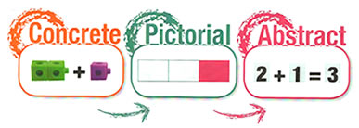
Essential thought process for calculating:
Always model with manipulatives
1 Estimate first
2 Can I do it in my head?
3 Can I do it with practical equipment?
4 Can I do it with some jottings?
5 Which written method do I need?

Concrete, Pictorial, Abstract

6 Have I checked my answers? Can I
use the inverse?
Involve problem solving as much as possible

Always look for real life applications

Progression in the use of manipulatives to support learning
USE IT!

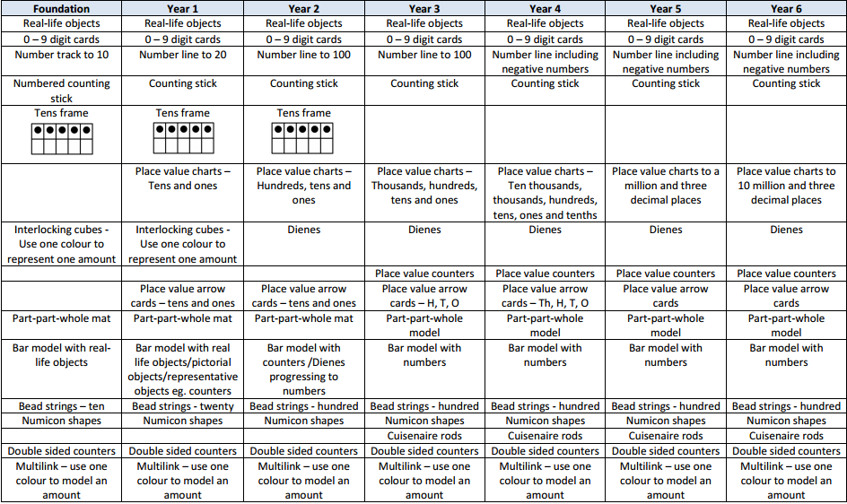
Maths Working Wall
DISPLAY IT!

BUILD IT! | Use real life objects on the display which the children can see, touch and feel. Encourage them to use the objects to explore the maths concepts.
DRAW IT! | Show a pictorial representation of the concept. Encourage the children to draw it in their books. Making jottings and representations is a good thing! | 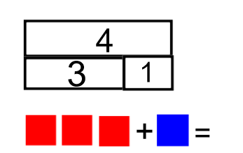
SOLVE IT! | Show the mathematical representation of the concept. | 3 + 1 = 4 4 = 1 + 3  1 + 3 = 4 4 = 3 + 1  4 – 1 = 3 3 = 4 - 1  4 – 3 = 1 1 = 4 - 3
PRACTISE IT! | Encourage the children to practice the concept.  Interactive opportunity – ask the children to respond to questions, encourage them to add and explain what they know and leave them homework to take to master the concept. | 4 + 1 = ?  5 + 2 = ?  2 + 5 = ?  1 + 4 = ?
CHALLENGE IT! | Set a challenge to be solved (Mastery materials).  Interactive opportunity – leave the manipulatives out for the children to use in their investigation/ problem solving. | 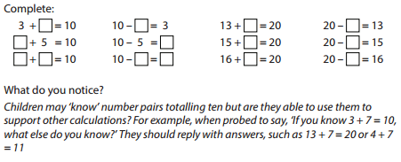
SAY IT! | Use and display the vocabulary related to the concept. | Add, addition, plus, sum, more, increase, total, altogether
Classroom Visual Prompts
SEE IT!

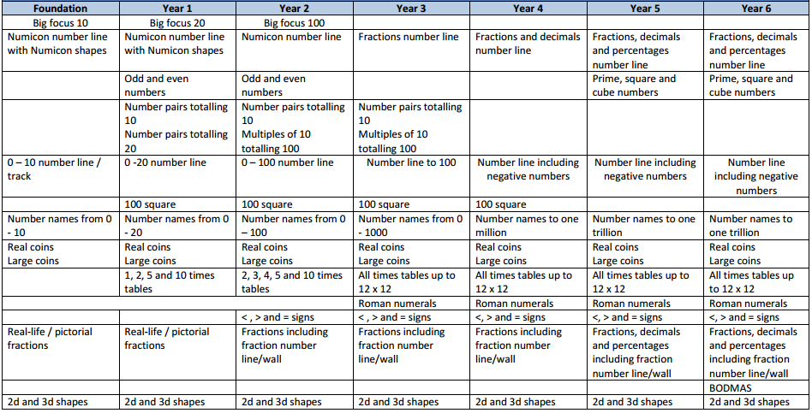

Progression in the teaching of Counting – Foundation Stage

Pre-counting  A focus on the concept of more or less. Develop these concepts through comparison only and no counting is involved. | Ordering  Reciting number names in order – forwards and backwards from any starting point. | One to one correspondence  Matching number words to objects.  To help with co-ordination, move the objects as they count, use large rhythmic movements or clap as they count. | Cardinality (knowing the final number counted is the total number of objects)  From a large amount of objects, count out a smaller group – knowing that the number they stop counting on is the total number of objects in their group.
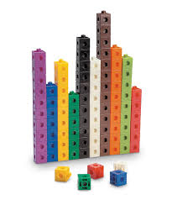Let the children sort groups of objects explicitly using the language of more and less.  Which group has the most?  Which group has the least? | Count orally on a daily basis. Rote count to begin with so that the children are able to understand number order and can hear the rhythm and pattern. Use a drum or clap to keep the beat. 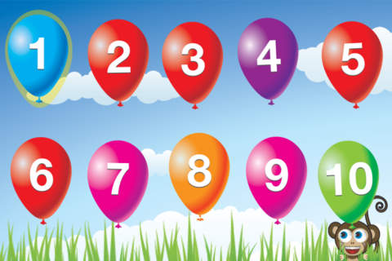 | Sing counting songs such as 5 little ducks, 1,2,3,4,5…, 10 green bottles etc so that the children have visual and kinaesthetic resources.  Play counting games – moving along a track, knocking down amounts of skittles etc.  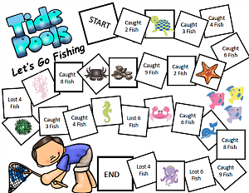 | Give the children real life objects i.e a fruit bowl of fruit, to count. Let them move the objects as they count them.  How many bananas are there in my fruit bowl?  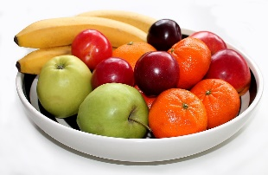
Substitising (recognise small numbers without counting them)  Recognise numicon shape dot patterns, dot patterns on dice, patterns on playing cards and small groups of shapes stuck on to cards. | Abstraction  Counting anything – mixtures of different objects, or similar objects of very different sizes.  Children find it difficult to count objects they can’t move, touch or see (They move around) | Mastery  Children need to know that no matter what order the objects are in, there is still the same amount there. They can be rearranged and the amount doesn’t change. | End of year counting expectations  • count reliably to 20  • count reliably up to 10 everyday objects  • estimate a number of objects then check by counting  • use ordinal numbers in context eg first, second, third  • count in twos, fives and tens  • order numbers 1-20  • say 1 more/ 1 less than a given number to 20
Play flash card games, order dice displaying different numbers, order numicon and say the numbers out loud etc. | Give the children pictures and ask How many… questions.  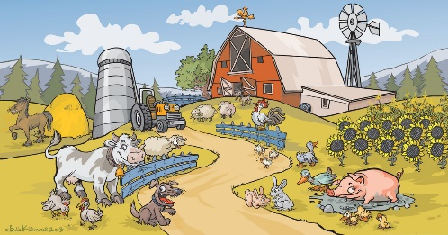  How many sheep are there? How many ducks are there? | 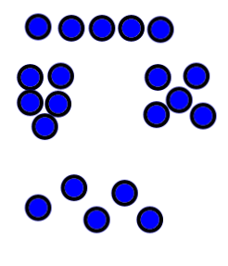  No matter how the 5 objects are arranged, they are still 5 objects.

Progression in the teaching of Place Value

 | Year 1 | Year 2 | Year 3 | Year 4 | Year 5 | Year 6
Place Value | Count, read and write numbers to 100 in numerals  Identify and represent numbers using objects and pictorial representations | Count in steps of 2,3 and 5 from 0 and in 10s from any number  Read and write numbers to 100 in numerals and words  Recognise the place value of each digit in a 2-digit number  Identify, represent and estimate numbers using different representations  Compare and order numbers from 0 to 100 using < and >  Use place value facts to solve problems | Count in 4, 8, 50, 100, find 10 or 100 more or less  Read and write numbers to 1000 in numerals and words  Recognise the place value of each digit in 3-digit numbers  Identify, represent and estimate numbers using different representations  Compare and order numbers up to 1000  Use place value facts to solve number and practical problems | Count in 6,7,9,25 and 1000, find 1000 more or less than a given number  Count backwards through zero to include negative numbers  Recognise the place value of each digit in a 4-digit number  Order and compare numbers beyond 1000  Identify, represent and estimate numbers using different representations  Round any number to the nearest 10,100 or 1000  Use place value to solve problems  Read Roman Numerals up to 100 | Count on and back in steps of powers of 10 for any given number to 1,000,000  Interpret negative numbers in context  And count on an back across zero into negative numbers  Read, write, order and compare numbers to at least 1,000,000 and determine the value of each digit  Round any number up to 1,000,000 to the nearest 10,100,1000, 10,000 and 100,000  Read Roman Numerals uo to 1000 | Read, write, order and compare numbers up to 10,000,000 and determine the value of each digit  Round any whole number to a required degree of accuracy  Use negative numbers in context and calculate across zero  Solve problems involving the above
Progression in models and images for Place Value

Objective | Concrete  BUILD IT/ USE IT! | Pictorial  DRAW IT! | Abstract  SOLVE IT!
Subitise the numbers 1-5 | 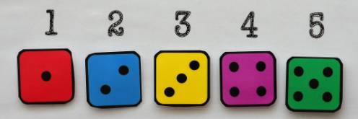  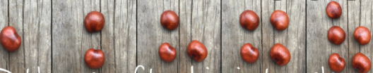 | 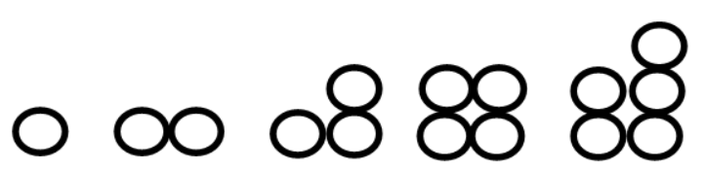  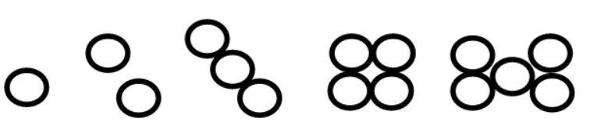
Subitise the numbers 1-10 | 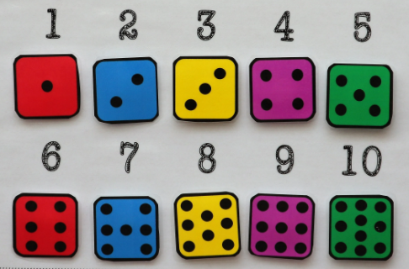
Represent numbers 0- 10 with objects | 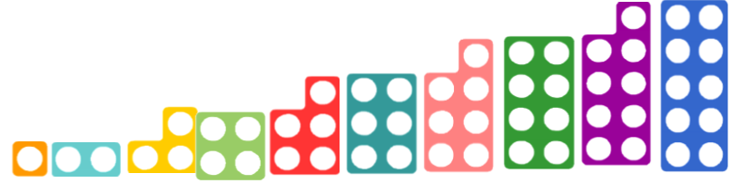  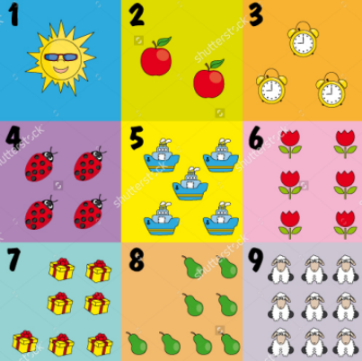  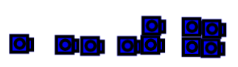 | 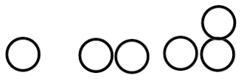 | 0,1, 2, 3, 4, 5, 6, 7, 8, 9, 10
Recognising the value of each digit in a 2-digit number | 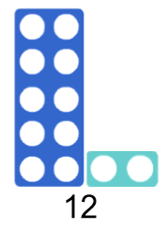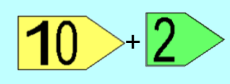  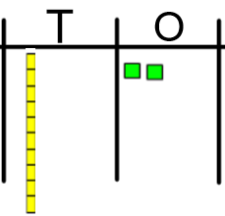  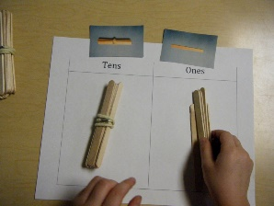 | 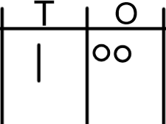 | 10 + 2 = 12  One ten and two ones  twelve
Comparing and ordering 2-digit numbers | 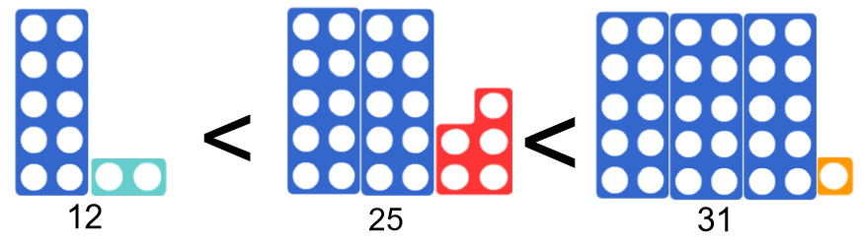  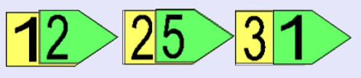  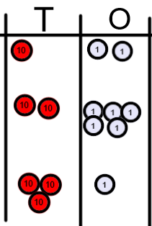 | 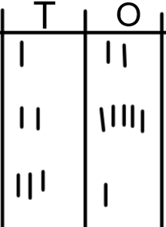 | 12 < 25 < 31  - Compare the tens first, then compare the ones!
Recognising the value of each digit in a 3-digit number | 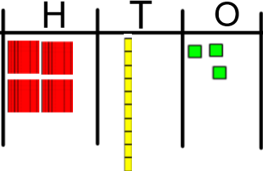  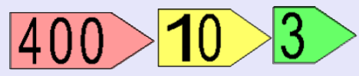 | 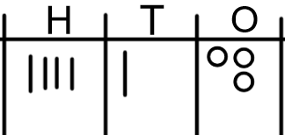 | 400 + 10 + 3  413  Four hundred and thirteen
Ordering and comparing 3-digit numbers | 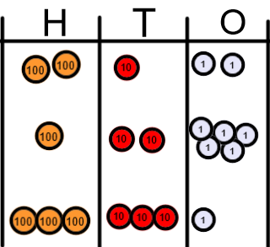  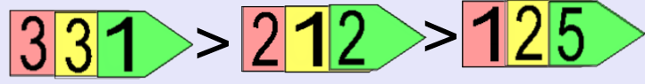 | 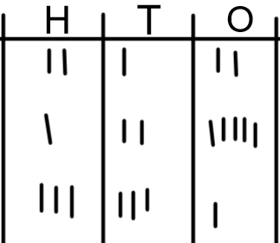 | 331 > 212 > 125  - Compare the value of hundreds  - Compare the value of tens  - Compare the value of ones
Recognise the value of each digit in a 4-digit number | 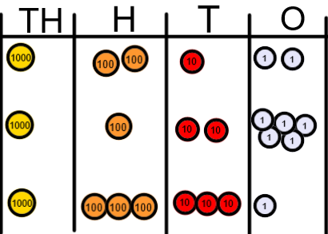 | 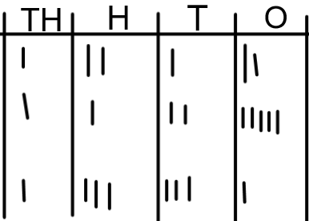 | 1000 + 200 + 10 + 2 = 1,212  1000 + 100 + 20 + 5 = 1,125  1000 + 300 + 30 + 1 = 1,331  One thousand, two hundred and twelve  One thousand, one hundred and twenty-five  One thousand, three hundred and thirty-one
Rounding numbers to the nearest 10 | 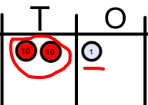  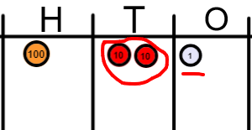 | 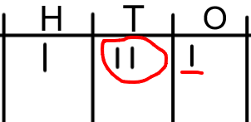 | 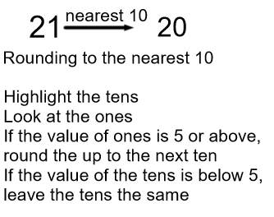  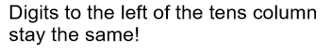  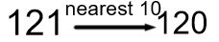
Rounding numbers to the nearest 100 | 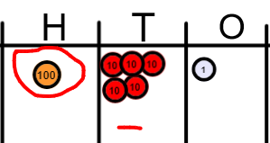  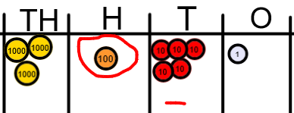 | 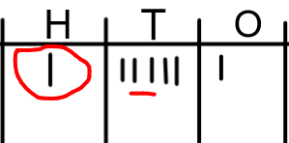  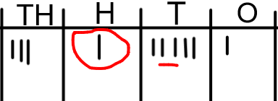 | 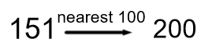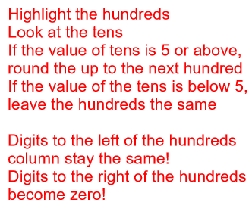  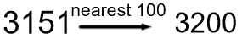
Rounding numbers to the nearest 1000 | 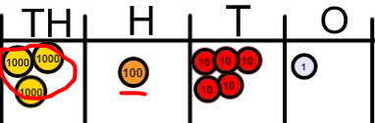  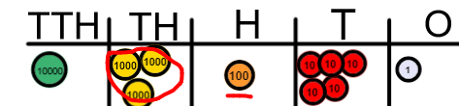 | 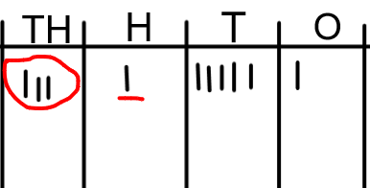  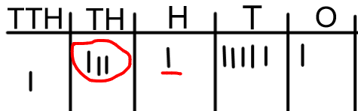 | 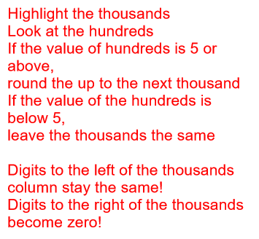  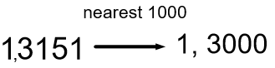  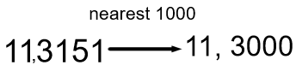
Rounding decimals to the nearest tenth (1 decimal place) | 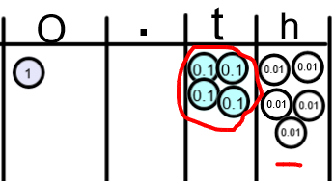 | 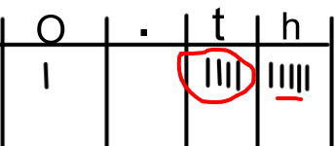 | 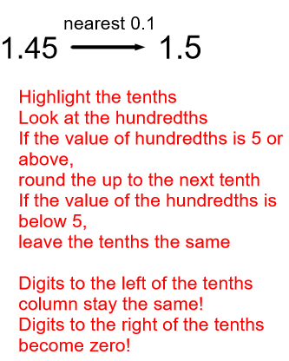

Progression in the teaching of Calculations

 | Year 1 | Year 2 | Year 3 | Year 4 | Year 5 | Year 6
Addition | Combining two parts to make a whole: part, part whole model and bar model  Add one more  Add two ones  Number bonds to 20  Solve problems (Concrete and pictorially) with missing numbers | Fluency in number bonds to 20  Related facts to 100 (e.g. 2 + 8 = 10 therefore 20 + 80 = 100) Part, part whole and bar model  Adding TO + O mentally  Adding TO + O using number line  Counting on  Adding TO + T mentally  Adding TO + T using number line  (concrete, Pictorial, Abstract)  Adding two 2 digit numbers mentally and on a number line  Begin using a column method with no re-grouping/ exchanging (Expanded/ partitioning)  Commutative law  Solve problems with inverse relationship and missing numbers | Add a 3-digit number and ones mentally  Add a 3-digit number and tens mentally  Add a 3-digit number and hundreds mentally  (Partitioning)  Column method for addition without re-grouping/ exchanging  (estimating and checking answers with the inverse)  Column method for addition with re-grouping/ exchanging ones and tens.  Solve problems including missing number problems  (Concrete, Pictorial Abstract) | Add a 4-digit number and ones mentally  Add a 4-digit number and tens mentally  Add a 4-digit number and hundreds mentally  Add a 4-digit number and thousands mentally  Column method with re-grouping/ exchanging  Use inverse operations to check  Solve multi-step problems | Add large numbers mentally  Column method with re-grouping/ exchanging  Column method with decimals (same amount of decimal places)  (Concrete, Pictorial Abstract)  Solve multi-step problems  Use rounding to check answers | Add large numbers mentally  Column method with re-grouping/exchanging.  Column method with decimals (different amounts of decimal places)  (Concrete, Pictorial Abstract)  Solve multi-step problems  Use rounding to check answers
Subtraction | Take away ones (counting back)  Find the difference  Inverse of addition number bonds  Part, part whole and bar model  Solve problems (concrete and pictorial) including missing numbers. | Develop fluency of number bonds and inverse of addition  Subtract ones from a 2-digit number mentally and counting on, on a number line  Subtract tens from a 2-digit number mentally and on a number line  Subtract two 2-digit numbers mentally and on a number line  (Concrete, Pictorial, Abstract)  Begin the column method (expanded or partitioned) with no re-grouping/ exchanging  Solve problems (Concrete, Pictorial, Abstract) including missing numbers.  Commutative law | Subtract ones from a 3-digit number mentally  Subtract tens from a 3-digit number mentally  Subtract hundreds from a 3-digit number mentally  (Concrete, Pictorial, Abstract)  Column Subtraction without re-grouping/ exchanging  Solve problems (Concrete, Pictorial and abstract) involving missing numbers.  Use the inverse to check answers | Subtract ones from a 4-digit number mentally  Subtract tens from a 4-digit number mentally  Subtract hundreds from a 4-digit number mentally  Subtract thousands from a 4-digit number mentally  (Concrete, Pictorial, Abstract)  Column Subtraction with re-grouping/ exchanging  Use inverse operations to check answers  Solve problems (Concrete, Pictorial and abstract) involving missing numbers. | Subtract large numbers mentally  Column method for subtraction with re-grouping/exchanging  Column method with decimals (Same amount of decimal places)  (Concrete, Pictorial, Abstract)  Solve multi-step problems  Use rounding to check answers. | Subtract large numbers mentally  Column method for subtraction with re-grouping/exchanging  Column method with decimals (different amount of decimal places)  (Concrete, Pictorial, Abstract)  Solve multi-step problems  Use rounding to check answers.
Multiplication | Doubling (CPA)  Counting in multiples  Arrays (with support)  Use CPA and Arrays with support to solve problems | Doubling (CPA)  Counting in multiples (2,5,10)  Repeated addition  Arrays  Commutative law  Solve problems using arrays and repeated addition | Consolidate counting in 2,5, 10  Counting in multiples (3,4,8)  Repeated addition (CPA)  Arrays(CPA)  Commutative law  Use known number facts and partitioning to multiply 2-digit by 1 digit numbers mentally  Progress to written grid and column method (expanded or partitioned)  Solve problems inc where n objects are connected to m objects (CPA) | Rapid recall of multiplication facts up to 12 x 12  Use known number facts to multiply mentally inc. x 0, x1 and multiplying 3 numbers  Recognise and use factor pairs  Column (or grid) multiplication  2 and 3 digit multiplied by 1 digit) (CPA)  Solve problems inc. distributive law and where n objects are connected to m objects (CPA) | Consolidate rapid recall of facts  Multiply mentally using known facts  Column multiplication (up to 4 digit numbers by 1 or 2-digit numbers)  (CPA)  Multiply decimals using column method  Identify multiples and factors  Identify prime numbers  Solve problems inc factors, multiple, squares and cubes (CPA) | Multiply mentally using known facts  Column method (4-digit by 2- digit numbers)  Solve multi-step problems inc. common factors, common multiples, and prime numbers  (CPA)
Division | Sharing objects into groups (CPA)  Solve one step problems using concrete materials with support | Relate division to multiplication facts (2, 5, 10)  Divide mentally using inverse multiplication facts  Division as grouping  Use arrays (CPA)  Use a number line (CPA)  Solve problems using arrays, repeated addition and mental methods (CPA) | Recall division facts for 3,4,8 times tables  Divide mentally using known facts inc. 2-digit by 1-digit number.  Divide 2-digit by 1-digit numbers using arrays (grouping) (CPA)progressing to the written short division method (CPA)  Solve problems inc. missing numbers and where n objects are connected to m objects. | Rapid recall of division facts for up to 12 x table  Division using known facts mentally  Division with arrays with remainders  Short division up to 3-digit by 1-digit (CPA)  Solve problems inc missing numbers (CPA) | Divide numbers mentally using known facts  Short division up to 4-digit by 1 digit number interpreting remainders appropriately for the context (CPA) | Short division  Long division up to 4-digit by 2-digit numbers interpreting remainders as whole numbers, fractions or round (CPA)  Dividing a decimal by a whole number

Progression in the teaching of Calculations
Add it!

Objective | Concrete  BUILD IT/USE IT! | Pictorial  DRAW IT! | Abstract  SOLVE IT!
Counting objects and adding one | 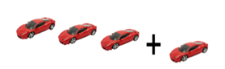  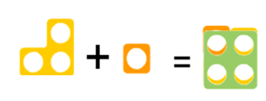 | 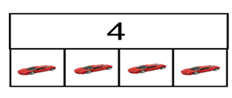 | 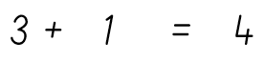
Adding two ones | 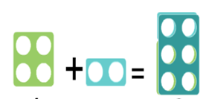 | 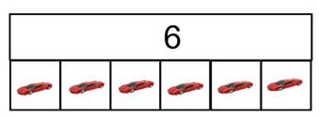 | 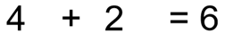
Using a number line to count on | 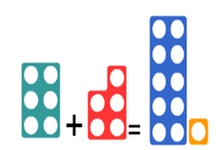 | 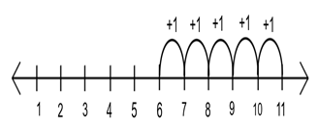  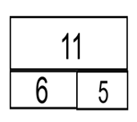 | 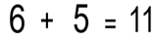
Adding tens and ones on a number line | 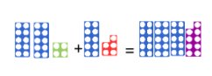 | 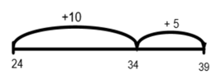  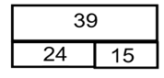 | 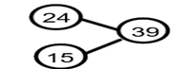  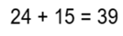
Adding two 2-digit numbers without re-grouping/ exchanging | 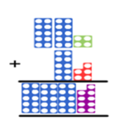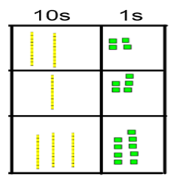 | H T O  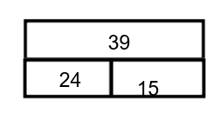 | 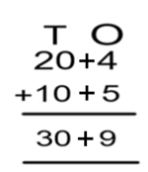
Partitioning method when crossing ten (not re-grouping or exchanging) | 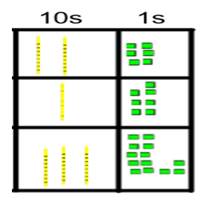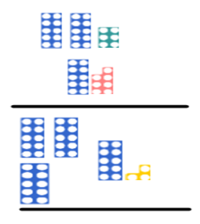 | 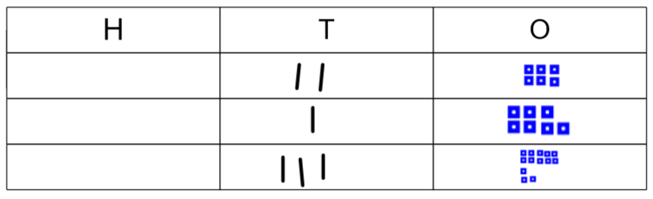 | 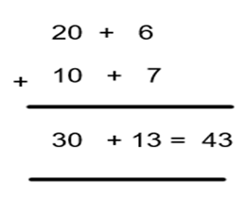
Adding using the column method without re-grouping/exchanging | 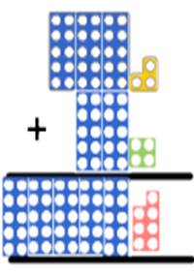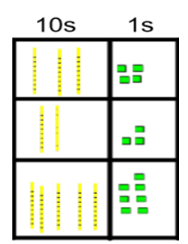 | 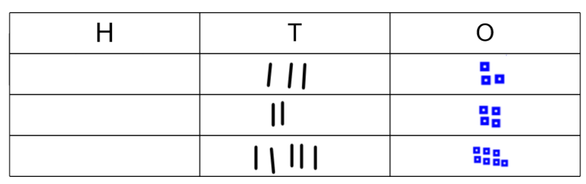  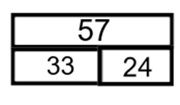 | 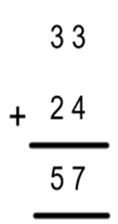
3 digit column method without re-grouping/ exchanging | 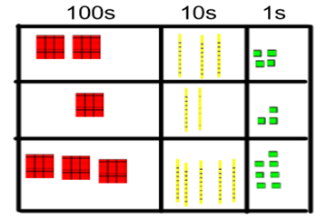 | 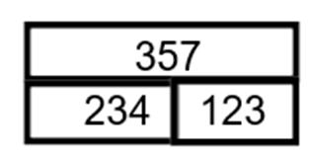  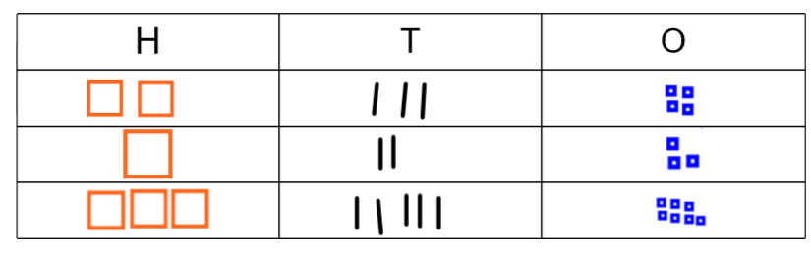 | 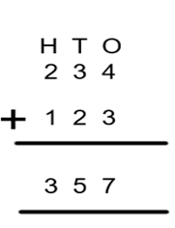
Column addition with re-grouping/ exchanging | 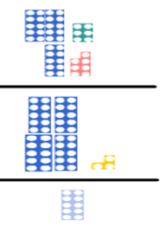  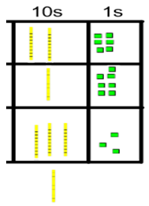  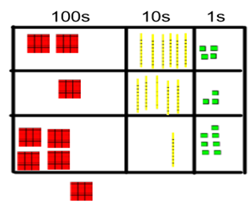 | 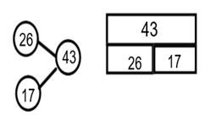  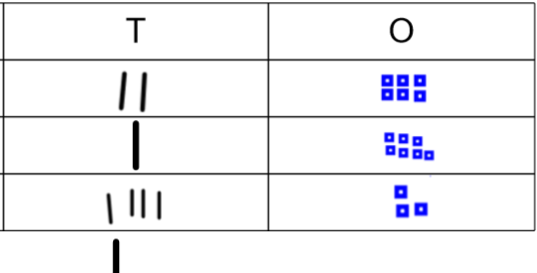  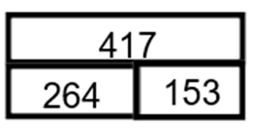 | 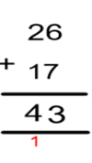  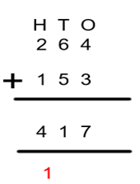
Column addition re-grouping/ exchanging ones and tens together | 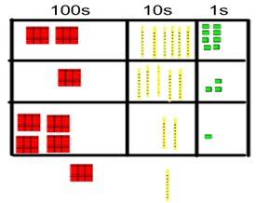 | 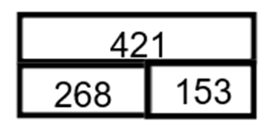 | 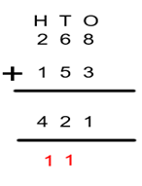
Applying the column method to larger numbers and adding decimals | 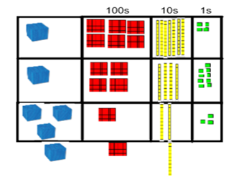  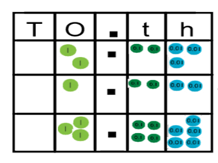 | 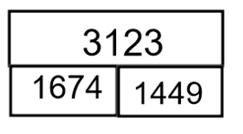 | 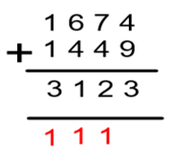  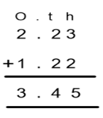
Progression in the teaching of Calculations
SUBTRACT IT!

Objective | Concrete  BUILD IT/ USE IT! | Pictorial  DRAW IT! | Abstract  SOLVE IT!
Taking away ones | 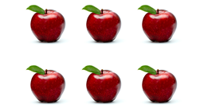 | 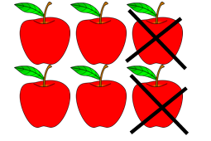  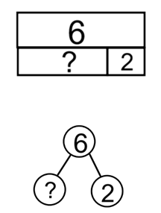 | 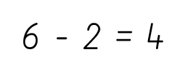
Find the difference between two numbers | 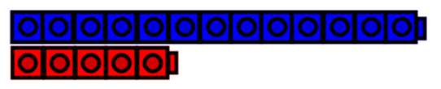 | 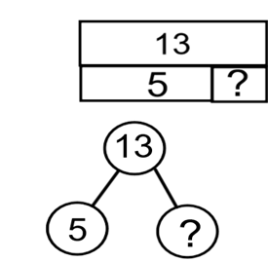 | 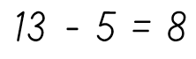
Use a number line to find the difference |  | 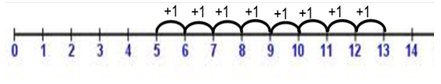
Using number bonds to 10 to make more efficient jumps on a number line | 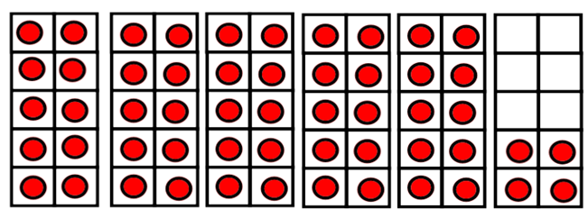 | 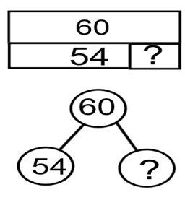  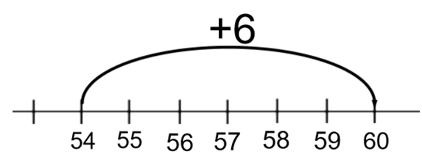 | 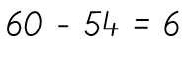
Jumping in tens and ones efficiently on a number line |  | 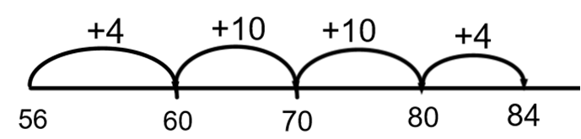  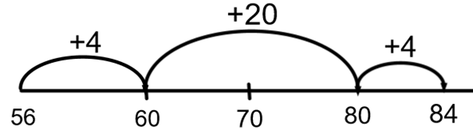 | 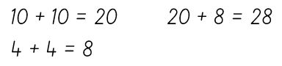  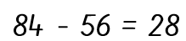
Progressing towards written column method – partitioning and without re-grouping/exhcanging | 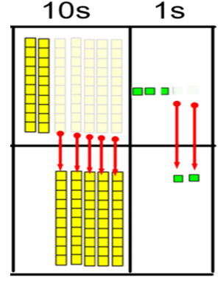 | 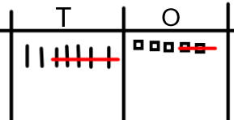 | 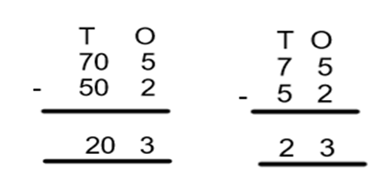
Subtracting using the column method up to 3 digit numbers without exchanging | 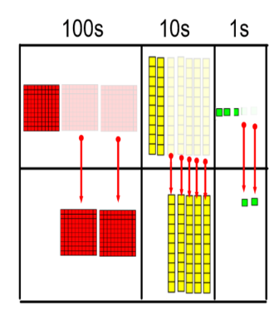 | 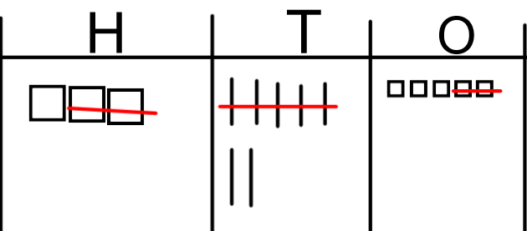 | 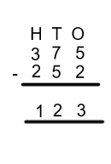
Column method with re-grouping/ exchanging | 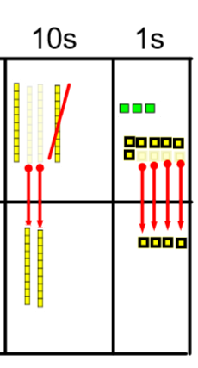 | 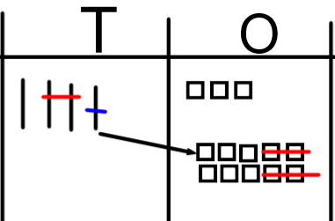 | 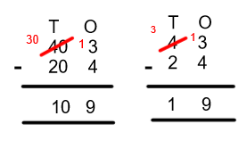
 | 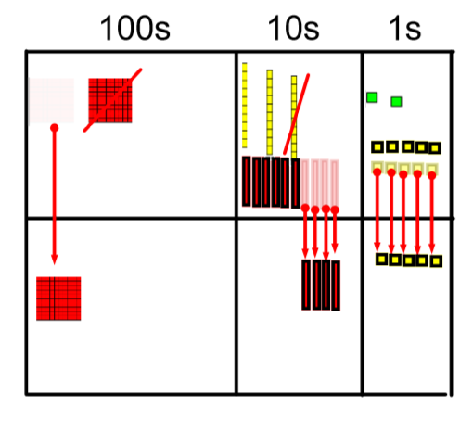 |  | 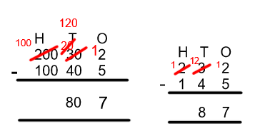
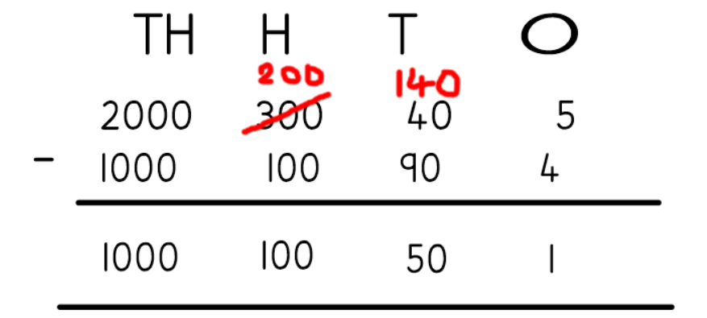

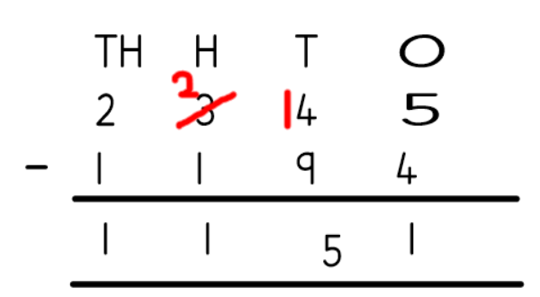

Progression in the teaching of Calculations
Multiply it!

Objective | Concrete  BUILD IT/USE IT! | Pictorial  DRAW IT! | Abstract  SOLVE IT!
Grouping in 2s,5s and 10s | 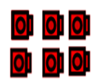 | 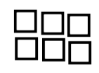 | 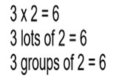
Counting in 2s, 5s and 10s | 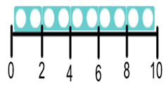  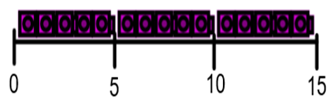 | 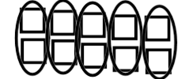  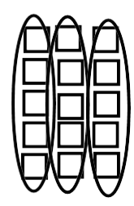 | 0,2, 4, 6, 8, 10…  …10, 8, 6, 4, 2,0  0,5,10,15…  …15,10,5,0
Using repeated addition | 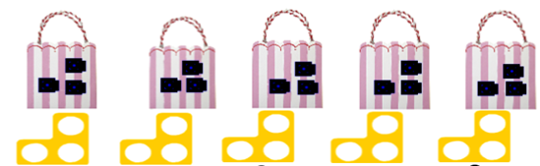 | 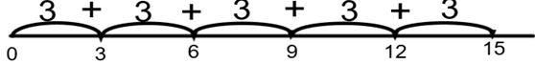  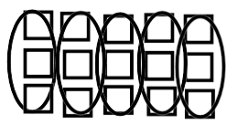 | 5 x 3 = 15
Using arrays and commutative law | 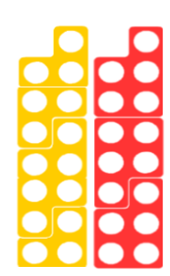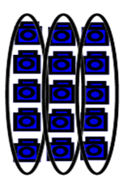  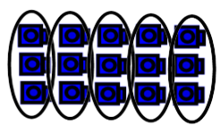 | 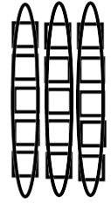  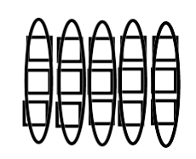 | 3 x 5 = 15  5 x 3 = 15
Deriving associated division facts with arrays | 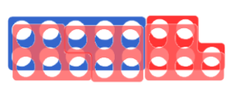  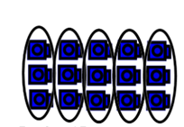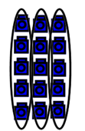 |  | 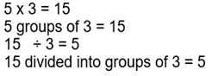  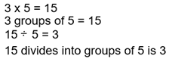
Multiplying by ten | 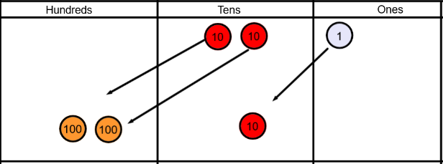 | 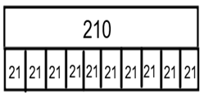  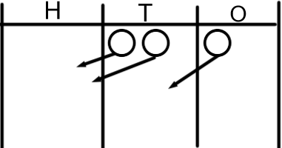 | 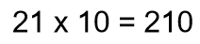
Multiplying by 100 | 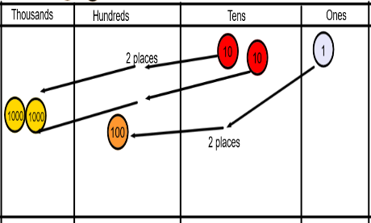 | 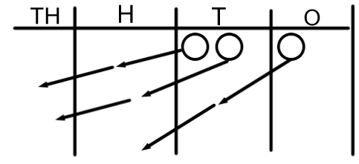 | 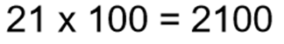
Partitioning and grid method | 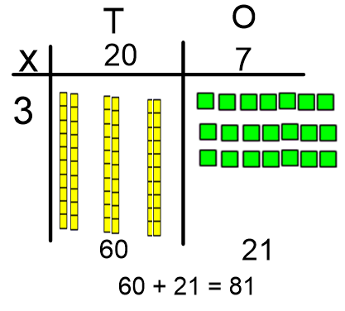 | 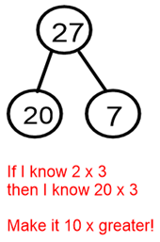  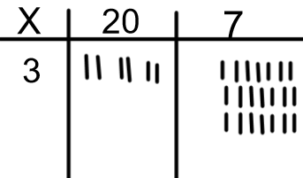 | 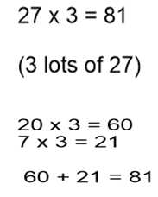
Multiplying 2 digit by 2 digit numbers | Use dienes as above | 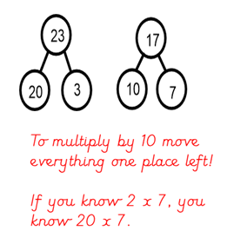  Draw the dienes as above | 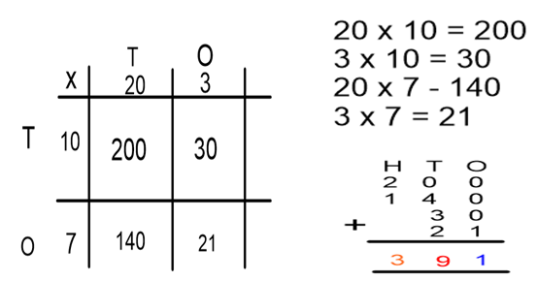
Multiplying 3 digit by 2 digit numbers – grid method |  | 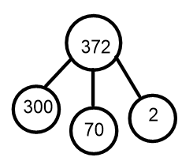  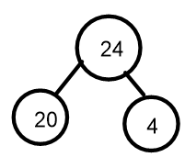 | 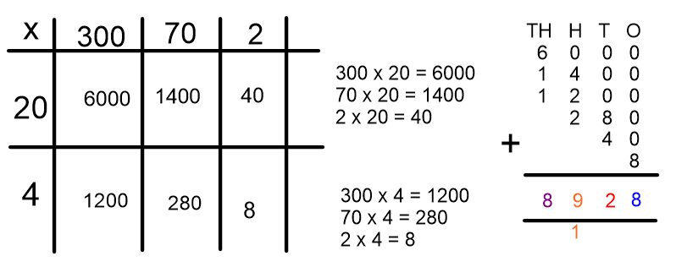
Efficient written column method | 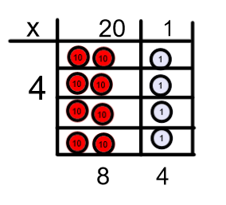 | 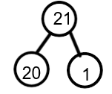  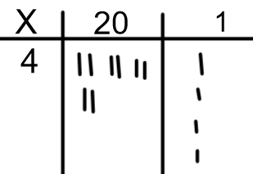 | 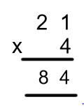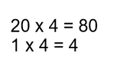
Efficient column method with re-grouping/ exchanging | 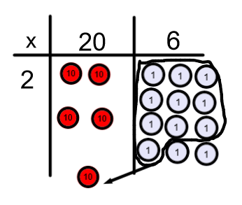  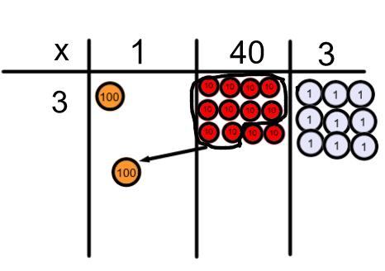 | 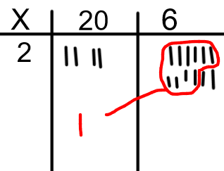  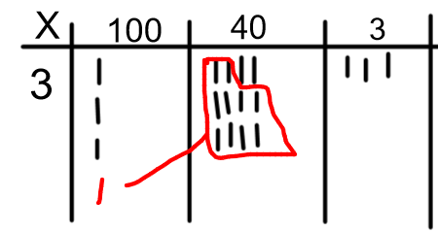 | 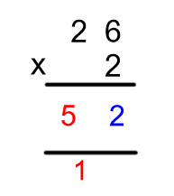  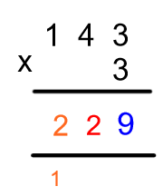
Efficient column method 2-digit by 2- digit  or 3 digit by 2 digit | 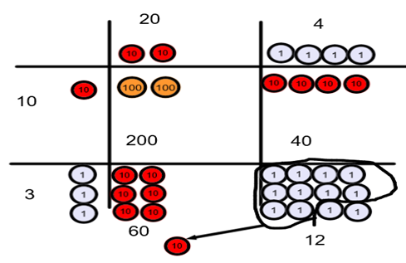 | Draw the dienes/ place value coutners as above | 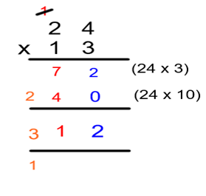
Efficient column method for multiplying decimals |  | 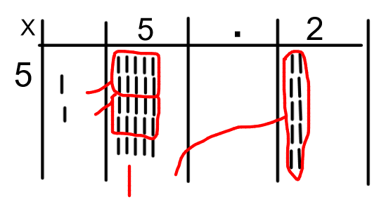 | 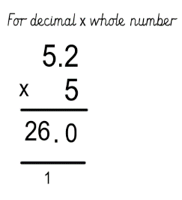  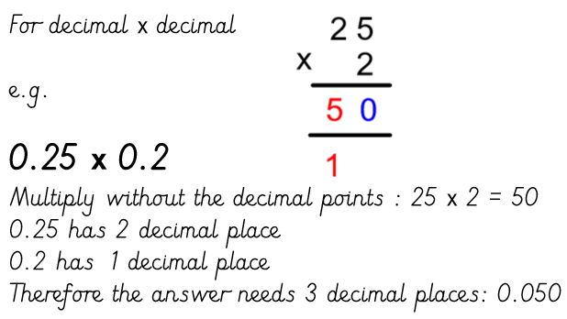

Progression in the teaching of Calculations
Divide it!

Objective | Concrete  BUILD IT/USE IT! | Pictorial  DRAW IT! | Abstract  SOLVE IT!
Sharing objects (2, 5, 10) | 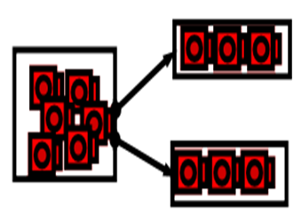 | 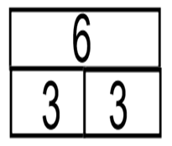  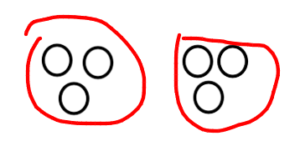 | 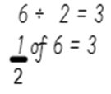
Division as grouping (2,5,10) | 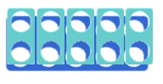  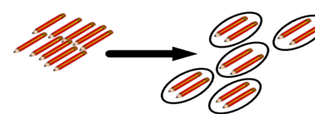 | 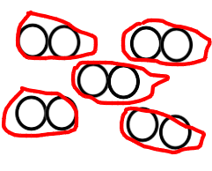  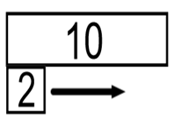 | 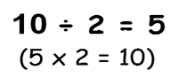
Using a number line for grouping | 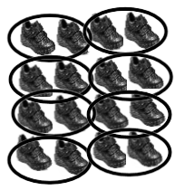 | 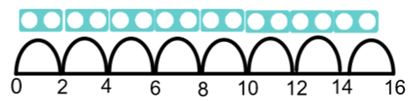  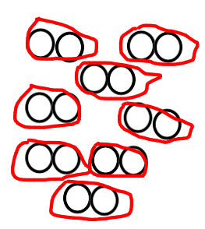 | 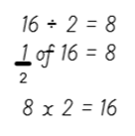
Commutative law with arrays | 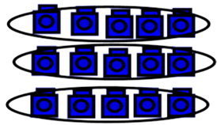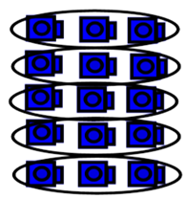 | 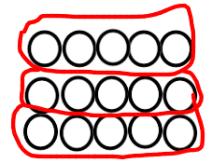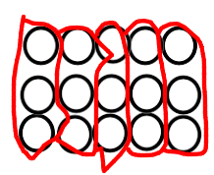 | 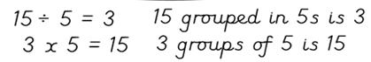  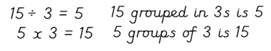
Division with remainders (Sharing) | 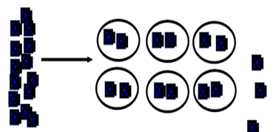 | 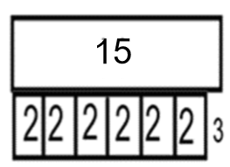  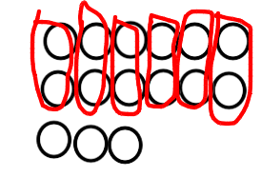 | 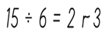
Division with remainders (grouping) | 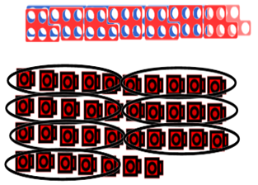 | 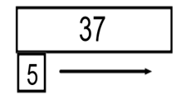  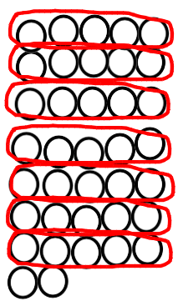 | 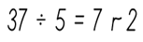
Dividing by 10 | 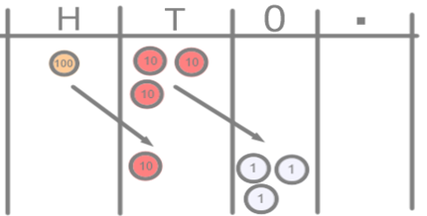 | 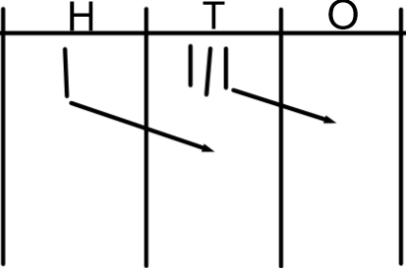 | 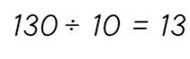
Dividing by 100 | 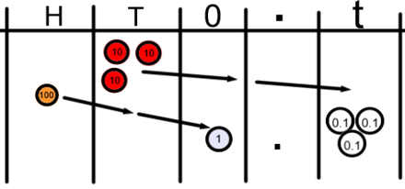 | 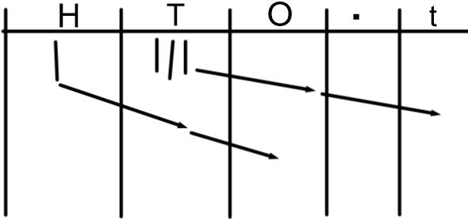 | 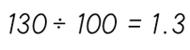
Short division (no remainders) | 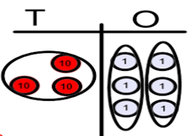 | 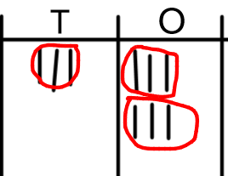 | 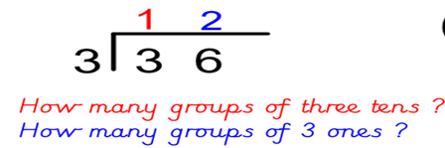
Short division with re-grouping/exchanging | 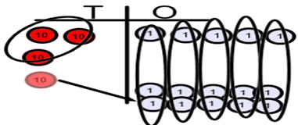 | 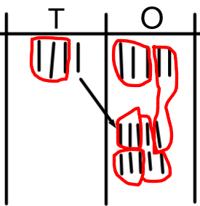 | 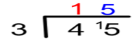
Short division with re-grouping/exchanging | 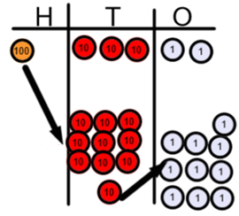 | 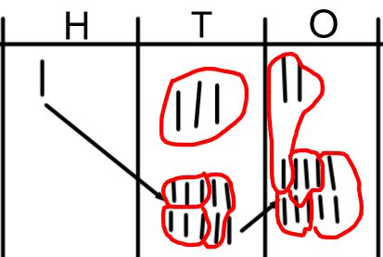 | 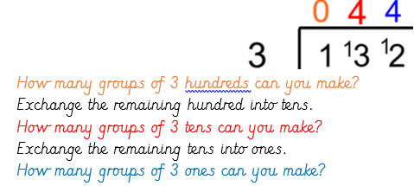
Short division with remainders | 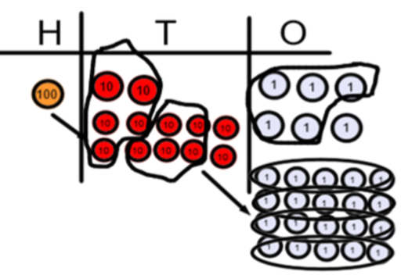 | 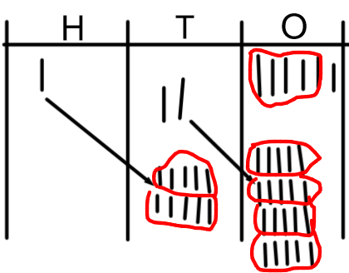 | 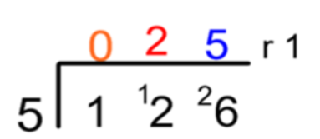  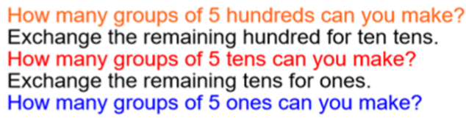
Long division (y6) | 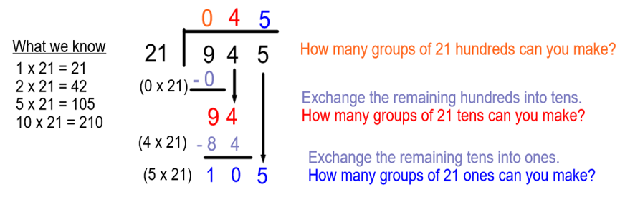
Dividing decimals | 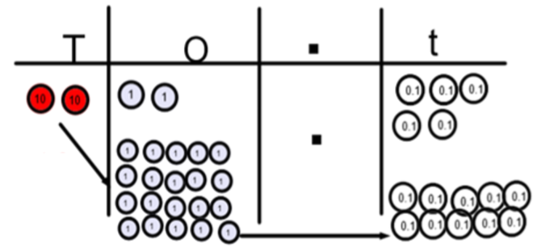 |  | 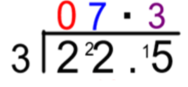  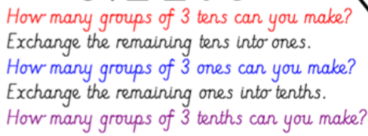
Expressing remainders as fractions | 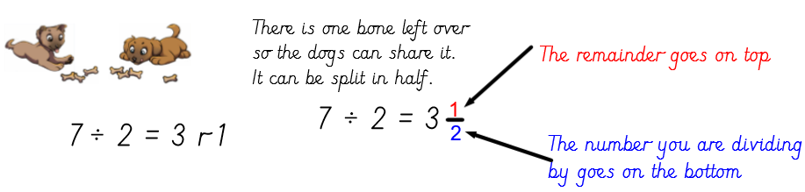

Progression in teaching Fractions

Objective | Concrete  BUILD IT/ USE IT! | Pictorial  DRAW IT! | Abstract  SOLVE IT!
Finding half of a shape | 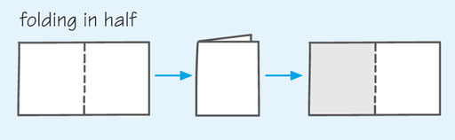 | 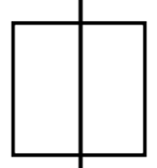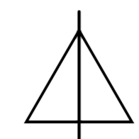 | 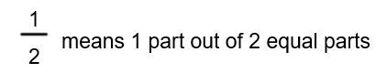
Finding a quarter of a shape | 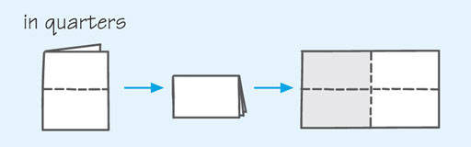 | 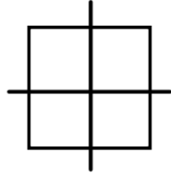 | 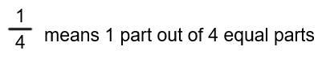
Finding half by grouping in 2s (not sharing into 2 groups)  Knowing half of even numbers to 20 | 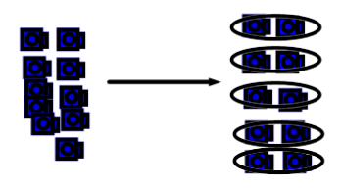 | 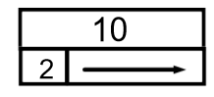 | 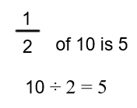
Finding a quarter by grouping in 4s (not sharing into 4 groups) | 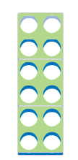 | 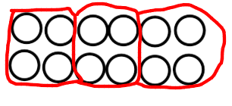  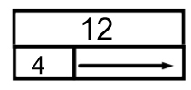 | 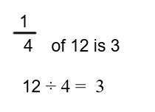
Using multiplication and division facts to find fractions of a number | 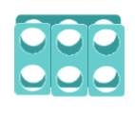 | 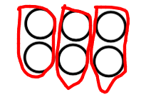  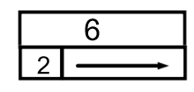 | 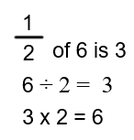
Finding other fractions of shapes |  |  | 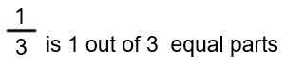
Finding non-unit fractions of a number using sharing (understanding numerator and denominator) | 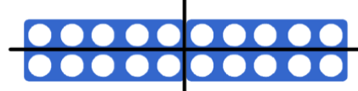 | 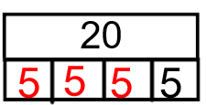  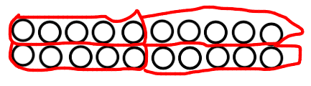 | 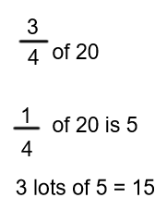
Use known number facts to find unit and non-unit fractions of amounts |  |  | 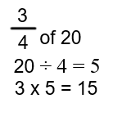
Recognise simple equivalent fractions | 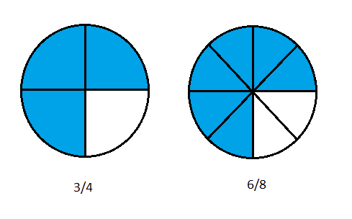  (Fraction pieces) | 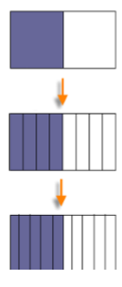 (Bar model) | 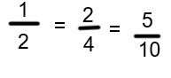
Compare and order fractions with the same denominator | 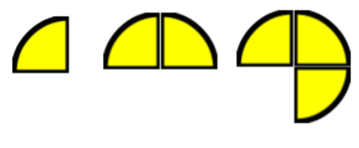  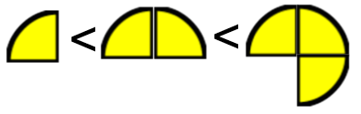 | 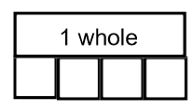 | 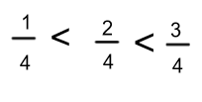
Compare and order unit fractions |  | 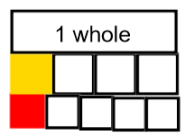 | 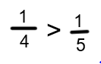
Recognising decimal equivalence for fractions – tenth and hundredths | 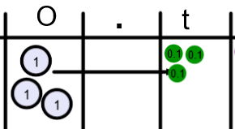 | 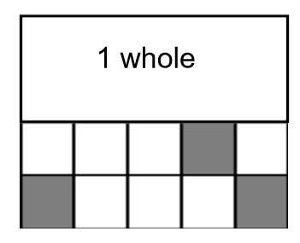  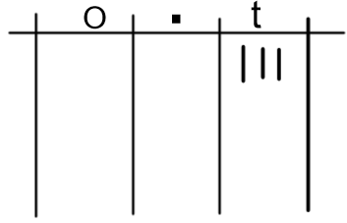  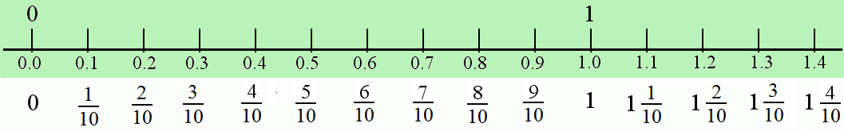 | 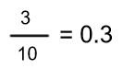
Recognise decimal equivalence for fractions – half, quarter, three quarters, one fifthtg5b | 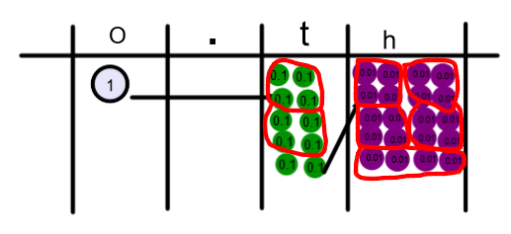 | 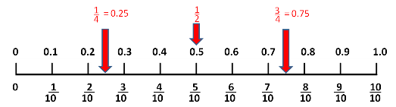  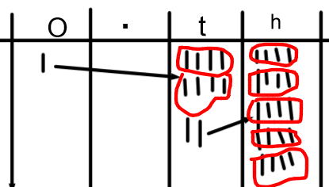 | 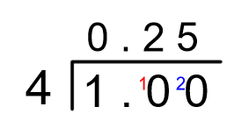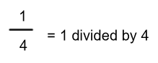  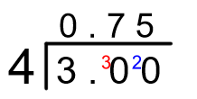  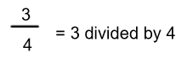
Adding fractions with the same denominator |  | 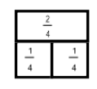 | 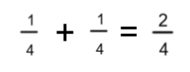
Adding fractions with different denominators |  | 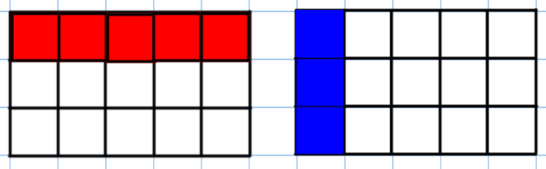  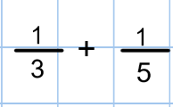 | 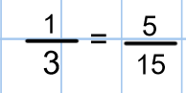  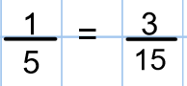  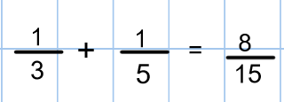
Adding Mixed numbers with different denominators. |  | 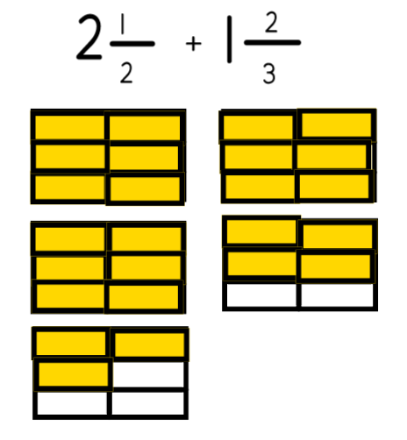 | 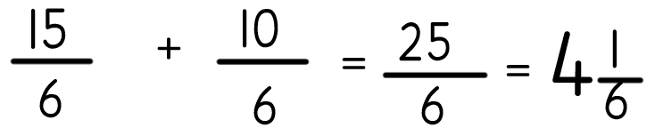
Subtracting fractions with the same denominator |  | 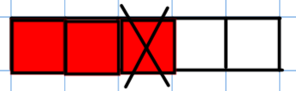 | 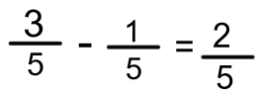
Subtracting fractions with different denominators |  | 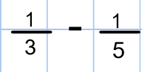  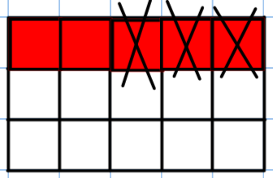 | 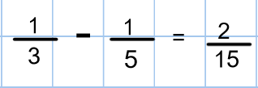
Subtracting mixed numbers with different denominators. |  | 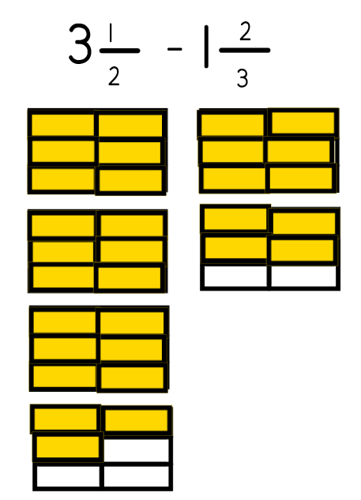 | 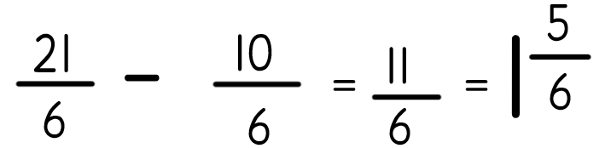
Multiplying fractions |  | 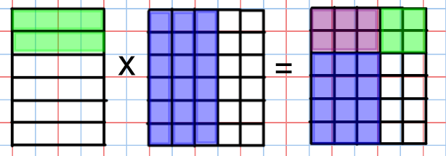 | 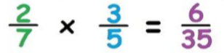  Multiply the numerators and multiply the denominators!
Dividing fractions by a whole number |  | 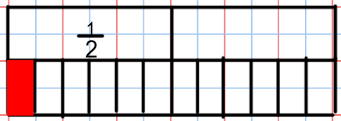  Draw the first fraction as a bar model.  Divide all parts of the bar model into equal parts determined by the whole number.  Determine your answer by determining the size of each piece. | 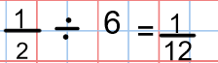  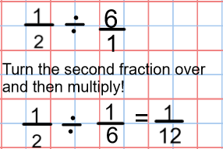
Dividing a fraction by a fraction |  | 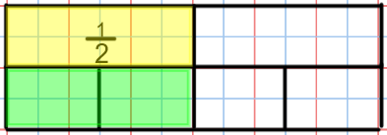  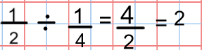  Draw the first fraction in a bar model.  Divide the whole bar into equal parts determined by the second fraction.  How many of the second fraction parts are equal to the first fraction? | 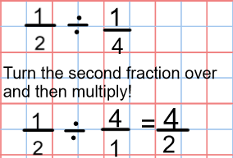

Expectations in Reason and Problem Solving
Throughout all years at school, all pupils are given opportunities to reason in every lesson. Pupils will use dialogic talk, using sentence stems and the correct vocabulary, to reason and prove answers to each other. From Year 2, they are expected to write full sentence answers to reasoning questions.
Reasoning questions can be in the form of:
- True / false/ prove it.
- Answer free zones (prove how they got the answer)
- Spot the mistake.
- What comes next?
- Missing numbers
- What’s the same and what’s different?
- Odd one out
- Always, Sometimes, Never
Problem Solving
In all year groups, children are given opportunities to learn and apply the 8 different problem-solving strategies:
- Act it out.
- Trial and error.
- Trial and Improvement.
- Make a list or table.
- Find a Pattern.
- Simplify.
- Work backwards.
- Use Algebra.

Place value

EYFS | Year1 | Year 2 | Year 3 | Year 4 | Year 5 | Year 6
Count  Subitise  order  Forwards  Backwards  Number  Digit  One more  One less  Number bond | Oral counting (to 100)  Twenty-one  Twenty-two…  One hundred  Written numerals and words (1 to 20)  One, two, three…twenty  Tens  Ones | Oral counting to 100  Written numerals and words 20-100  Twenty-one  Twenty-two… etc…  One hundred  digit  Two-digit number  Place value  Estimate  Compare  Greater than  Less than  Greatest  Least | Counting to 1000.  Writing numerals and words 100 – 1000.  Three-digit number  Hundreds  Approximately  Round (up / down)  Nearest 10  Ascending  Descending  Increase  decrease | Tenths  hundredths  Decimal (places)  Round (to nearest)  Thousand more/less than  Negative integers  Count through zero  Roman numerals (I to C) | Powers of 10  Millions  Hundred thousand  Ten thousand | Order of operations  BIDMAS

Addition / Subtraction
EYFS | Year1 | Year 2 | Year 3 | Year 4 | Year 5 | Year 6
Add  Plus  Altogether  Part  more  Whole  Take away  Less | Add / addition  One more  Equals  total  Number bonds  Subtraction  One less | Plus  More  Addition facts  Altogether  commutative  Number sentence  Inverse  Minus  Less  partition | Difference between  Exchange  Column addition  Column subtraction  Formal written method

Multiplication / Division

EYFS | Year1 | Year 2 | Year 3 | Year 4 | Year 5 | Year 6
Odd  Even  Equal  unequal | Times  Lots of  Repeated  Share  Group / groups of | Multiplication  Multiplication fact  Groups of  Repeated addition  Double  Half  Three times  Ten times  commutative  Arrays  row  column  Divide / divided by  Divided into  Equal groups  Share equally  Division fact | Multiple  product  Factor  Near double  Remainder | Multiplication  facts (up to  12x12)  Division facts  Inverse  Derive | Factors  factor pairs  common factors  common multiple  Prime  Square number  Cubed number  Short division  Divisor  Quotient  dividend | Long division

Fractions / decimals / percentages
EYFS | Year1 | Year 2 | Year 3 | Year 4 | Year 5 | Year 6
Half | Whole  Half  Quarter  Share  Equal parts | Equivalent fraction  Numerator  Denominator  Two halves  Two quarters  Three quarters  One third  Two thirds | Mixed number  Unit fraction  Non-unit fraction  Fifths  Sixths  Sevenths  Eighths  Nineths  tenths | Equivalent decimals  and fractions  hundredths  decimal point | Proper  Improper  Simplify  Percentage  Thousandths  Integer  Complements

Ratio and proportion
EYFS | Year1 | Year 2 | Year 3 | Year 4 | Year 5 | Year 6
Ratio
Proportion
Relative size
Missing values
Scale factor

Measurement (height, length, weight/ mass, capacity)
EYFS | Year1 | Year 2 | Year 3 | Year 4 | Year 5 | Year 6
Measure  Wide  Narrow  Long  Short  Longest / longer  Shortest / shorter  Height  Weight  Heavy  heaviest  Light  lightest  Full  Half full  Empty | Length  Longer / longest  Shorter / shortest  Tall  Centimetre  Metre  Capacity  Litre  Half full  Quarter full  Mass  Grams  Kilograms | Measure  Measuring scale  Estimate  Volume  Temperature  Mililitres  Money  Pounds  Pence  Change  Compare  Twice  half | Measurement  Size  Compare  Enough  Not enough  Nearly  Close to  The same as  Approximately  Roughly  Just over / just under  Kilometre  Mile  Kilogram  perimeter | Converting  Rectilinear shapes  Compound shapes  Area  Square metres  Square centimetres | Imperial units  Metric units  Inches  Conversion  Cubic centimetres  Pounds (lb)  pints | Miles  Feet  Cubic metres  Cubic centimetres  Gallons  Stones  Onces

Measurement (time)
EYFS | Year1 | Year 2 | Year 3 | Year 4 | Year 5 | Year 6
Quicker  Slower  Earlier  Later  Before  After  First  Next  Then  Today  Yesterday  Tomorrow | O’clock  Half past  Minutes  Hours  Morning  Afternoon | Analogue clock  Minutes in and hour  Hours in a day  Quarter past  Quarter to | Digital  Duration  Nearest minute  Roman numerals  12-hour  24-hour  Am / pm  Noon  Midnight  Days in each month  Year  Leap year | Converting  Hours to minutes  Minutes to seconds  Years to months  Weeks to days

Position and Direction
EYFS | Year1 | Year 2 | Year 3 | Year 4 | Year 5 | Year 6
Over  Under  Between  Around  Through  On  Into  Next to  Beneath  On top of | Before  After  Next  In front  Behind  Left  Right  Top  Middle  Bottom | Pattern  Sequence  Straight line  Rotation  Right angle  Half turn  Quarter turn  Three quarter turn  Clockwise  Anti-clockwise |  | Coordinates  Translation  translate  Quadrant  x-axis, y-axis  Perimeter and area

Geometry (shape)
EYFS | Year1 | Year 2 | Year 3 | Year 4 | Year 5 | Year 6
2-d shapes  Square  Rectangle  Circle  Triangle  3-d shapes  Cube  Cone  Cuboid  Curved  Straight  Flat  Faces  sides  corners | 2 dimensional  Square  Rectangle / oblong  Triangle  Hexagon  Pentagon  circle  Sides  Corners  faces  curved  flat  straight  Symmetrical  Pattern | Quadrilateral  3 dimensional  Polygon  Cuboid  Cube  cylinder  Prism  Cone  Edges  Vertices  Faces  Line of symmetry  Vertical line | Regular  irregular  pentagonal  octagonal  hexagonal  vertex  Horizontal  Parallel lines  Acute angle  Obtuse angle  Right-angle | orientation  Triangles  Isosceles  Scalene  Right-angled  Equilateral  Parallelogram  Rhombus  Trapezium | Reflect  Reflex angle  Angles on a straight ling  Angles around a point  Vertically opposite  Missing angles | Radius  Diameter  Circumference  dimensions

Statistics
EYFS | Year1 | Year 2 | Year 3 | Year 4 | Year 5 | Year 6
Information  Graph  Pictogram | Information  Graph  pictogram | data  Tally  Graph  Pictogram  Title  Most popular  Least popular | Interpret  accurate  Present  Table  Frequency  Scale | Continuous data  Line graph | Timetable  Two-way timetables  Maximum  Minimum | Pie chart  mean

Date written: 5.12.23
Date of review: 5.12.24

