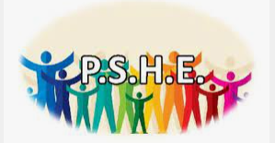
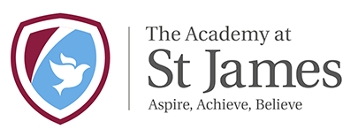

PSHE Vison
Academy St James’ Primary School and Nursery is a nurturing learning environment in which every child is encouraged to develop their full potential by being knowledgeable and expert learners.
As a school, we believe that children are all individuals and therefore, we aim to empower our children to become ambitious learners who are able to work independently, are resilient, can question, are empathetic and supportive of others and have the self-belief needed for a successful future. Our curriculum is fully inclusive and is developed based on the 9 protected characteristics of inclusion and diversity.
The teaching and learning of PSHE supports and upholds this vision.
PSHE deals with the diverse beliefs, values and attitudes that individuals and societies hold. They help pupils to develop themselves, their understanding of the world, and their ability to communicate their feelings. PSHE helps children to acquire British values and attitudes, which are necessary if they are to make sense of their experiences within school and life itself, value themselves, respect others, appreciate differences and diversity and feel confident and informed as a British citizen.
PSHE education cannot exist in isolation. At Academy St James Primary School and Nursery, it is part of a whole school approach and our curriculum provides a range of opportunities for children to make links to other areas of learning and explore a wide range of social, moral, cultural and behavioural issues.
As a school, we aim to enrich the lives of our children by providing them with the skills and opportunities to apply their learning within and beyond the curriculum. PSHE underpins our school ethos and is delivered as a rolling programme from Nursery to Year 6. It also includes a multi-agency approach.
Through PSHE, we believe we can enhance children’s education and help them become caring, respectful and confident individuals who will contribute positively to our school and the wider community now and in the future.
Our PSHE curriculum ensures all our pupils:
- Learn about being healthy
- Understand how to stay safe
- Know what healthy relationships are
- Have respect and tolerance of others
- How to live in the wider world as they grow, including how to save money and different careers

Embedded within our curriculum are our schools core values and 5 ways of being.

Our PSHE reading spine has been designed to support the wide range of diversities, which exist within our school, community and wider world. Children learn about families and relationships through the use of reading material, which is age appropriate.

